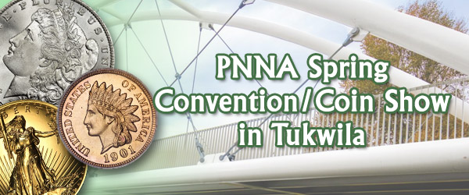
PNNA Conventions &
Coin Shows in
Tukwila, Washington

Collector Exhibits

2020s
This document is intended as a supplement to:
past convention & coin show reports on the website.
In memory of PNNA exhibiting legends:
Byron F. Johnson, Del Cushing and Larry Rowe
Table of Contents
2020 Convention & Coin Show Exhibit Reports 3
2021 Convention & Coin Show Exhibit Reports 3
Exhibits at the 2022 PNNA Fall Coin Show 4
2022 Convention & Coin Show Exhibit Reports 5
Exhibits at the 2023 PNNA Convention 6
Exhibits at the 2023 PNNA Fall Coin Show 7
2023 Convention & Coin Show Exhibit Reports 7
Exhibits at the 2024 PNNA Convention 8
2024 Convention & Coin Show Exhibit Reports 9

All the exhibit case images in this document (and a few more) are available to be viewed and studied at the highest available resolution by visiting https://pnna.org/exhibits/images/. This is a great way to learn from the past and prepare for your next collector exhibit! Look for file names in the images folder containing the exhibit number shown in brackets.
For all years, where a class is omitted in the exhibit results, there were no entries in that class.

2020 Convention & Coin Show Exhibit Reports
CANCELLED due to virus concerns! The PNNA Convention/Spring Coin Show was scheduled for April 17-19, 2020, in Tukwila, Washington.
CANCELLED due to virus concerns! The PNNA fall show in Tukwila was scheduled for Sept. 25-27, 2020, but was cancelled.

2021 Convention & Coin Show Exhibit Reports
CANCELLED due to virus concerns! The PNNA Convention/Spring Coin Show was scheduled for April 9-11, 2021, in Tukwila, Washington.
The Pacific Northwest Numismatic Association 16th Annual Fall Coin Show was held October 8-10, 2021, in Tukwila, Washington. All previous PNNA fall coin shows were in Portland, in cooperation with the Willamette Coin Club (WCC). This was the first PNNA Tukwila fall coin show!
According to PNNA convention chairman Kevin Charboneau, “I think the PNNA show was a great success. There was a steady stream of buyers coming through the door. The vendors I spoke with were very happy.” Although a few dealers didn’t come and educational activities including collector exhibits were more limited (just one noncompetitive exhibit on the bourse floor), overall, it was a big success for people returning to a PNNA show for the first time in two years.

Exhibits at the 2022 PNNA Fall Coin Show
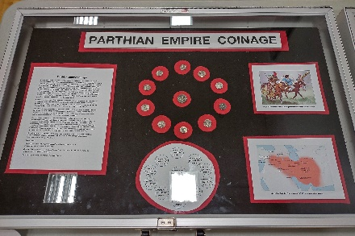
Class 1 — Coins
1st Place — Tim Kalkwarf – Parthian Empire Coinage. [Exh-2022-1]
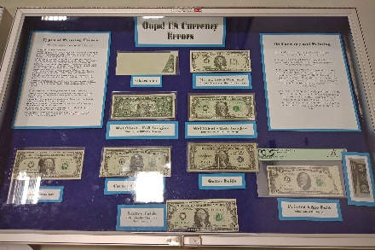
Class 2 — Paper Money
1st Place & 2nd Best of Show & Del Cushing Memorial (People’s Choice) Award —
Tony Kalt – Oops! US Currency Errors. [Exh-2022-4]
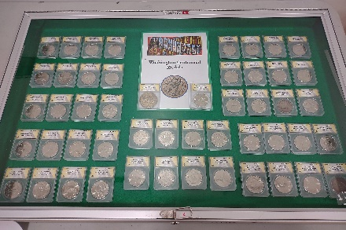 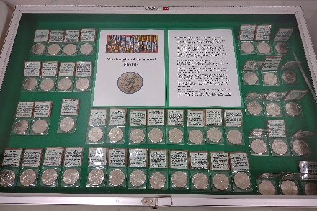 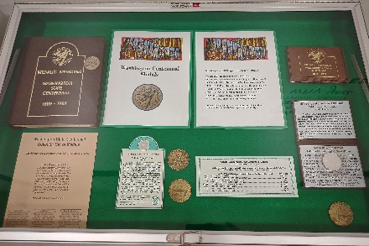
Class 3 — Tokens, Medals and Exonumia
1st Place — Tony Kalt – Washington Centennial Medals. [Exh-2022-3]
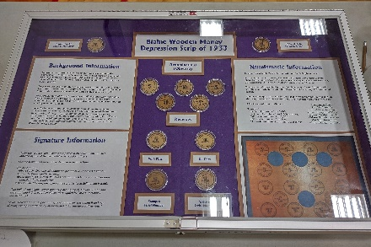
Class 6 — Pacific Northwest
1st Place & C.E. “Hepp” Heppner (Best Token & Medal) Award
& Byron F. Johnson Memorial (Best of Show) Award —
Tony Kalt – Blaine Wooden Money: Depression Scrip of 1933. [Exh-2022-2]
Judges: Eric Holcomb, Danny Bisgaard, James Reinders.

2022 Convention & Coin Show Exhibit Reports
See above for the results of this year’s competitive displays in Tukwila (at the fall show), which include awards normally given at the spring convention. There were four competitive exhibits in six cases, covering four of the six classes. Although there weren’t a lot of exhibits, we are underway again! Thanks to the exhibitors!
Congratulations to the winners. They received awards for their entries. Thank you to the judges listed above, and to Eric Holcomb for serving as Chief Judge. Their work was very much appreciated.
The PNNA Convention & Spring Coin Show (71st Annual) was held April 8-10, 2022, at the Tukwila Community Center, Tukwila, Washington.
This was the first PNNA spring convention in three years, and was a successful return to action, even though activities such as numismatic theater, collector exhibits, and scout clinics were cancelled or not scheduled. According to Rick Schulz, “Dealers I talked to all reported a good show, so those attending came to buy and sell. This bodes well for upcoming local shows.”
The PNNA 17th Annual Fall Coin Show was held October 7-9, 2022, in Tukwila, Washington. This was the second PNNA Tukwila fall coin show! (The first 15 annual fall coin shows were jointly hosted with the WCC in Portland.)
In 2021, there was just one collector exhibit at the fall show, located in the bourse area, but there were a few more exhibits at the fall 2022 show, and awards were made. The location of the exhibits was in the fitness room across the hall from the bourse entrance, as at most past shows.

Exhibits at the 2023 PNNA Convention
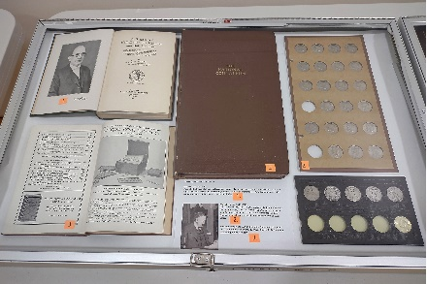 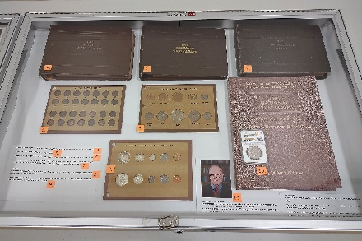
Gawain O’Connor –
Collecting with Classic Coin Albums. [Exh-2023-1]
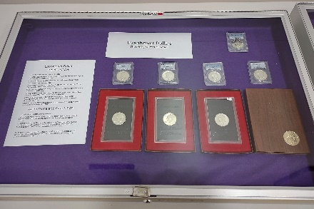 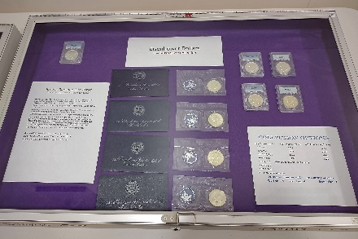
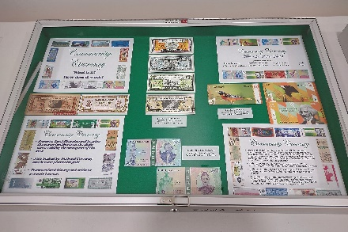 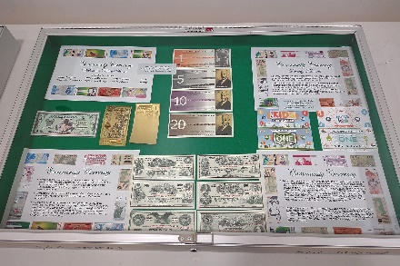
Tony Kalt –
Eisenhower Dollars: The 40% Silver Collection and Community Currency. [Exh-2023-2 and -3]
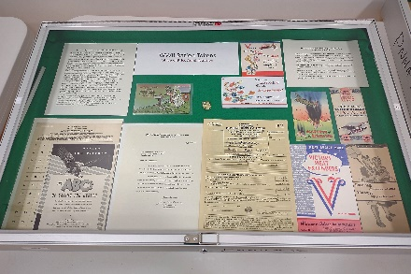 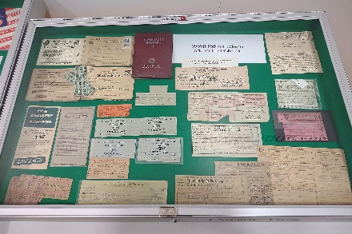 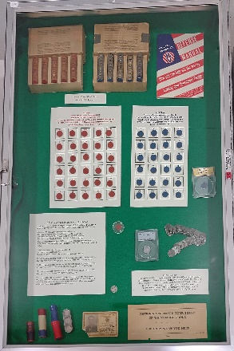
Tony Kalt –
WWII Ration Tokens: Office of Price Administration. [Exh-2023-4]
Judges: none (noncompetitive)
Exhibit Organizer: Eric Holcomb.

Exhibits at the 2023 PNNA Fall Coin Show
(no photos available)
Class 1 — Coins
1st Place & 2nd Best of Show — Tony Kalt – Common Cents – Unique Cents.
(no photos available)
Class 3 — Tokens, Medals and Exonumia
1st Place & Byron F. Johnson Memorial (Best of Show) Award — anonymous – Boeing Club medals.
Also 1st Place & C.E. “Hepp” Heppner (Best Token & Medal) Award.
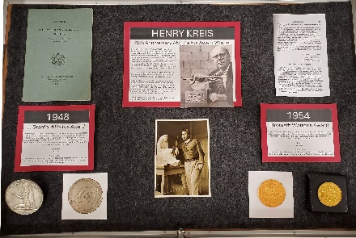 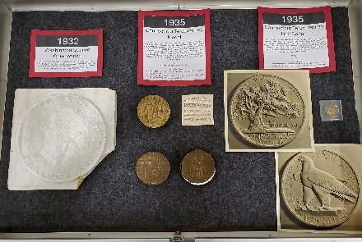 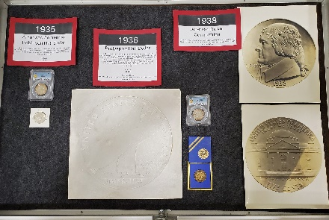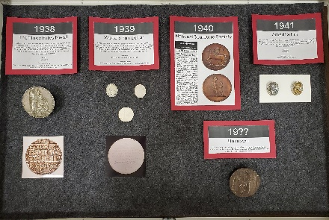 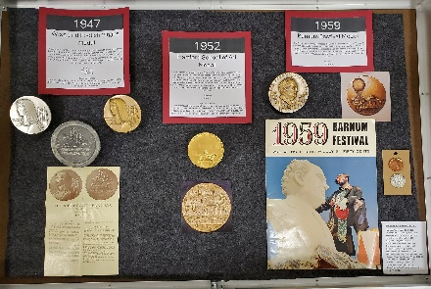
Class 5 — Topical
1st Place & 3rd Best of Show & Del Cushing Memorial (People’s Choice) Award —
Karl Kreis – Henry Kreis – 75th Anniversary ANS Saltus Award Winner. [Exh-2023-fall-1]
Judge: Danny Bisgaard.

2023 Convention & Coin Show Exhibit Reports
See above for the results of this year’s competitive displays in Tukwila (at the fall show), which include awards normally given at the spring convention. There were three competitive exhibits, covering three of the six classes. Although there weren’t a lot of exhibits, we continue to be underway again! Thanks to the exhibitors!
Congratulations to the winners. They received awards for their entries. Thank you to the judge listed above, who also filled in for Eric Holcomb as Chief Judge. His work was very much appreciated.
The PNNA Convention & Spring Coin Show (72nd Annual) was held April 14-16, 2023, at the Tukwila Community Center, Tukwila, Washington.
All exhibits were noncompetitive at this convention, in part due to lack of entries.
The PNNA 18th Annual Fall Coin Show was held October 6-8, 2023, in Tukwila, Washington.

Exhibits at the 2024 PNNA Convention
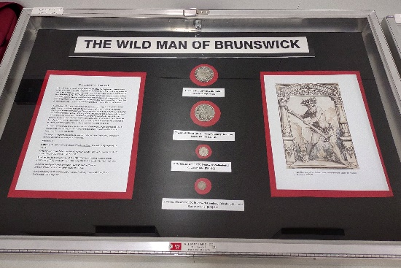
Class 1 — Coins
1st Place & 3rd Best of Show — Tim Kalkwarf – The Wildman of Brunswick. [Exh-2024-1]
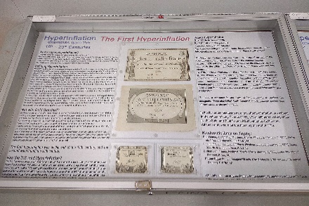 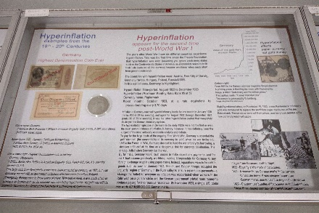
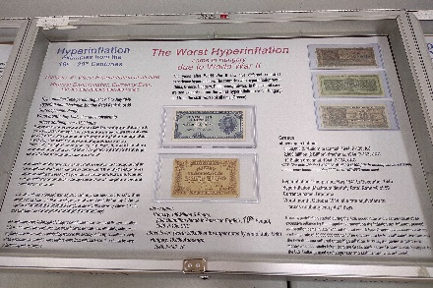 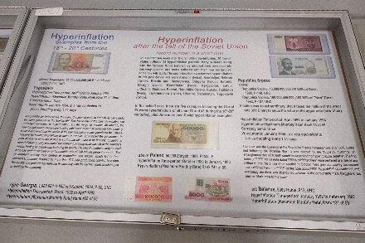
Class 2 — Paper Money
1st Place & Byron F. Johnson Memorial (Best of Show) Award — James Reinders –
Hyperinflation: Examples from the 18th-20th Centuries. [Exh-2024-7]
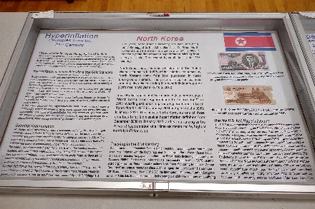 (one case not shown) 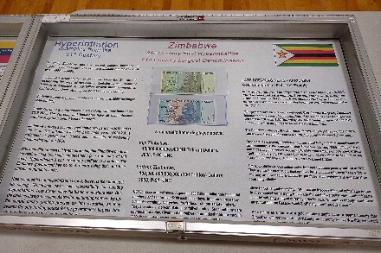
Class 5 — Topical
1st Place & 2nd Best of Show — James Reinders – Hyperinflation: Examples from the 21st Century. [Exh-2024-6]
Judges: Eric Holcomb, Danny Bisgaard.

2024 Convention & Coin Show Exhibit Reports
See above for the results of this year’s competitive displays in Tukwila (at the spring convention). There were three competitive exhibits, covering three of the six classes. Although there weren’t a lot of competitive exhibits, we continue to be underway again! Thanks to the exhibitors!
Congratulations to the winners. They received awards for their entries. Thank you to the judges listed above. Their work was very much appreciated.
Also, thanks for four non-competitive exhibits (not pictured above). These included a “Coin Collecting 101” exhibit, appropriate for National Coin Week, and shown several times before, and an exhibit for which a coin had not yet been returned by a grading service, which will hopefully be shown with the coin this fall.
The PNNA Convention & Spring Coin Show (73rd Annual) was held April 12-14, 2024, at the Tukwila Community Center, Tukwila, Washington.
The PNNA 19th Annual Fall Coin Show is scheduled for October 4-6, 2024, in Tukwila, Washington.

