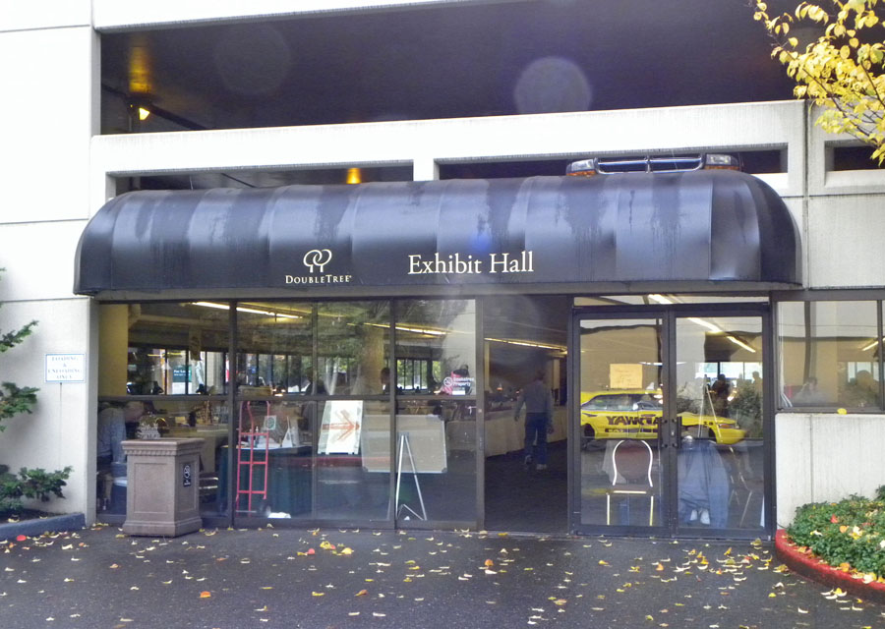
PNNA/WCC Fall Coin Shows in
Portland, Oregon

Collector Exhibits

2010-2019
This document is intended as a supplement to:
Past fall coin show reports:
2005-2019 reports consolidated into a 23-page PDF file
In memory of PNNA exhibiting legends:
Byron F. Johnson, Del Cushing and Larry Rowe

Table of Contents
Exhibit Results at the 2010 PNNA/Willamette Fall Coin Show 3
Exhibit Results at the 2011 PNNA/Willamette Fall Coin Show 4
Exhibit Results at the 2012 PNNA/Willamette Fall Coin Show 4
Exhibit Results at the 2013 PNNA/Willamette Fall Coin Show 5
Exhibit Results at the 2014 PNNA/Willamette Fall Coin Show 6
Exhibit Results at the 2015 PNNA/Willamette Fall Coin Show 7
Exhibit Results at the 2016 PNNA/Willamette Fall Coin Show 8
Exhibit Results at the 2017 PNNA/Willamette Fall Coin Show 9
Exhibit Results at the 2018 PNNA/Willamette Fall Coin Show 10
Exhibit Results at the 2019 PNNA/Willamette Fall Coin Show 11
2019 Portland Coin Show Exhibit Report 12

All exhibits at the fall shows were entered in a single class unless otherwise noted.
Where a class is omitted in the exhibit results, there were no entries in that class.
For most of the fall coin shows, there are no written exhibit reports, however,
the results may have been reported in The Nor’wester.
All the exhibit case images in this document (and a few more) are available to be viewed and studied at the highest available resolution by visiting https://pnna.org/exhibits/images/. This is a great way to learn from the past and prepare for your next collector exhibit! Look for file names in the images folder containing the exhibit number shown in brackets.

Exhibit Results at the 2010 PNNA/Willamette Fall Coin Show
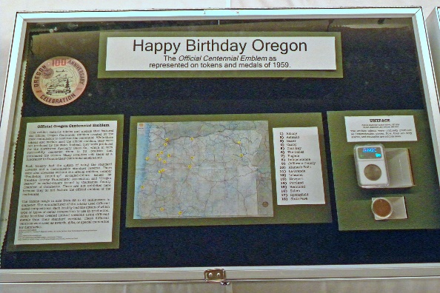 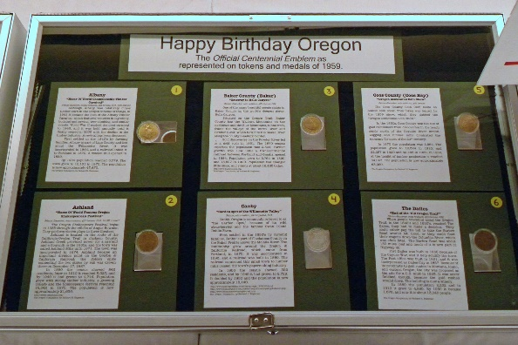 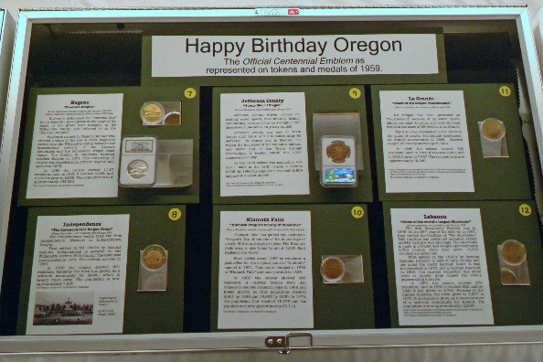 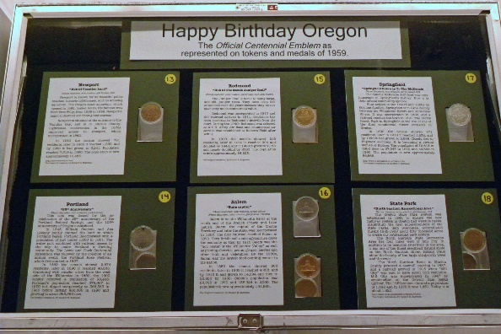
1st Place — Katie Reinders – Happy Birthday Oregon: The Official Centennial Emblem
as represented on tokens and medals of 1959. [Exh-2010P-3]
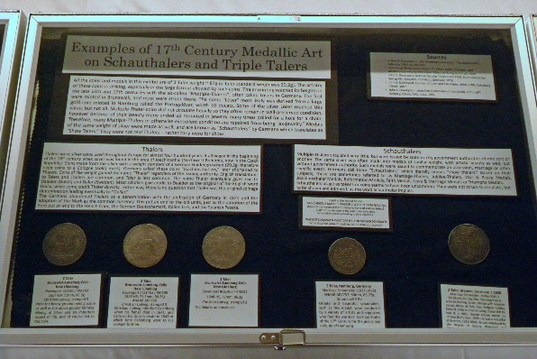 | 2nd Place — James Reinders – Examples of 17th Century Medallic Art on Schauthalers and Triple Talers. [Exh-2010P-5]
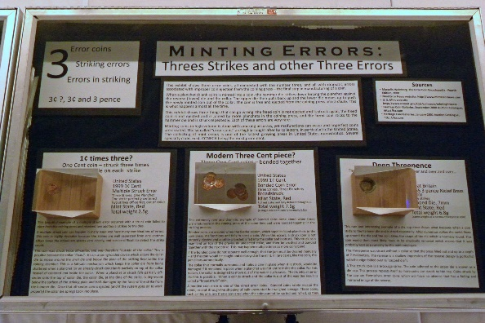 | 3rd Place — James Reinders – Minting Errors: Three Strikes and other Three Errors.  [Exh-2010P-6]
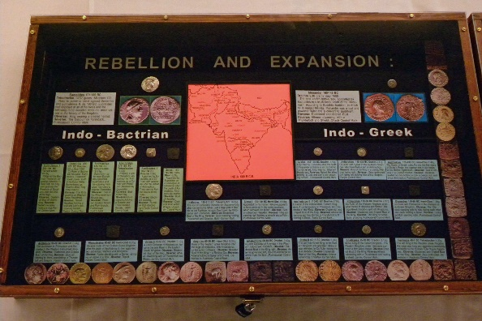 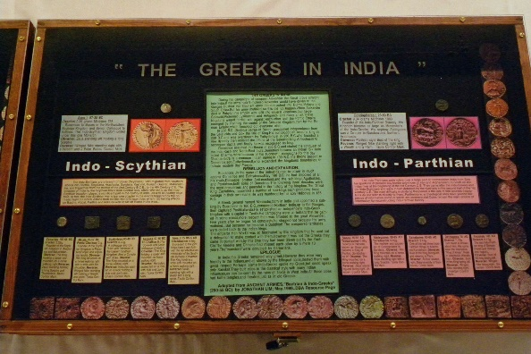
4th Place — Gerald R. Williams – Rebellion and Expansion: The Greeks in India. [Exh-2010P-7]
Judges: Scott Loos, Eric Holcomb.

Exhibit Results at the 2011 PNNA/Willamette Fall Coin Show
See photos of an earlier version of this exhibit at the 2010 show (above).
1st Place — Katie Reinders – Happy Birthday Oregon: The Official Centennial Emblem as represented on tokens and medals of 1959.
2nd Place — James Reinders – A Swedish 3 Daler Plate from the Nicobar Wreck.
3rd Place — Marie Fernandez – Mint Marks of U.S. Coins.
Judges: Eric Holcomb, Scott Loos, and Danny Bisgaard.

Exhibit Results at the 2012 PNNA/Willamette Fall Coin Show
1st Place — James Reinders – Complete German States 3 Mark Commemorative Type Set
and Clock Makers Collection. Note: James agreed to accept a single first place award for his two exhibits, which were judged first (German exhibit) and second (clock exhibit).
2nd Place — Gerald R. Williams – The Arts: Numismatic Contribution of the Cooper Union.
3rd Place — Katie Reinders – Happy Birthday Oregon: Pendleton Round-Up.
4th Place — Marie Fernandez – Should IN GOD WE TRUST be on Coins?
Judges: Eric Holcomb, Gawain O'Connor, and Danny Bisgaard.

Exhibit Results at the 2013 PNNA/Willamette Fall Coin Show
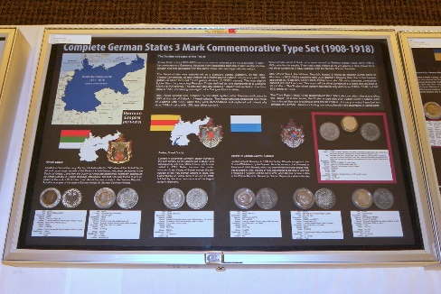 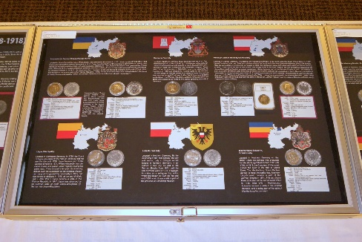
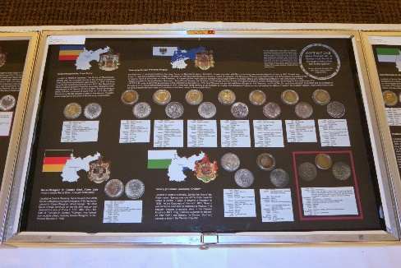 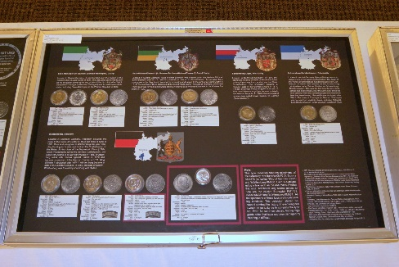
1st Place — James Reinders – Complete German States 3 Mark Commemorative Type Set (1908-1918). [Exh-2013P-4]
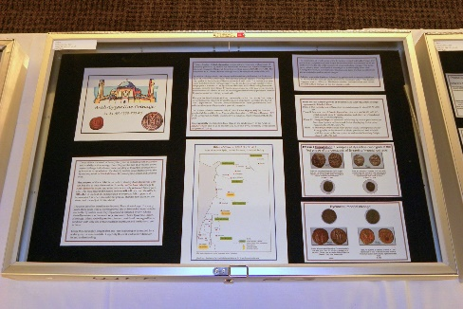 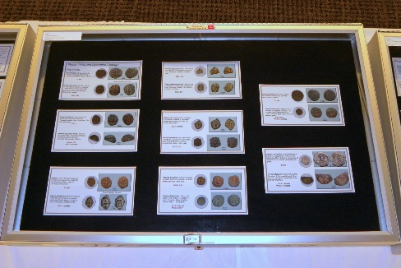 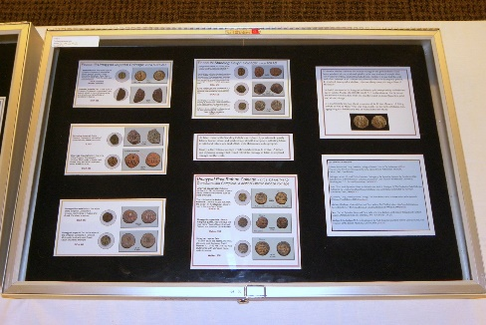
2nd Place — Larry Gaye – Arab-Byzantine Coinage (31-81 AH / 658-700 AD). [Exh-2013P-6]
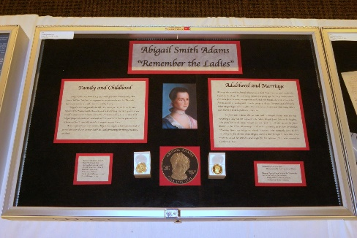 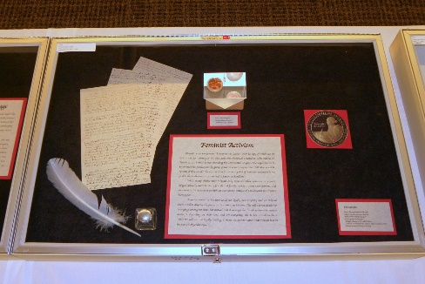
3rd Place — Katie Reinders – Abigail Smith Adams - "Remember the Ladies". [Exh-2013P-2]
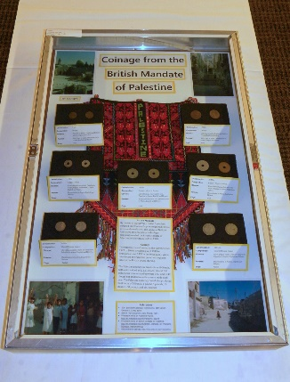
Best New Exhibitor — Tim Bishopric – Coinage from the British Mandate of Palestine. [Exh-2013P-7]
Judges: Eric Holcomb, Danny Bisgaard, and Del Cushing.

Exhibit Results at the 2014 PNNA/Willamette Fall Coin Show
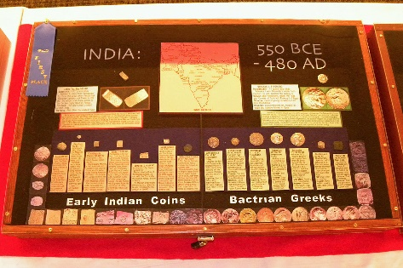 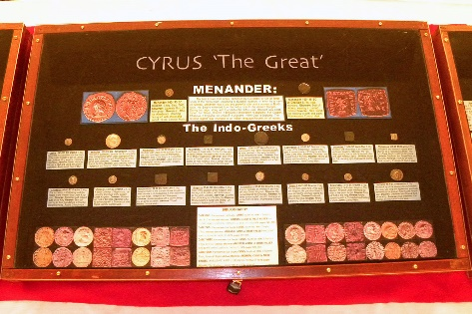
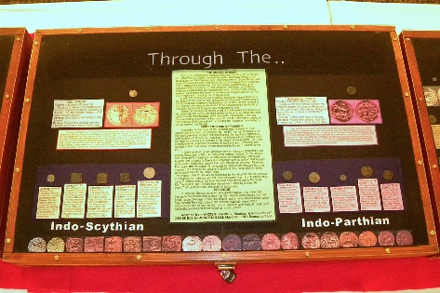 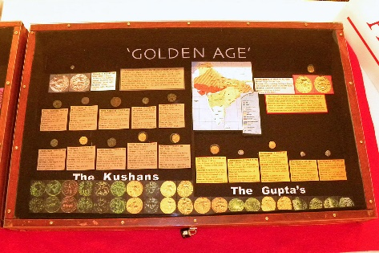
1st Place — Gerald R. Williams – India: 550 BCE-480 AD, Cyrus "The Great" through the "Golden Age." [Exh-2014P-1]
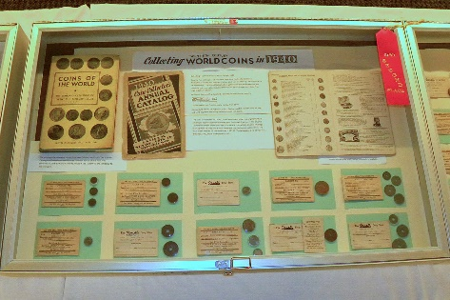 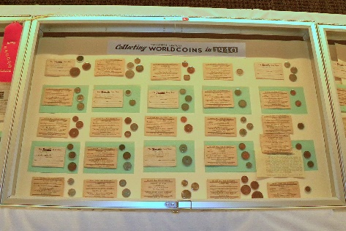
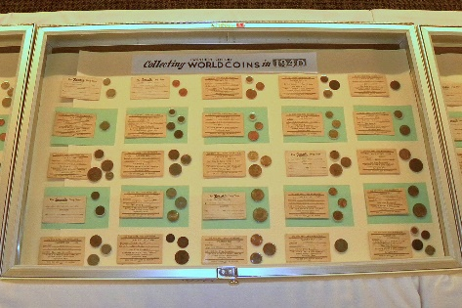 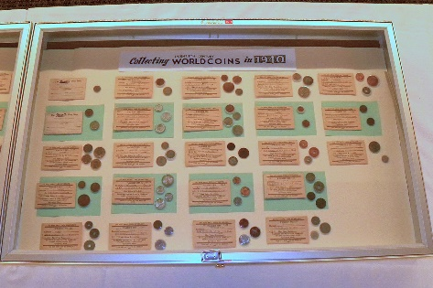
2nd Place — Gawain O'Connor – Collecting Twentieth Century World Coins in 1940. [Exh-2014P-3]
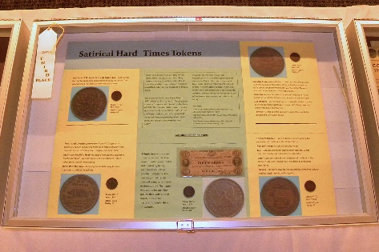
3rd Place — Tim Bishopric – Satirical Hard Times Tokens. [Exh-2014P-2]
Best New Exhibitor and YN Exhibitor — Vladimir Vesely – John C. Ainsworth, etc.
(Portland National Bank president)
Judges: Eric Holcomb, Danny Bisgaard, and James Reinders.

Exhibit Results at the 2015 PNNA/Willamette Fall Coin Show
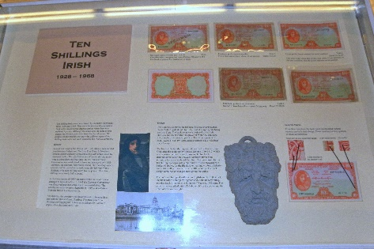 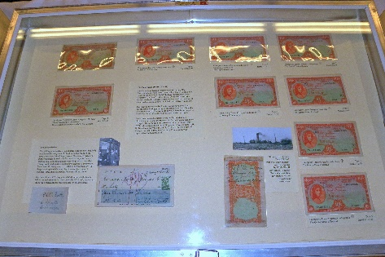 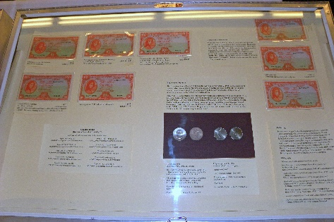
1st Place — Gawain O'Connor – Ten Shillings Irish 1928-1968. [Exh-2015P-1]
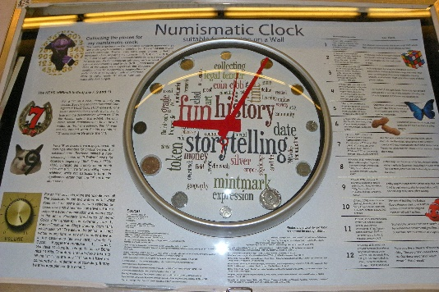
2nd Place — James Reinders – Numismatic Clock: Suitable for hanging on a wall. [Exh-2015P-5]
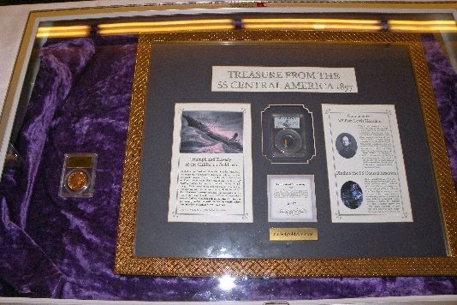
3rd Place — Dennis Reed – Treasure from the SS Central America 1857. [Exh-2015P-6]
Judges: Eric Holcomb, Danny Bisgaard, Tom Sheehan, and Ken Hill.

Exhibit Results at the 2016 PNNA/Willamette Fall Coin Show
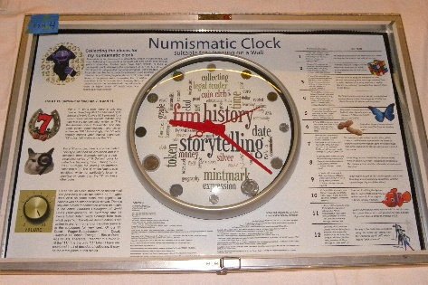
1st Place and People's Choice — James Reinders – Numismatic Clock: Suitable for hanging on a wall. [Exh-2016P-4]
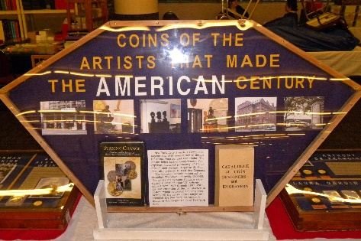 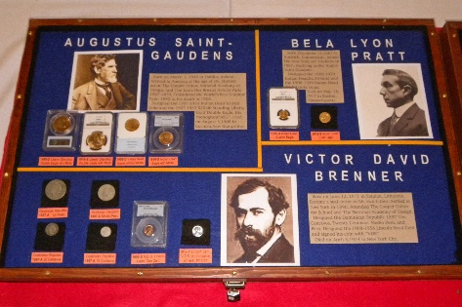 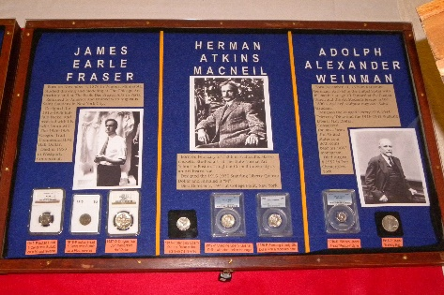
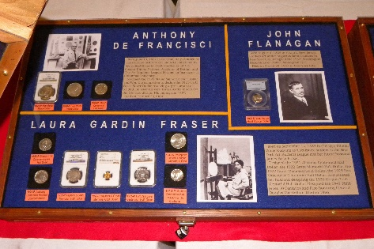 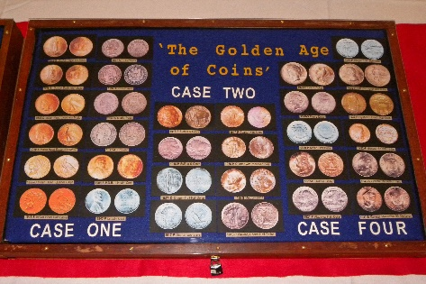
2nd Place — Gerald Williams – Coins of the Artists that made the American Century. [Exh-2016P-3]
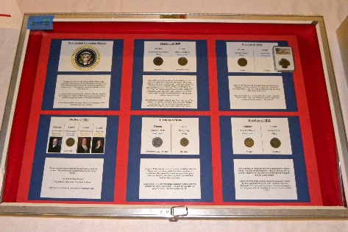 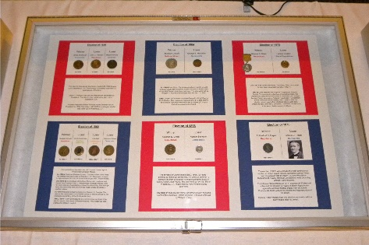 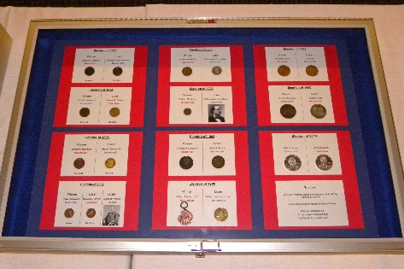
3rd Place and Best New Exhibitor — Jason Breedlove – Presidential Campaign Medals. [Exh-2016P-2]
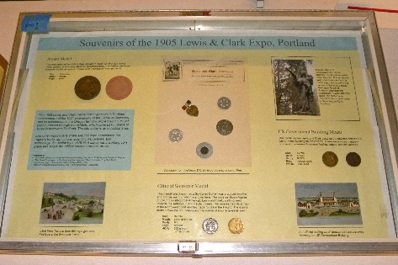 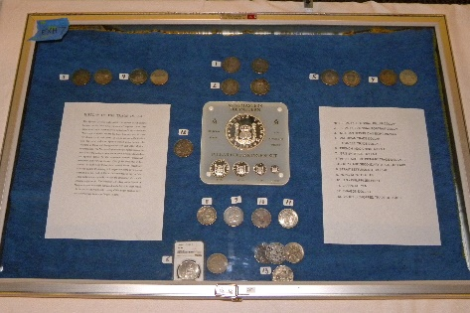 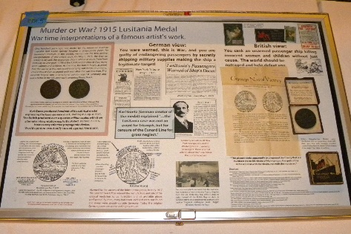
Other Competitive Exhibits —
Tim Bishopric (left) – Souvenirs of the 1905 Lewis & Clark Expo, Portland. [Exh-2016P-1]
Francisco Lazzara (center) – History of the Trade Dollar. [Exh-2016P-7]
James Reinders (right) – Murder or War? 1915 Lusitania Medal. [Exh-2016P-5]
Judges: Eric Holcomb, Danny Bisgaard, and John Brown.

Exhibit Results at the 2017 PNNA/Willamette Fall Coin Show
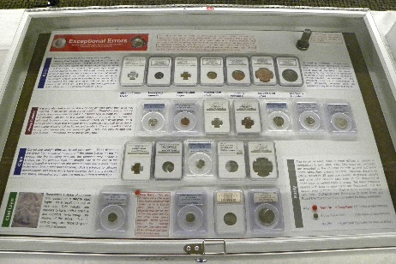 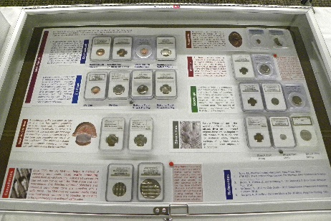
1st Place and Best New Exhibitor — Jimmy Krozel – Exceptional Errors. [Exh-2017P-2]
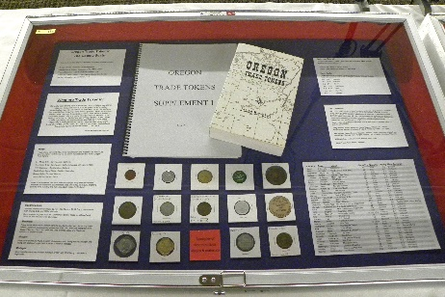 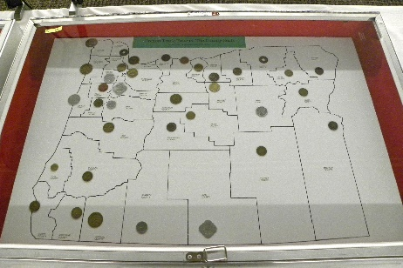
2nd Place — Jason Breedlove – Oregon Trade Tokens: The County Seats. [Exh-2017P-3]
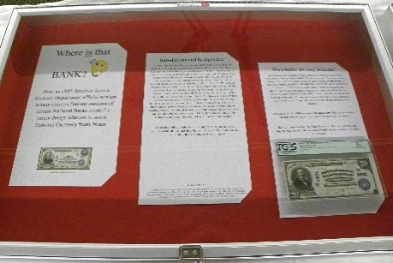 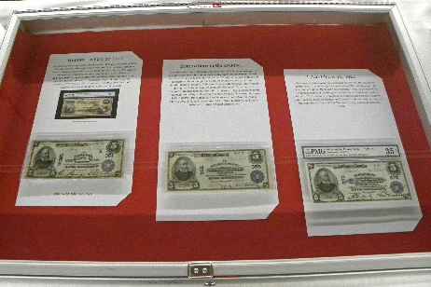
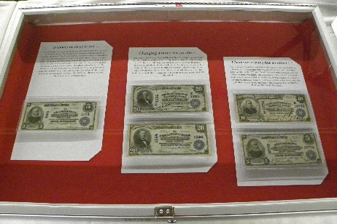 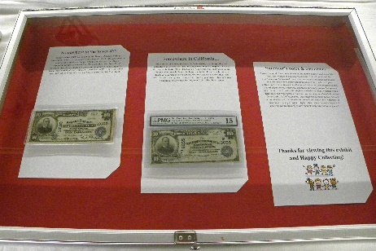
3rd Place — Tom Tullis – Where is that Bank? [Exh-2017P-1]
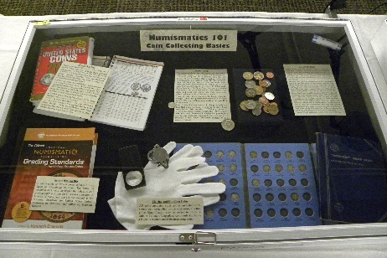 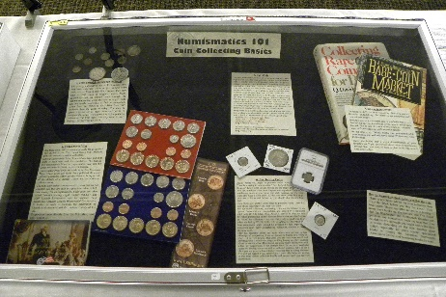
Non-Competitive Exhibit —
James Reinders – Numismatics 101: Coin Collecting Basics. [Exh-2017P-4]
Judges: Eric Holcomb, Danny Bisgaard, and James Reinders.

Exhibit Results at the 2018 PNNA/Willamette Fall Coin Show
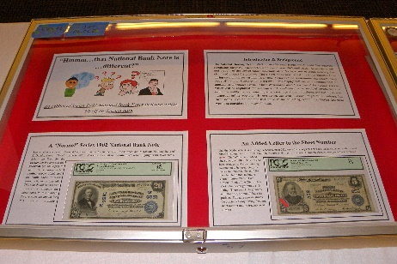 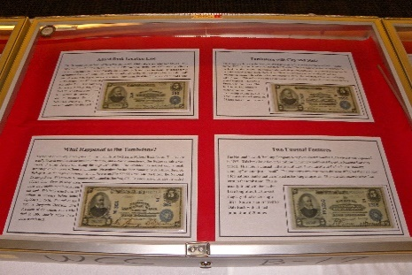 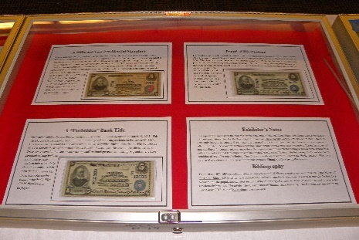
1st Place — Tom Tullis – Hmmm … that National Bank Note is different. [Exh-2018P-1]
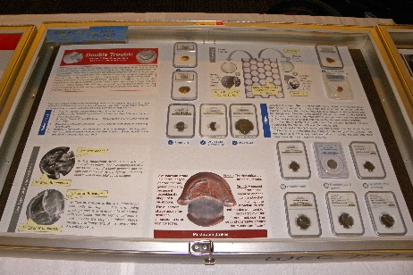 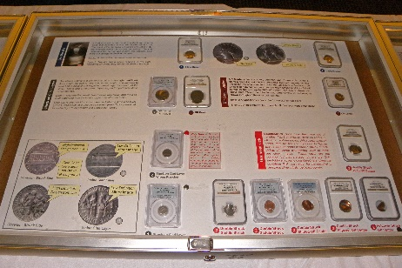 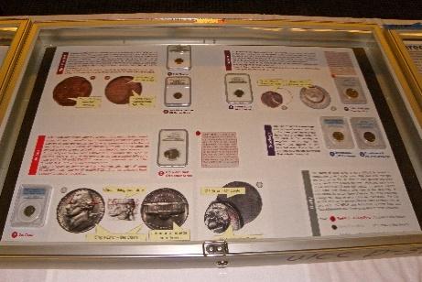
2nd Place — Jimmy Krozel – Double Trouble. [Exh-2018P-7]
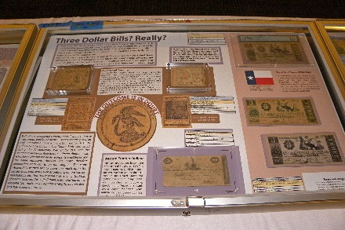 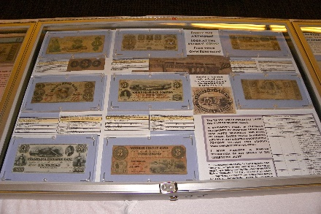
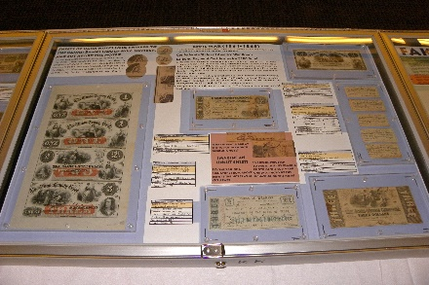 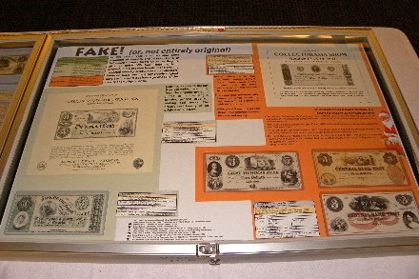
3rd Place — James Reinders – Three Dollar Bills? Really? [Exh-2018P-4]
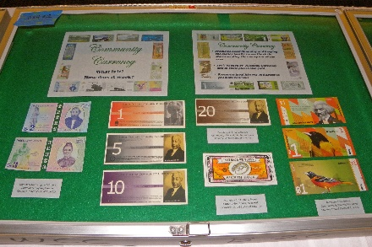 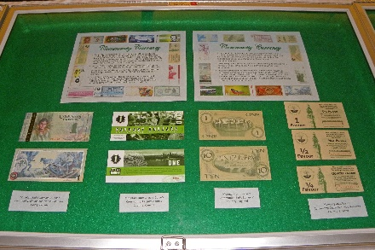 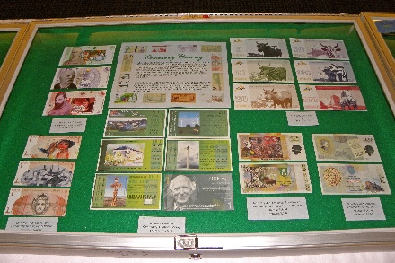
People’s Choice — Tony Kalt – Community Currency. [Exh-2018P-2]
Non-Competitive Exhibit —
Jimmy Krozel – CONECA.
Judges: Eric Holcomb, Danny Bisgaard.

Exhibit Results at the 2019 PNNA/Willamette Fall Coin Show
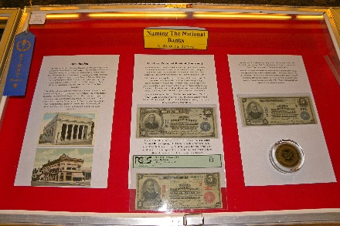 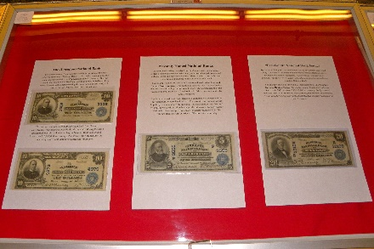 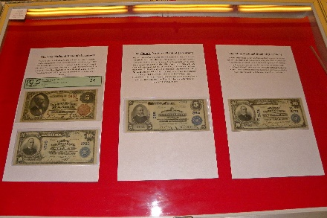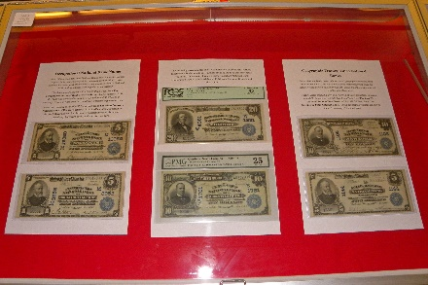 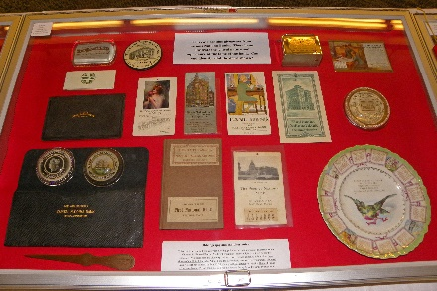
Class 2 — Paper Money
1st Place (2nd Best of Show) — Tom Tullis – Naming the National Banks: A Historical Survey.
2nd Place — Arthur Schweizer – 100 Year Evolution of the Ten Dollar Bill. [Exh-2019P-2]
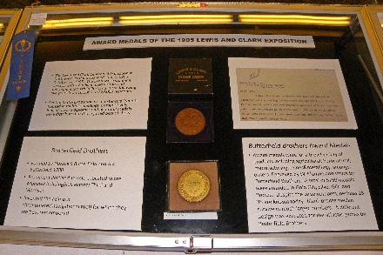 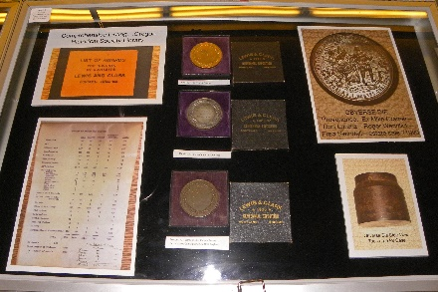 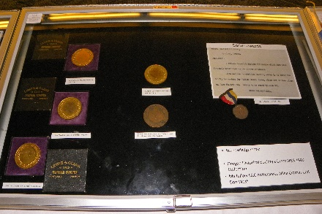
Class 3 — Tokens, Medals and Exonumia
1st Place — Nathan Markowitz – Award Medals of the 1905 Lewis and Clark Exhibition.
2nd Place — Jason Breedlove – Salt River Tickets: The Numismatics of Political Failure. [Exh-2019P-3]
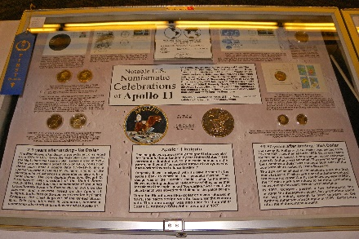 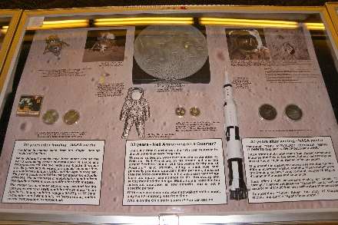 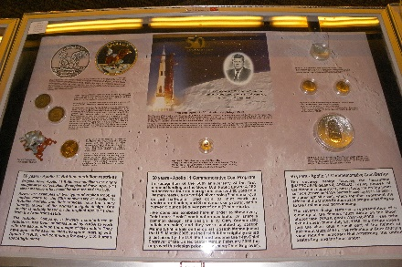
Class 4 — Common Element
1st Place & Best of Show Award — James Reinders –
Notable U.S. Numismatic Celebrations of Apollo 11. [Exh-2019P-5]
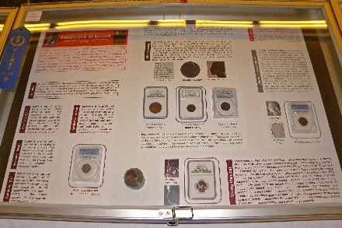 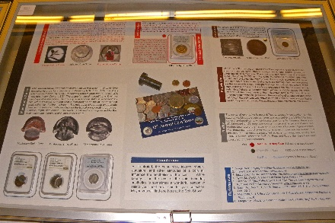
Class 5 — Topical
1st Place (3rd Best of Show) — Jimmy Krozel – Aesthetics of Errors. [Exh-2019P-6]
Judges: Eric Holcomb, Danny Bisgaard, John Brown.

2019 Portland Coin Show Exhibit Report
See above for the results of the 2019 competitive displays in Portland. There were six competitive exhibits in 17 cases, covering four of the six new classes. Thanks to all the exhibitors!
Congratulations to all the winners. They received awards for their entries. Thank you to the judges listed above, to Eric Holcomb for serving as Chief Judge, and to Tom Tullis for serving as Exhibit Chairman. Their work was very much appreciated.
This was the first year that exhibits at the fall coin show could be entered in one of six classes (as is true at the spring convention) rather than in a single class.
All shows were cancelled in 2020, and then beginning in 2021, both the PNNA spring and fall shows are in Tukwila, and the Portland fall coin show is run separately by the Willamette Coin Club (WCC).

