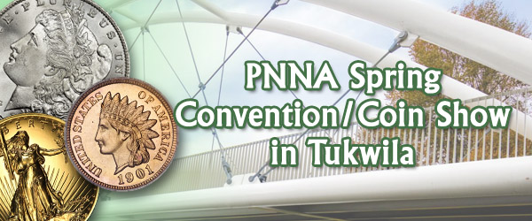
PNNA Spring Conventions in
Tukwila, Washington

Collector Exhibits

2001-2009
This document is intended as a supplement to:
Past spring convention reports:
2001-2019 reports consolidated into a 40-page PDF file
In memory of PNNA exhibiting legends:
Byron F. Johnson, Del Cushing and Larry Rowe

Table of Contents
2001 Convention Exhibit Report by Larry Rowe, Exhibit Chairman 3
Exhibit Results at the 2002 PNNA Convention 5
2002 Convention Exhibit Report by Larry Rowe, Exhibit Chairman 5
Exhibit Results at the 2003 PNNA Convention 6
2003 Convention Exhibit Report by Larry Rowe, Exhibit Chairman 6
Exhibit Results at the 2004 PNNA Convention 7
2004 Convention Exhibit Report by Larry Rowe, Exhibit Chairman 7
Exhibit Results at the 2005 PNNA Convention 8
PNNA Exhibits (2005) - What Next? by Larry Rowe, Exhibit Chairman 8
Exhibit Results at the 2006 PNNA Convention 9
Exhibits Improve (2006) by Larry Rowe, Exhibit Chairman 10
Some ANA Exhibit Reports (2003-2006) 11
Exhibits at the ANA 2003 Anniversary Convention 11
Exhibits at the ANA 2004 Spring Convention 11
Exhibits at the 2004 ANA Anniversary Convention 11
Exhibits at the 2005 ANA Anniversary Convention 11
Exhibits at the 2006 ANA Anniversary Convention 11
Exhibit Results at the 2007 PNNA Convention 12
Exhibiting at PNNA Becoming a Thing of the Past (2007) by Larry Rowe, Exhibit Chairman 12
Exhibit Results at the 2008 PNNA Convention 13
2008 Convention Exhibit Report by Larry Rowe, Exhibit Chairman 13
Exhibit Results at the 2009 PNNA Convention 14
2009 Convention Exhibit Report by Larry Rowe, Exhibit Chairman 15
“Oregon at 150” Exhibits 15

All the exhibit case images in this document (and a few more) are available to be viewed and studied at the highest available resolution by visiting https://pnna.org/exhibits/images/. This is a great way to learn from the past and prepare for your next collector exhibit! Look for file names in the images folder containing the exhibit number shown in brackets.
For all years, where a class is omitted in the exhibit results, there were no entries in that class.

Exhibits at the 2001 PNNA Convention
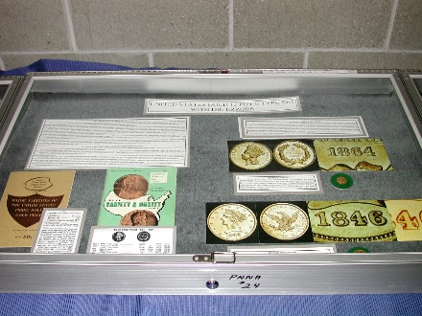 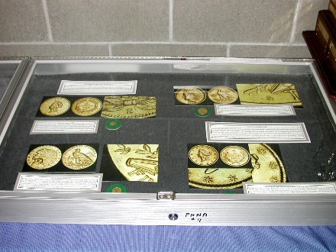
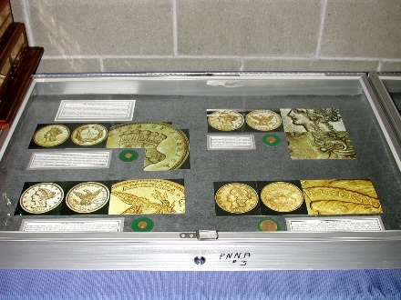 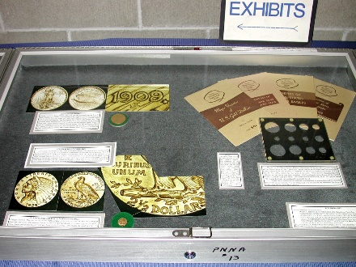
Class 1 — United States and Canadian Coins
1st Place — Kenneth R. Hill
United States Gold 12 Piece Type Set with Die Errors
Byron F. Johnson Memorial (Best of Show) Award [Exh-2001-Hill]
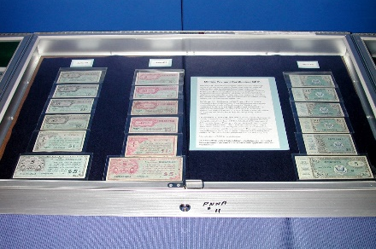 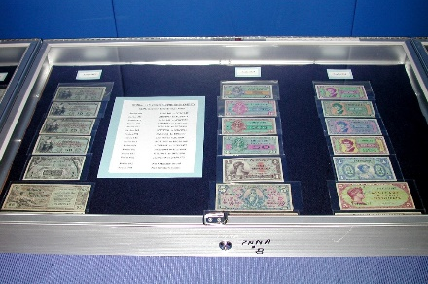 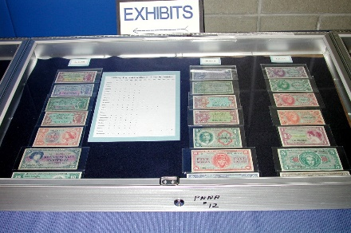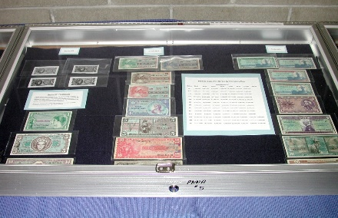 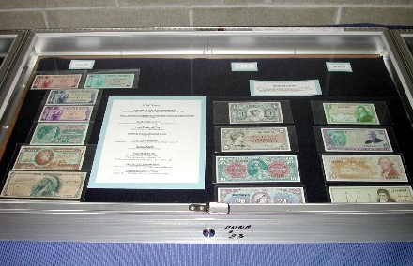 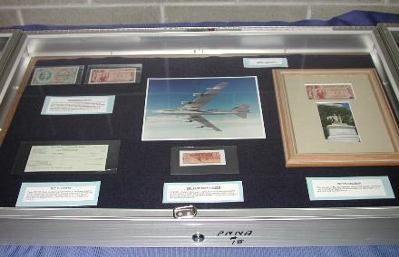
Class 2 — United States Paper Money
1st Place — Thomas A. Koch
Military Payment Certificate Type Exhibit [Exh-2001-Koch]
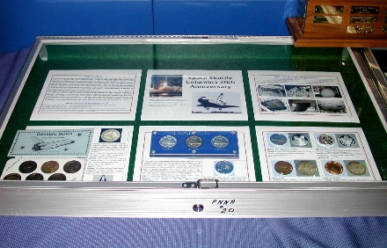 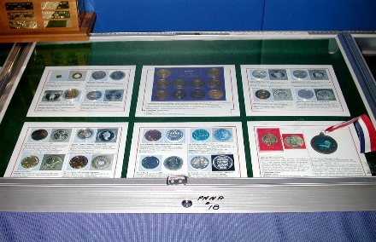
Class 3 — Tokens, Medals, and Decorations
1st Place — J. Eric Holcomb
Space Shuttle Columbia 20th Anniversary
C.E. Heppner Award (Tokens, Medals, and Decorations) [Exh-2001-Holcomb]
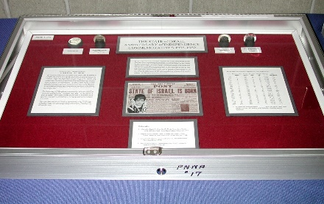 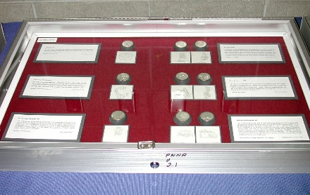 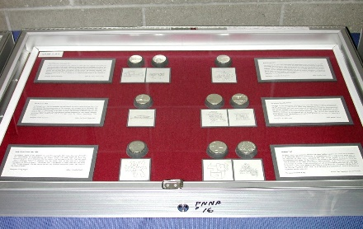
Class 4 — World Coins and Paper Money
1st Place — Ellis H. Corets
The State of Israel Anniversary of Independence Commemoratives 1958-1980 [Exh-2001-Corets]
First three cases of exhibit shown.
Judges: Joseph Boling, Tom Sheehan, and Robert Hoge.

2001 Convention Exhibit Report by Larry Rowe, Exhibit Chairman
The PNNA convention in Tukwila this year was a success. Everyone seemed to like the new convention venue. Not that there were no problems, but they were small and can be corrected for next year. Convention General Chairman Richard Billings did an excellent job with the assistance of Del Cushing. They are the ones who put this convention together and deserve the appreciation of the PNNA membership.
Exhibits this year were not numerous, but those that did take the time and make the effort to enter an exhibit did outstanding work. The work of Chief Judge Joseph E. Boling and judges Tom Sheehan and Robert Hoge, museum curator visiting from ANA, is very much appreciated.
The results of this year’s competitive exhibits are shown above, and the winners received a new type of award that the PNNA decided to offer beginning this year. Each winner received a plastic display plaque made by PNNA member Al Schy inscribed with proper data and containing a U.S. Silver Eagle for the current year.
Non-competitive exhibits consisted of University Coin Club’s traveling exhibit and a display of PNNA mementos.
I hope to see more of you enter an exhibit next year and make the competition more competitive.

Exhibits at the 2002 PNNA Convention
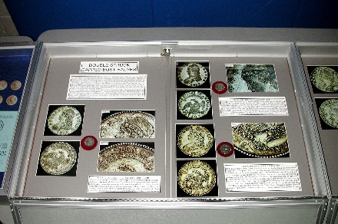 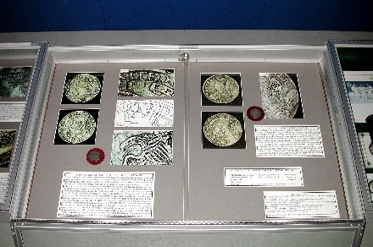
Class 1 — United States and Canadian Coins
1st Place — Kenneth R. Hill
Double Struck Capped Bust Half Dollars
Byron F. Johnson Memorial (Best of Show) Award [Exh-2002-Hill]
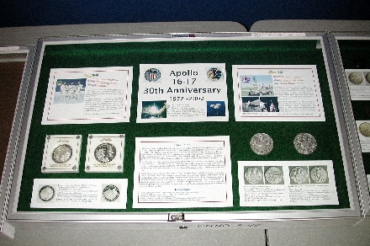 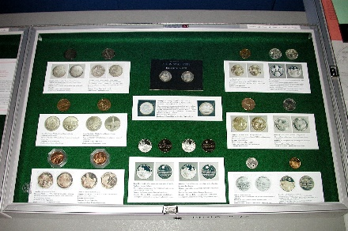
Class 3 — Tokens, Medals, and Decorations
1st Place — J. Eric Holcomb
Apollo 16-17 30th Anniversary 1972-2002
C.E. Heppner Award (Tokens, Medals, and Decorations) [Exh-2002-Holcomb]

2002 Convention Exhibit Report by Larry Rowe, Exhibit Chairman
And Then There Were None. Competitive exhibits at this year’s PNNA convention in Tukwila were great, but — there were only two of them!
It seems that each year there are less, and less competitive exhibits entered for the annual convention. The Board of Directors has done several things to encourage people to exhibit. A monetary award of $100 is given to the Best of Show winner to offset expenses to take the exhibit and enter it in ANA competition. Exhibit rules were revised to be more in line with ANA rules to make the transition from regional to national exhibiting easier. New awards were introduced last year that contained an actual silver Eagle coin to make them worth something, and not just another plaque. New display cases were purchased to standardize exhibit sizes and make them more attractive. Exhibits have been taken out of the back of the bourse area and put closer to the entrance so the public will take notice of the displays. We are fortunate to have the best exhibit judge in the nation in our association. Mr. Joe Boling, who is the Chief Judge for the ANA, leads the judging team at the PNNA conventions, this year assisted by Tom Sheehan. You get expert judging to learn how to build even better exhibits. What more can PNNA do to encourage exhibiting? If you have any suggestions or ideas, please let the PNNA know.
See the table above for the two winning exhibits. Both exhibits were worthy of the awards that they received as determined by the judges and did not win the awards just because they did not have any competition.
There were also non-competitive exhibits. The University Coin Club had their stand-alone exhibit of the different facets of coin collecting available, but it was not set up due to lack of available space. The PNNA memorabilia display was once again on display. This display is always of interest to the public. The ANA also had an exhibit of ancient coins pertaining to the Olympic Games which PNNA president Scott Loos arranged to have displayed.
Thanks to all who took the time and trouble to exhibit at this year’s PNNA convention.

Exhibits at the 2003 PNNA Convention
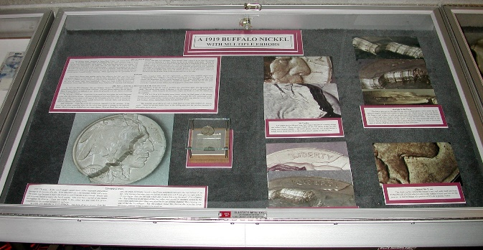 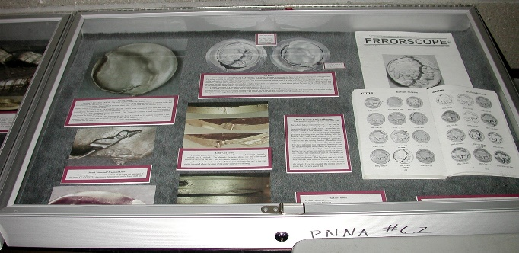
Class 1 — United States and Canadian Coins
1st Place — Kenneth R. Hill
A 1919 Buffalo Nickel with Multiple Errors
Byron F. Johnson Memorial (Best of Show) Award [Exh-2003-Hill]
Class 3 — Tokens, Medals, and Decorations
1st Place — Susan L. Billings
Freedom from Addiction - Examples of Recovery Tokens - Old and New
C.E. Heppner Award (Tokens, Medals, and Decorations)
Class 4 — World Coins and Paper Money
1st Place — Steve Cox
Lebanese Banknotes Issued by the “Banque De Syrie Et Du Liban,” 1945-1950
Judges: Joseph Boling, Tom Sheehan, and Scott Loos.

2003 Convention Exhibit Report by Larry Rowe, Exhibit Chairman
There was a modest increase in the number of competitive exhibits at the 2003 PNNA Convention in Tukwila, WA. This year saw four entries, an increase of two, but a 100% gain over last year. This is a step in the right direction. One of the entries was a first-time exhibitor who not only took a first place but won the Best Tokens and Medals award. Exhibiting is rewarding, ask those who have done it.
Again, the Exhibit Chairman expresses thanks to the judges for their difficult work. The Chief Judge was Joe Boling, assisted by Tom Sheehan and Scott Loos.
Congratulations to the winners and thanks for adding to the quality of the convention.
There were also non-competitive exhibits which were of interest. The PNNA collection of memorabilia was on display, which always draws a crowd. An exhibit entitled New Money for Old - The Euro Changeover was displayed by Greg P. Franck-Wieby of Silverton, Oregon. ANA candidate for Vice President William H. Horton, Jr. of Keyport, NJ displayed an exhibit entitled Several Ways of Collecting Obsolete Paper Money as another step in his goal to exhibit in every state of the country.
Thanks to all who participated this year, and I hope that displays will increase 100% again.

Exhibits at the 2004 PNNA Convention
Class 3 — Tokens, Medals, and Decorations
1st Place — Susan L. Billings
Limited Edition Error Token – The Man on the Bed
2nd Place – Rollie Finner
The 1969 Navajo Code Talkers Medal
Class 4 — World Coins and Paper Money
1st Place and Byron F. Johnson Memorial (Best of Show) Award — Steve Cox
The Bank of France 500 Francs Note of 1918
2nd Place – Eric Holcomb
25th Anniversary of the First Men on the Moon Commemorative Coin Set
from the Marshall Islands
Class 6 — Pacific Northwest Numismatic Material
1st Place and C.E. Heppner Award (Tokens, Medals, and Decorations) — Ken Hill
An Oregon Exchange Company 5 D. Gold Piece
Non-competitive Exhibits
Extreme Copper by Greg Franck-Weiby
Judges: Joseph Boling, Tom Sheehan, and Del Cushing.

2004 Convention Exhibit Report by Larry Rowe, Exhibit Chairman

Exhibits at the 2004 PNNA Convention: VERY GOOD, VERY FEW
“These are some of the finest exhibits I have ever seen” a judge was heard to remark. It was true. It is too bad more collectors do not know the joy of building an exhibit and sharing their collecting interest with others.
Congratulations to all the winners. Thank you to the judges for their time and expertise in judging.
No photos of the 2004 exhibits are available.

Exhibits at the 2005 PNNA Convention
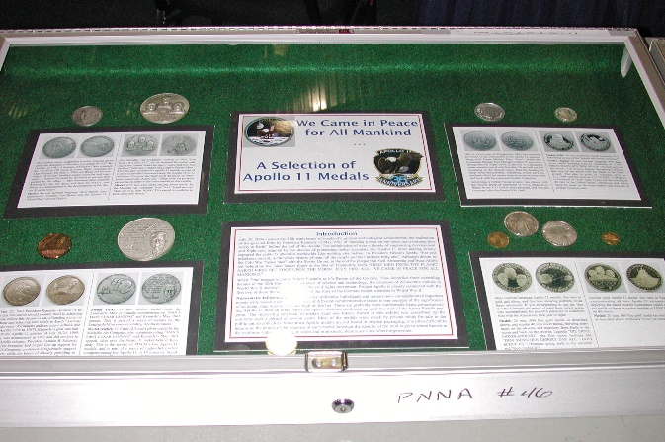
Class 3 — Tokens, Medals, and Decorations
1st Place, C.E. Heppner Award (Tokens, Medals, and Decorations),
Byron F. Johnson Memorial (Best of Show) Award — Eric Holcomb
We Came in Peace for All Mankind - A Selection of Apollo 11 Medals [Exh-2005-Holcomb]
Class 5 — General or Specialized
1st Place — Susan L. Billings
Chasing Alcoholics Anonymous Founders Day Conference Tokens
Non-competitive Exhibits
PNNA Memorabilia, Canadian Commemorative Silver Dollars
Judges: Joseph Boling, Arthur Fitts, and Prue Fitts.

PNNA Exhibits (2005) - What Next? by Larry Rowe, Exhibit Chairman
Exhibiting at PNNA conventions is somewhat of a mystery. Why are entries declining each year? The purpose of going to the trouble of building an exhibit is to show off what you collect to other collectors and the public in such a way as to stimulate interest and promote education. By creating categories for displays and having competition it encourages exhibitors to make attractive displays and develop their skills. To be best in your category or best of show can be a great sense of achievement. The PNNA has several ways to support exhibiting. The best numismatic judge of exhibits in the nation, Joe Boling, is our chief judge. He is assisted by other judges all who have been trained by him. PNNA offers nice awards for winners, and monetary awards to the best of show winner to advance their display to ANA competition. PNNA offers space at each convention for displays. So why are there not more displays? Is it because they do not have a high sense of priority? Is it due to the rather complex application form? Is it because the awards do not mean much anymore? I would like to hear from anyone who might have a suggestion about how exhibiting might be improved. (Please contact the current PNNA board via info@pnna.org.)
Congratulations to the competitive winners. I also want to thank our guest judges from ANA who assisted Joe Boling. Prue and Arthur Fitts from Framingham, MA came to our convention this year. It was great to have them bring their expertise to judge our exhibits. (Yes, they were certified by Joe.)
No other photos of the 2005 exhibits are available.

Exhibits at the 2006 PNNA Convention
Class 3 — Tokens, Medals, and Decorations
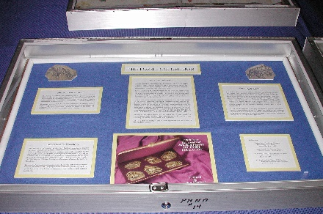 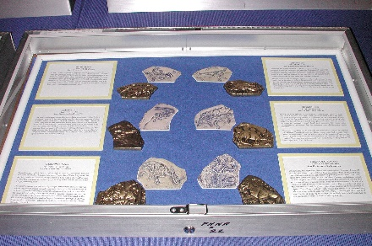
1st Place, C.E. Heppner Award (Tokens, Medals, and Decorations),
Ellis Corets – The Fossil Collection [Exh-2006-Corets-2]
Class 4 — World Coins and Paper Money
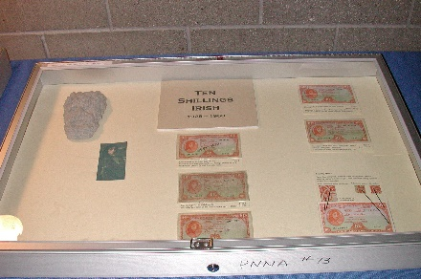 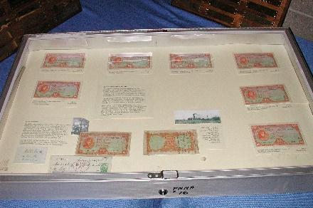 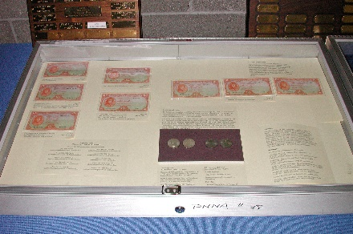
1st Place – Gawain O’Connor – 10 Shillings Irish [Exh-2006-Irish]
2nd Place – Greg Franck-Weiby – Spectrum of Paper Money
Class 5 — General or Specialized
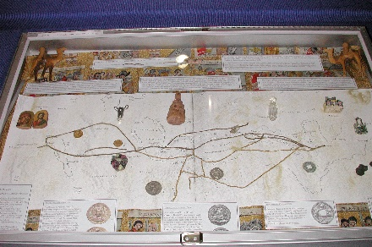 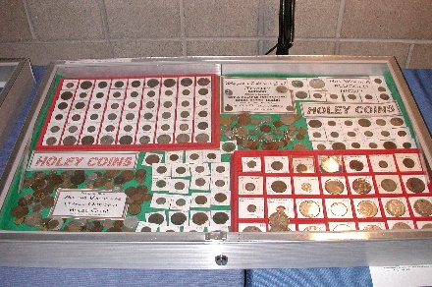
1st Place – Prue Morgan Fitts – Coins & Commerce Along the Silk Road [Exh-2006-FittsP]
2nd Place – Dave Whitcher – Holey Coins [Exh-2006-Holey]
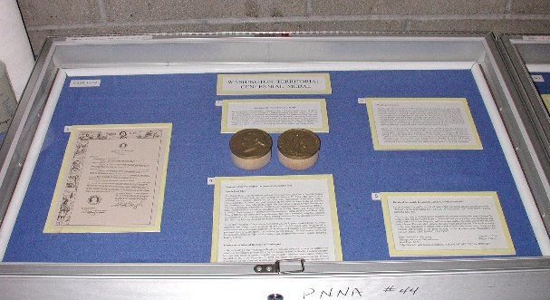
Class 6 — Pacific Northwest Numismatic Material
1st Place, C.E. Heppner Award (Tokens, Medals, and Decorations),
Byron F. Johnson Memorial (Best of Show) Award — Ellis Corets
Washington Territory Centennial Medal [Exh-2006-Corets-1]
Judges: Joseph Boling, Eric Holcomb, Arthur Fitts.

Exhibits Improve (2006) by Larry Rowe, Exhibit Chairman
It was encouraging to have more people participate in exhibiting at the PNNA convention and coin show this year. There was quite a variety of numismatic interest represented at the show. I have been trying to find ways to reverse the steady decline of exhibits over the past years and am encouraged by the turn around. This does not mean that there isn’t room for further improvement. Exhibiting is fun; try it next year!
We had the honor of ANA Director Prue Fitts attending the show and entering an exhibit of her own. Sadly, we will no longer have the services of Joe Boling in future conventions. He has served as Chief Judge for many years. He is moving to Indiana later this year and will not be available for service. I wish to thank Joe for his many years of dedication to PNNA. Thanks also to Eric Holcomb and Arthur Fitts who served as judges.
Thanks to all who participated in exhibiting at the PNNA convention this year!

Some ANA Exhibit Reports (2003-2006)

Exhibits at the ANA 2003 Anniversary Convention
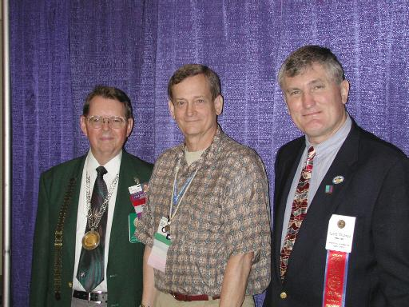
59 exhibitors showed 94 competitive exhibits at the Baltimore ANA anniversary convention; two were from PNNA members. Eric Holcomb entered an exhibit titled George Washington Large & Small Eagle Cents from the Eliasberg Collection, and Ken Hill showed A 1919 Buffalo Nickel with Multiple Errors, winning second place in the errors class. PNNA officers or members Ken Hill, Eric Holcomb, Scott Loos, Tom Sheehan, and Joe Boling served as judges in Baltimore. The photo shows Ken Hill receiving his second-place award for the same exhibit shown above that won "Best of Show" at the PNNA convention. Left: Chief Judge Joseph Boling. Center: Ken Hill. Right: ANA President John Wilson.

Exhibits at the ANA 2004 Spring Convention
The ANA National Money Show (early spring convention) was held in Portland, Ore., March 26-28, 2004.
See the document “ANA Conventions and Shows in Portland, Oregon 1998 to 2015” on the PNNA website at https://pnna.org/pdf/ANA_Portland_shows.pdf. There is a photo of Steve Cox receiving the Best‐in‐Show exhibit award from ANA chief judge Joseph Boling.

Exhibits at the 2004 ANA Anniversary Convention
Fifty-five exhibitors showed eighty competitive exhibits at the Pittsburgh ANA convention; only one was a PNNA member. Eric Holcomb entered an exhibit titled We Came in Peace for All Mankind - A Selection of Apollo 11 Medals. He earned second place in class 15, modern mint medals. PNNA officers or members Eric Holcomb, Scott Loos, John Wilson, and Joe Boling served as judges in Pittsburgh.

Exhibits at the 2005 ANA Anniversary Convention
Fifty-five exhibitors showed eighty-two competitive exhibits at the San Francisco ANA convention (ANA World's Fair of Money®). The following PNNA members were participants: Dr. Robert Myles (three exhibits); Ellis Corets (four exhibits); Steve Cox (2nd runner-up for best in show); James Reinders (two exhibits); Tom Sheehan (two exhibits); Michael Turrini; Eric Holcomb, and Allen Berman. This is an exceptional turnout by members of our association. PNNA officers or members Arthur Fitts, Prue Fitts, Eric Holcomb, Scott Loos, Tom Sheehan, John Wilson, and Joe Boling served as judges in San Francisco.

Exhibits at the 2006 ANA Anniversary Convention
Seven PNNA members served as judges at the Denver World’s Fair of Money, where four PNNA members were exhibitors. Ellis Corets won second runner up for best of show with his exhibit “The State of Israel Anniversary of Independence Commemoratives 1958-1980,” which also won the Judaica class. J. Eric Holcomb won second place in the tokens class for “A Brief Introduction to Conder Tokens.” John Wilson won the obsolete paper money class with “Scovill Manufacturing Co.,” with Corets taking third for “Original Stock Certificate of the Second Bank of the United States.” In US gold coins, Kenneth R. Hill took second place with “An Oregon Exchange Company 5D. Gold Piece.” Corets won the modern mint medals class with “The Fossil Collection.”

Exhibits at the 2007 PNNA Convention
Class 4 — World Coins and Paper Money
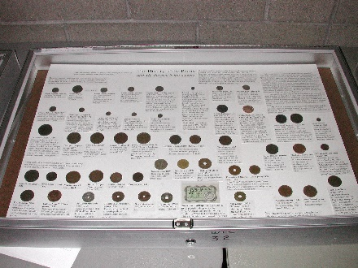
2nd Place – Greg Franck-Weiby – History of the Penny
(and why the cent is not a penny) [Exh-2007-Weiby]
Judges: Del Cushing, Tom Sheehan, Eric Holcomb.

Exhibiting at PNNA Becoming a Thing of the Past (2007)
by Larry Rowe, Exhibit Chairman
Exhibiting at a PNNA convention used to be an exhilarating experience. There were several entries covering many numismatic interests, with competition within various classes. Over the recent years the number of exhibits has decreased. Last year I was encouraged by a small increase in exhibiting, but this year there was only one exhibit entered in competition. I have asked for suggestions on how to improve exhibiting at PNNA but have not received any replies. Over the years I have made small revisions to help improve participation, all with no results. Am I not doing a good job of conducting the exhibit program? Does PNNA not place enough importance on exhibits at conventions? Please let me know what you think. Enough of my ranting. Here is this year’s report.
As there was only one competitive entry, it was judged, and an award given for the points it received. A single entry does not automatically receive first place. There were no awards given for Best of Show or Best Tokens and Medals this year.
Thanks to the following persons who entered non-competitive displays. They made the exhibit area interesting for the viewing public!
- Tom Sheehan – A Selection of Washington State National Bank Notes
- Gawain O’Conner – Ten Shillings Irish 1928-1968
- Steve Cox – A Timeline History of the Quarter Dollar
- J. Eric Holcomb – Medallic Portraits of Washington (poster exhibit)
- Milt Blackburn – Tonga, the Friendly Islands; Seychelles ‘Sex’ Banknote; and Black Parrot of the Seychelles
Thanks also to Del Cushing, Tom Sheehan, and Chief Judge Eric Holcomb for their participation in the judging process.
Let’s try to do better next year. The public does look at the displays. This is a good way to show off your special interest and educate others.
Editor’s Note: Some of the above exhibits (plus a few others) were also shown at the Washington State Quarter launch ceremony. So at least we did have one exhibiting success this spring! Dick Billings was also able to obtain the Mint’s “Excite-MINT” banner from the launch ceremony and display it at the convention.

Exhibits at the 2008 PNNA Convention
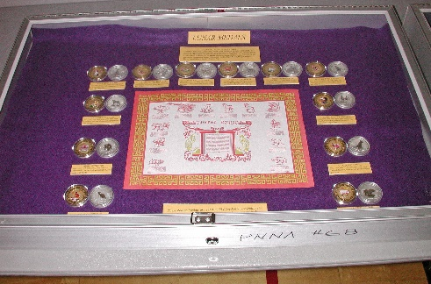 | Class 3 — Tokens, Medals, and Decorations  1st Place & C.E. Heppner Award (Tokens, Medals, and Decorations) –  Del Cushing – Lunar Medals [Exh-2008-3]
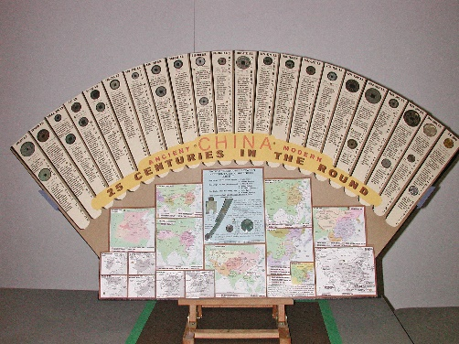 | Class 4 — World Coins and Paper Money  1st Place & Byron F. Johnson Memorial  (Best of Show) Award —  Gerald R. Williams – China: 25 Centuries in the Round [Exh-2008-4]
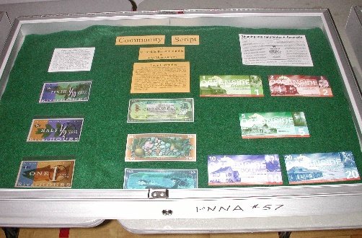 | Class 5 — General or Specialized  1st Place – Del Cushing – Community Script  [Exh-2008-5]
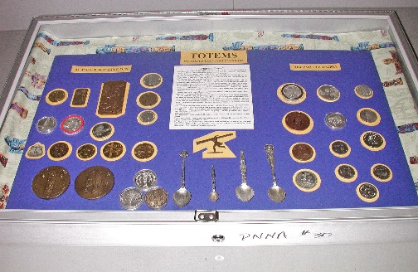 | Class 6 — Pacific Northwest Numismatic Material  1st Place — Del Cushing – Totems on Northwest Collectibles [Exh-2008-2]
Judges: Tom Sheehan, Ken Hill.

2008 Convention Exhibit Report by Larry Rowe, Exhibit Chairman
Larry Rowe was not able to attend the 2008 convention due to illness. In his place, PNNA Chief Judge Eric Holcomb took care of all exhibit duties and did a fine job.
Thanks to Del Cushing and Milt Blackburn for also bringing some non-competitive displays. They made the exhibit area more interesting for the viewing public!

Exhibits at the 2009 PNNA Convention
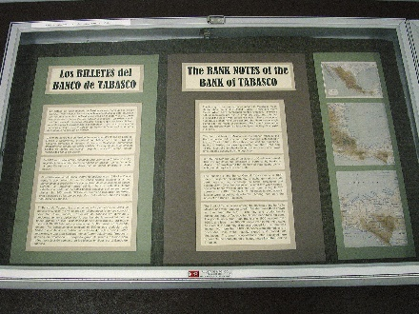 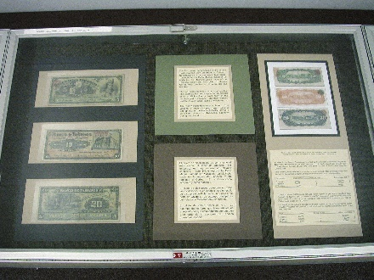 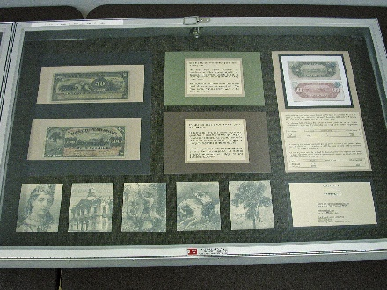
Class 4 — World Coins and Paper Money
1st Place & Byron F. Johnson Memorial (Best of Show) Award —
Steve Cox – The Bank Notes of the Bank of Tabasco [Exh-2009-2]
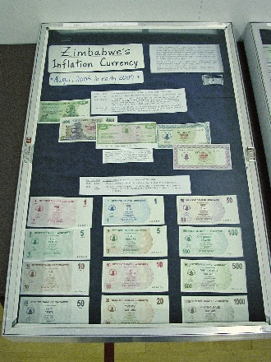 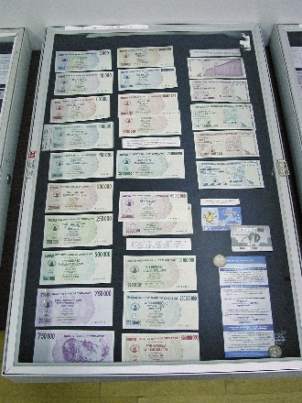 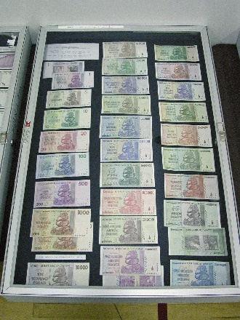 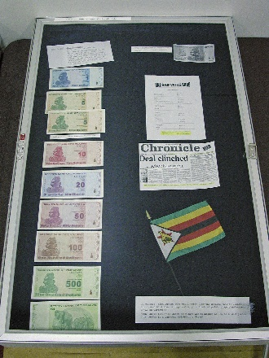
2nd Place – Milt Blackburn – Zimbabwe’s Inflation Currency – 2006-2009 [Exh-2009-4]
Class 5 — General or Specialized
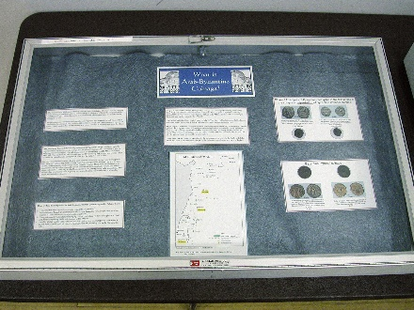 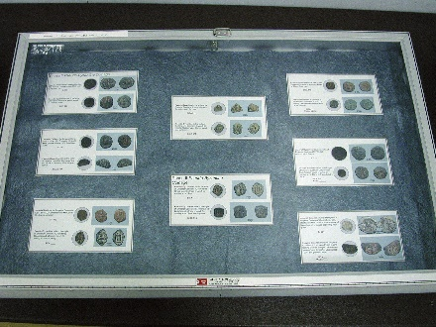 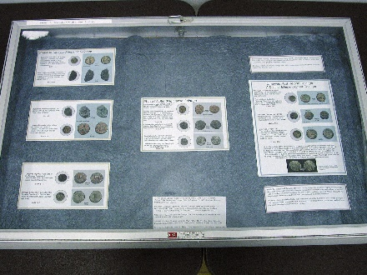
1st Place — Larry Gaye — What is Arab Byzantine Coinage? [Exh-2009-1]
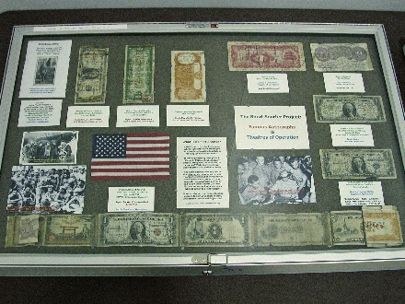 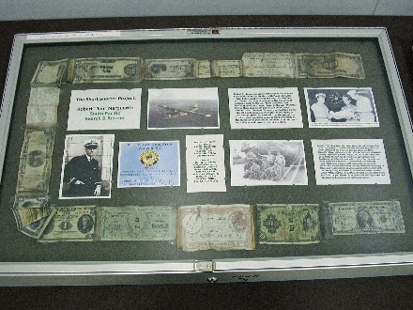 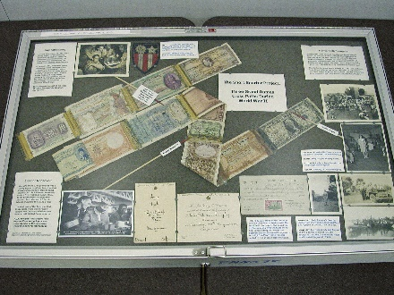
2nd Place – Tom Sparks — The Short Snorter Project [Exh-2009-3, first three cases shown]
Judges: Del Cushing, Al Westerhof, Eric Holcomb.

2009 Convention Exhibit Report by Larry Rowe, Exhibit Chairman
To those who remember, I was not able to attend last year’s convention due to illness. In my place, PNNA Chief Judge Eric Holcomb took care of all exhibit duties and did a fine job. As I am no longer on the board of directors, all my duties were to cease at the end of my term at last year’s convention. President Lisa Loos contacted me and asked if I would continue to serve as Exhibit Chairman, to which I agreed. Therefore, I have returned to handling convention exhibits. This is my report for 2009.
As usual, there were few but excellent exhibits. The judging of the competitive exhibits was carried out by Chief Judge Eric Holcomb, Del Cushing and Al Westerhof. My sincere thanks to all of them for donating their time to perform a difficult task. The following are the results of their work. (See table above.)
Congratulations to all the winners.
It occurred to me that most people do not know what exhibit winners receive for their awards, and thus never have seen any. Since the PNNA cannot afford to carry awards on hand for all the classes and placements to be presented at the convention, as the cost would be prohibitive, awards are custom made after the convention and mailed to the recipients.
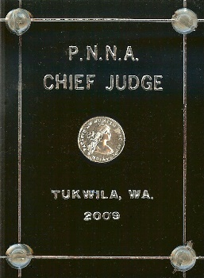
A 3x4” or 5x7” plaque is made by Northwest Numisplastics which has the proper information on it. To enhance the award, a feature item is encased in the plaque. For first place and best of show, a current one-ounce Silver Eagle is included. For second and third place (and for the judges), a current show medal is included. These make a very attractive award. These awards are not cheap to produce and make a nice memento.
Image: PNNA Chief Judge award plaque for 2009.
Looking forward to next year’s exhibits. — Larry Rowe, Exhibit Chairman

“Oregon at 150” Exhibits
The ANA board agreed to a special one-time-only “Oregon at 150” award for the best collector exhibit at the Portland ANA National Money Show dealing with Oregon’s Sesquicentennial celebration (1859-2009), including all aspects of the state’s history. We are pleased to report that several exhibits competed for this award!! Results can be found in a press release on the ANA website, or in the May 2009 edition of The Numismatist.

