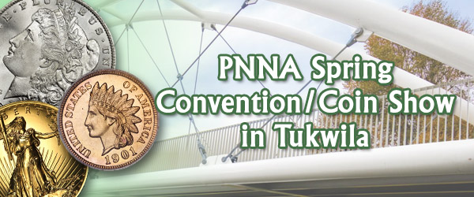
PNNA Spring Conventions in
Tukwila, Washington

Collector Exhibits

2010-2019
This document is intended as a supplement to:
Past spring convention reports:
2001-2019 reports consolidated into a 40-page PDF file
In memory of PNNA exhibiting legends:
Byron F. Johnson, Del Cushing and Larry Rowe

Table of Contents
Exhibit Results at the 2010 PNNA Convention 3
2010 Convention Exhibit Report by Larry Rowe, Exhibit Chairman 3
Exhibit Results at the 2011 PNNA Convention 4
2011 Convention Exhibit Report 5
Exhibit Results at the 2012 PNNA Convention 5
2012 Convention Exhibit Report 6
Exhibit Results at the 2013 PNNA Convention 7
2013 Convention Exhibit Report 7
Exhibit Results at the 2014 PNNA Convention 8
2014 Convention Exhibit Report 9
Exhibit Results at the 2015 PNNA Convention 10
2015 Convention Exhibit Report 11
Exhibit Results at the 2016 PNNA Convention 12
2016 Convention Exhibit Report 12
Exhibit Results at the 2017 PNNA Convention 13
2017 Convention Exhibit Report 14
Exhibit Results at the 2018 PNNA Convention 15
2018 Convention Exhibit Report 16
Exhibit Results at the 2019 PNNA Convention 17
2019 Convention Exhibit Report 18

All the exhibit case images in this document (and a few more) are available to be viewed and studied at the highest available resolution by visiting https://pnna.org/exhibits/images/. This is a great way to learn from the past and prepare for your next collector exhibit! Look for file names in the images folder containing the exhibit number shown in brackets.
For all years, where a class is omitted in the exhibit results, there were no entries in that class.

Exhibits at the 2010 PNNA Convention
Class 1 — United States and Canadian Coins
1st Place — Thomas A Tullis – The Bald Eagle as Portrayed on
United States Classic Commemorative Half Dollars
Class 4 — World Coins and Paper Money
1st Place — Gerald R. Williams – Rebellion and Expansion: The Greeks in India
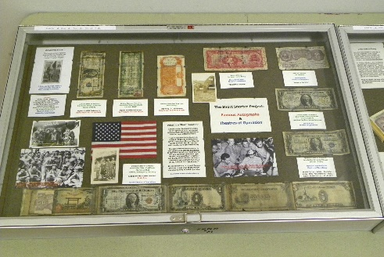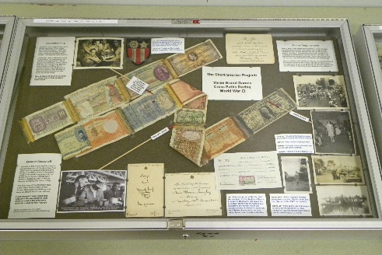
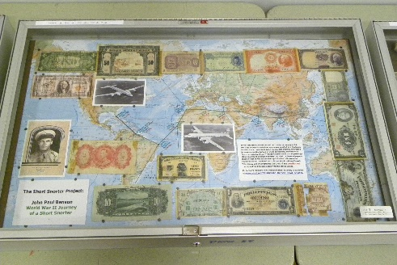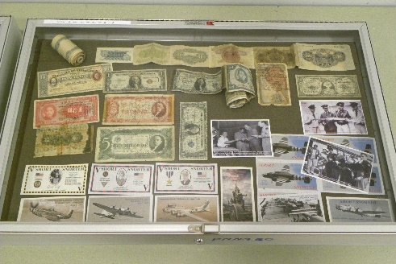
Class 5 — General or Specialized
1st Place & Byron F. Johnson Memorial (Best of Show) Award —
Tom Sparks – The Short Snorter Project. [Exh-2010-1]
Judges: Del Cushing, Tom Sheehan.

2010 Convention Exhibit Report by Larry Rowe, Exhibit Chairman
Once again, the exhibits at this year’s PNNA convention in Tukwila were of excellent quality, but not very many were entered. Exhibitors at ANA work very hard for many weeks and months to construct their displays and are very excited about the competition. What is lacking at PNNA that more collectors don’t enter exhibits? Perhaps it is because we are drawing from a smaller membership base than ANA. This exhibit chairman has done several things over the years to stimulate exhibiting without any great results. It would be a shame to discontinue exhibiting at PNNA; it is part of the convention experience. If you have any suggestions on how to improve competitive exhibiting, write to PNNA president Lisa Loos and offer your suggestions to her. I have served as your Exhibit Chairman for many years now, and it has been my pleasure to work with all who have exhibited. This is my final year that I volunteer for any numismatic committee. The time comes when you must pass on the duties to younger people. I have served in many capacities and enjoyed every bit of it.
See above for the results of this year’s competitive displays. It should be noted that although there were no 2nd or 3rd place awards, the 1st place winners had to score a minimum average of 75 points by the judges to qualify for 1st place. There was also a non-competitive exhibit displayed: J. Eric Holcomb, Apollo 13 40th Anniversary. {Eric is the Chief Judge and is unable to exhibit competitively.}
Congratulations to all winners. They will receive award plaques for their entries. I wish to thank Tom Sheehan and Del Cushing for volunteering to serve as judges, and Eric Holcomb for serving as Chief Judge. Their work is very much appreciated.

Exhibits at the 2011 PNNA Convention
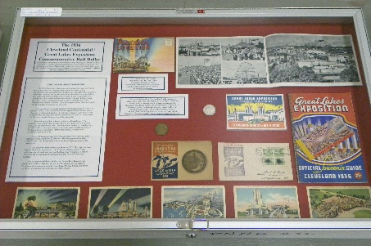 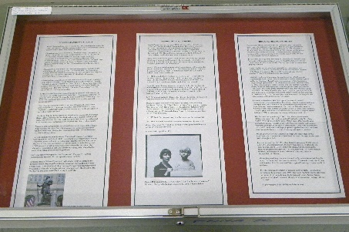 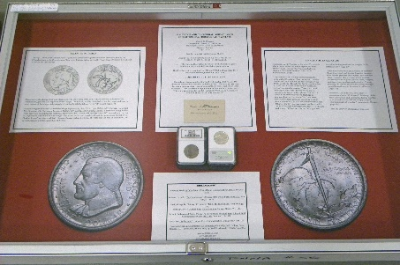
Class 1 — United States and Canadian Coins
1st Place — Thomas A Tullis – The 1936 Cleveland Centennial /
Great Lakes Exposition Commemorative Half Dollar. [Exh-2011-10]
2nd Place — Jeff Adolphson – World War II Tribute.
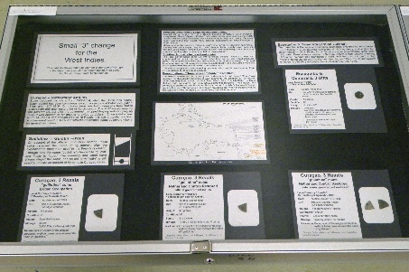 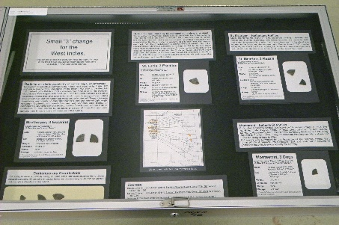
Class 3 — Tokens, Medals, and Decorations
1st Place & Byron F. Johnson Memorial (Best of Show) Award — James Reinders –
Small “3” Change for the West Indies. [Exh-2011-2]
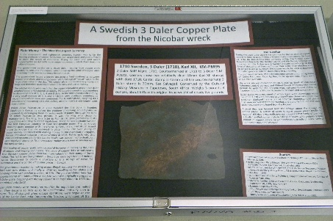  Class 4 — World Coins and Paper Money  1st Place — James Reinders – A Swedish 3 Daler Copper Plate from the Nicobar Wreck. [Exh-2011-3]  2nd Place — Gawain O’Connor – Squire Wood's Lamentation on the Refusal of His Halfpence. | 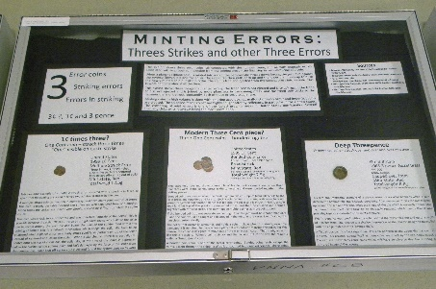  Class 5 — General or Specialized  1st Place — James Reinders – Minting Errors:  Three Strikes and other Three Errors. [Exh-2011-4]
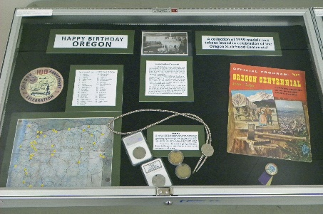 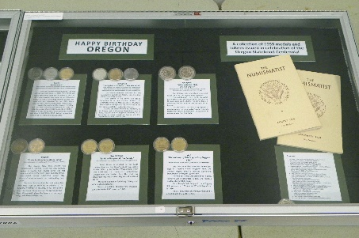
(First and last of six cases shown)
Class 6 — Pacific Northwest Numismatic Material
1st Place & C.E. Heppner Award (Tokens, Medals, and Decorations) — Katie Reinders –
Happy Birthday Oregon: A Collection of 1959 medals and tokens
issued in celebration of the Oregon Statehood Centennial. [Exh-2011-1]
Judges: Del Cushing, Tom Sheehan, Joe Boling.
Chief Judge: Eric Holcomb. Exhibit Chairman: Dan Vornbrock.

2011 Convention Exhibit Report
See above for the results of this year’s competitive displays. There were also three non-competitive exhibits displayed, by James Reinders, judge Tom Sheehan, and chief judge J. Eric Holcomb.
Normally the winner of Class 3 would receive the Heppner Award for tokens, medals, and decorations, however in this case it was determined that the Class 3 winning exhibit consisted mostly of cut coins (but which the chief judge allowed in Class 3), so the Heppner Award was given to the Class 6 winner instead. Since Katie is James' daughter, it was hard to object to this decision!
Congratulations to all the winners. They will receive award plaques for their entries. Thank you to the judges listed, to Eric Holcomb for serving as Chief Judge, and to Dan Vornbrock for serving as Exhibit Chairman for the first time this year. Their work was very much appreciated.

Exhibits at the 2012 PNNA Convention
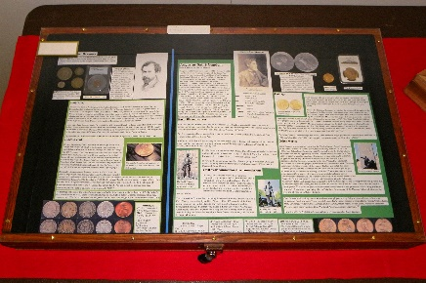 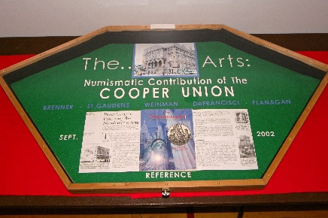 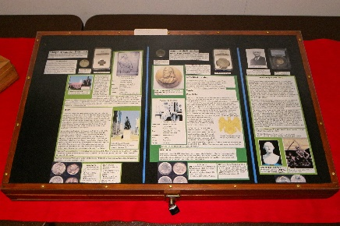 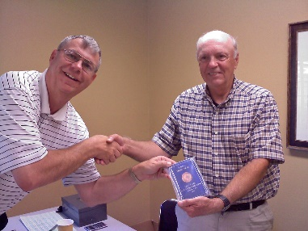
Class 1 — United States and Canadian Coins
1st Place — Gerald R. Williams – The Arts: Numismatic Contribution of the Cooper Union. [Exh-2012-1]
Bottom: Gerald (right) receives his award from Danny Bisgaard (left) at the August 2012 Mid-Valley
(Albany, OR) Coin Club meeting.
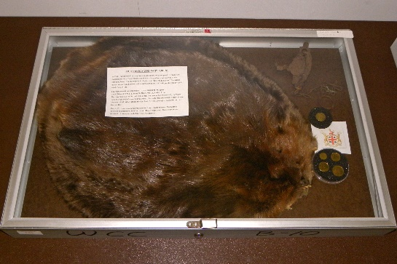 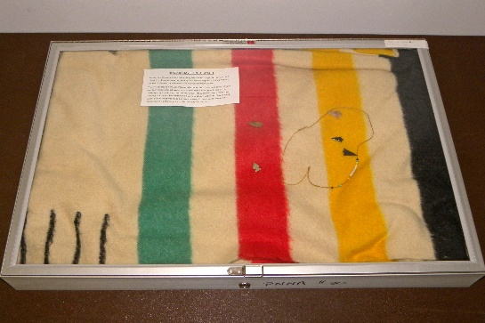
Class 3 — Tokens, Medals, and Decorations
2nd Place & C.E. Heppner Award (Tokens, Medals, and Decorations) —
Dan Vornbrock – Hudson Bay Company Tokens. [Exh-2012-3]
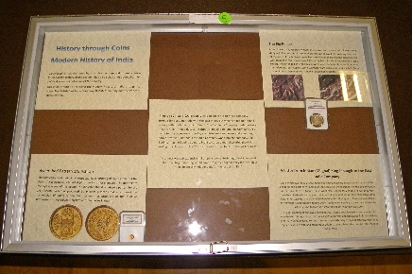 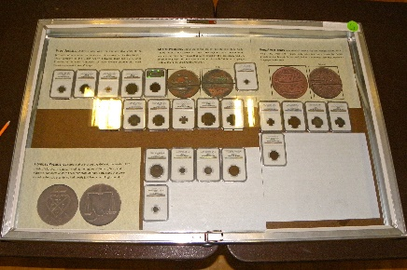 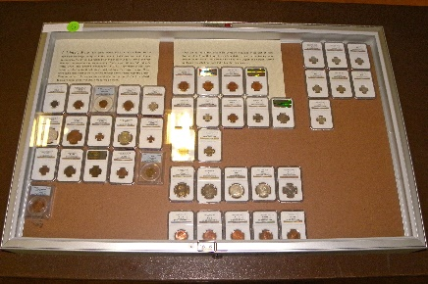
Class 4 — World Coins and Paper Money
1st Place — Suraj Guptha – History Through Coins: Modern History of India. [Exh-2012-5]
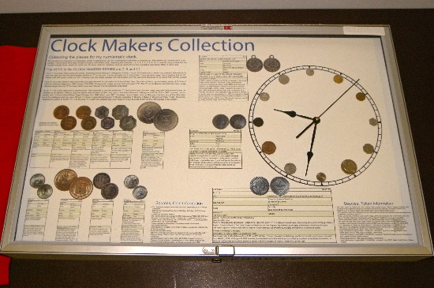
Class 5 — General or Specialized
1st Place & Byron F. Johnson Memorial (Best of Show) Award & People’s Choice Award —
James Reinders – Clock Makers Collection.
[Exh-2012-2]
Judges: Del Cushing, Tom Sheehan, Ken Hill.
Chief Judge: Eric Holcomb. Exhibit Chairman: Dan Vornbrock.

2012 Convention Exhibit Report
See above for the results of this year’s competitive displays. There was also one non-competitive exhibit displayed, by James Reinders, titled Numismatics 101.
Congratulations to all the winners. They will receive award plaques for their entries. Thank you to the judges listed, to Eric Holcomb for serving as Chief Judge, and to Dan Vornbrock for serving as Exhibit Chairman again this year. Their work was very much appreciated.
James Reinders' Byron Johnson award-winning exhibit from the PNNA show (see class 5 above) went on to the ANA National Money Show in Denver, where it won class 5 (The Arts) and the National Coin Week award (which carries an ANA summer seminar scholarship as part of the award).

Exhibits at the 2013 PNNA Convention
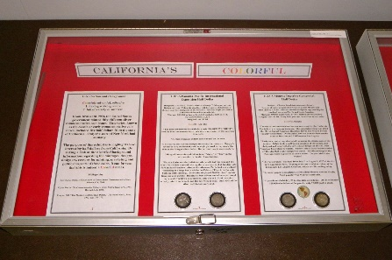 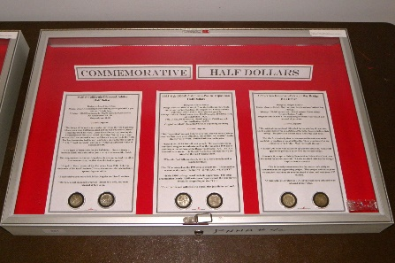
Class 1 — United States and Canadian Coins
1st Place & Byron F. Johnson Memorial (Best of Show) Award —
Thomas A. Tullis – California's Colorful Commemorative Half Dollars. [Exh-2013-4]
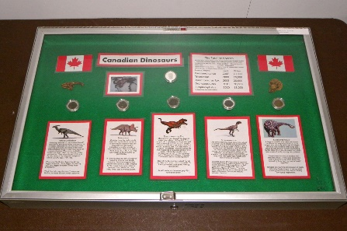 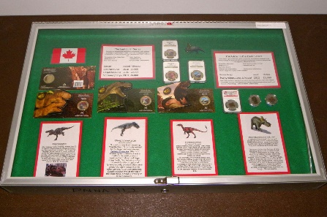
2nd Place — Anthony Kalt – Canadian Dinosaurs. [Exh-2013-2]
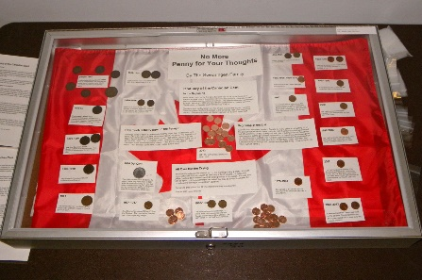
3rd Place — Gary Swearingen – No More Penny for Your Thoughts. [Exh-2013-1]
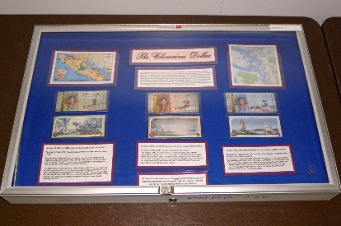 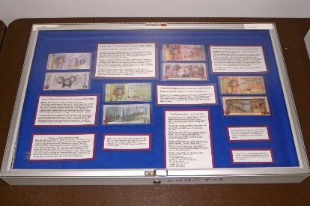 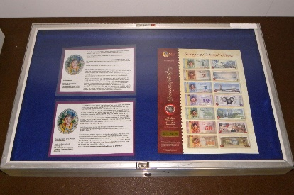
Class 6 — Pacific Northwest Numismatic Material
1st Place & 2nd Best of Show Award — Anthony Kalt – The Chemainus Dollar. [Exh-2013-3]
Judges: Del Cushing, Ken Hill, James Reinders.
Chief Judge: Eric Holcomb. Exhibit Chairman: Dan Vornbrock.

2013 Convention Exhibit Report
See above for the results of this year’s competitive displays. There were no non-competitive exhibits.
Congratulations to all the winners. They will receive award plaques for their entries. Thank you to the judges listed, to Eric Holcomb for serving as Chief Judge, and to Dan Vornbrock for serving as Exhibit Chairman again this year. Their work was very much appreciated.

Exhibits at the 2014 PNNA Convention
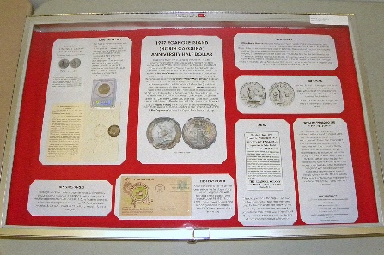
Class 1 — United States and Canadian Coins
1st Place — Thomas A. Tullis – 1937 Roanoke Island (North Carolina) Anniversary Half Dollar. [Exh-2014-1]
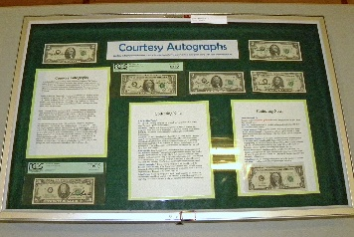 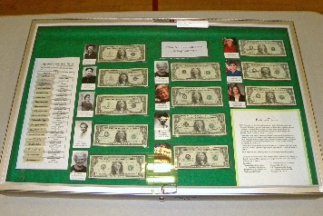 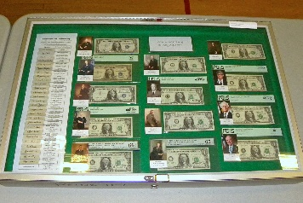 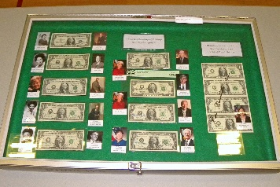
Class 2 — United States and Canadian Paper Money
1st Place — Anthony Kalt – Courtesy Autographs. [Exh-2014-2]
2nd Place — Tom Sparks – Short Snorters of Significance to Washington State.
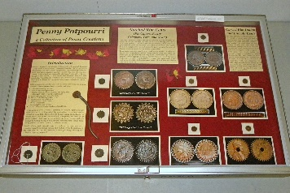 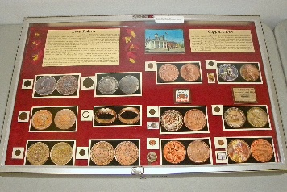 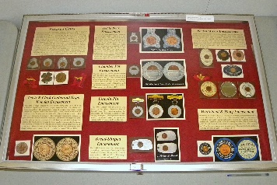 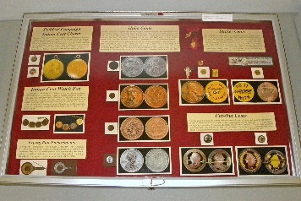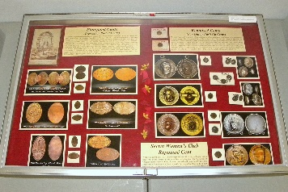 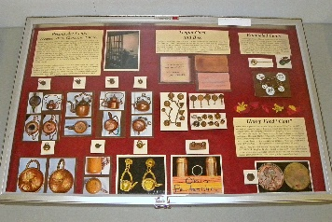 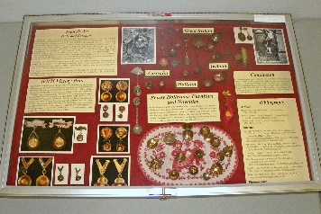
Class 3 — Tokens, Medals, and Decorations
1st Place & Byron F. Johnson Memorial (Best of Show) Award &
C.E. “Hepp” Heppner (Best Token & Medal) Award — Charmy Harker – Penny Potpourri. [Exh-2014-3]
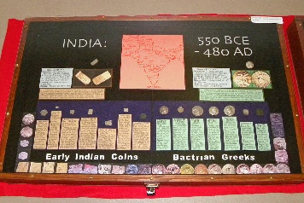 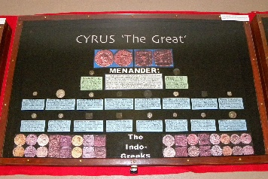 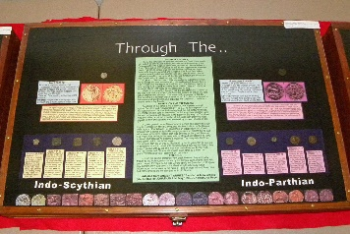 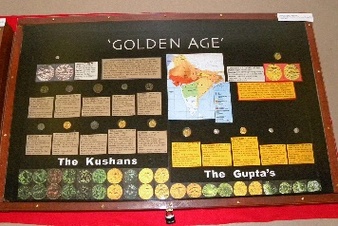
Class 4 — World Coins and Paper Money
1st Place — Gerald R. Williams – India: 550 BCE-480 AD, Cyrus “The Great” through the “Golden Age.” [Exh-2014-5]
2nd Place — Kevin Au – 18 Dimes to the Dollar: Gresham's Law at Work in 1920’s China.
3rd Place — Tom Sparks – Lee Moyne Mark (World War II) Short Snorter.
Class 6 — Pacific Northwest Numismatic Material
no award — Scott McClaine – Early Banks of the Lower Columbia River.
Judges: Danny Bisgaard, Del Cushing, James Reinders and Tom Sheehan.
Chief Judge: Eric Holcomb. Exhibit Chairman: Dan Vornbrock.

2014 Convention Exhibit Report
See above for the results of this year’s competitive displays. There were eight exhibits in 22 cases, the highest in several years. Thanks to all the exhibitors! There were no non-competitive exhibit displays due to space limitations. The PNNA is ordering more cases for next year.
Congratulations to all the winners. They will receive award plaques for their entries. Thank you to the judges listed, to Eric Holcomb for serving as Chief Judge, and to Dan Vornbrock for serving as Exhibit Chairman again this year. Their work was very much appreciated.

Exhibits at the 2015 PNNA Convention
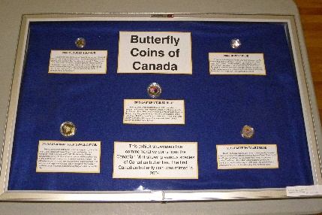  Class 1 — United States and Canadian Coins  1st Place — Benjamin M. – Butterfly Coins of Canada. [Exh-2015-8] | 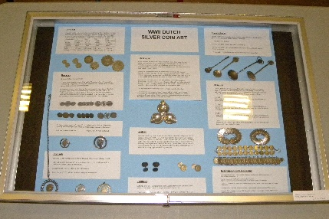  Class 5 — General or Specialized  1st Place — Kevin Au – WWII Dutch Silver Coin Art. [Exh-2015-5]  2nd Place — Benjamin M. – Elemental Coins.  3rd Place — Alexander M. – Alphabet Soup.
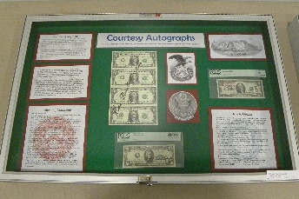 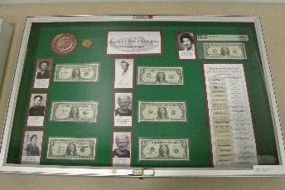 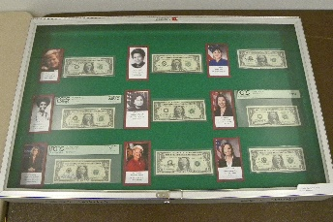 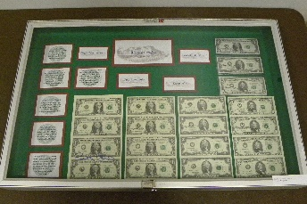
Class 2 — United States and Canadian Paper Money
1st Place and People’s Choice Award —
Anthony Kalt – Courtesy Autographs. (Photos show the first four of eight cases.) [Exh-2015-11]
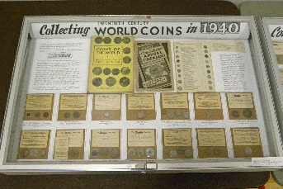 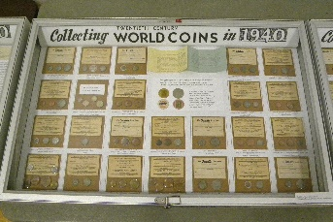 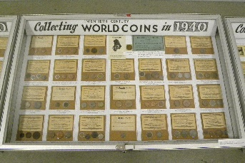 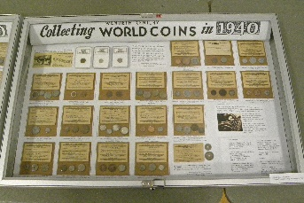
Class 4 — World Coins and Paper Money
1st Place & Byron F. Johnson Memorial (Best of Show) Award —
Gawain O'Connor – Collecting Twentieth Century World Coins in 1940. [Exh-2015-1]
2nd Place — Kevin Au – Silver Sixpence of King George VI and Queen Elizabeth II.
3rd Place — Alexander M. – Coins of Morocco.
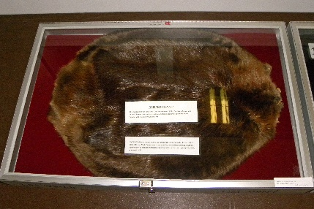 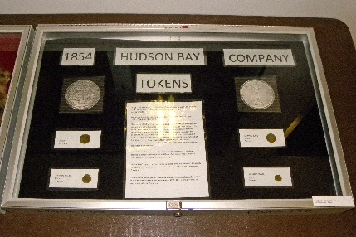
Class 6 — Pacific Northwest Numismatic Material
1st Place & C.E. “Hepp” Heppner (Best Token & Medal) Award — Dan Vornbrock –
1854 Hudson Bay Company Tokens. [Exh-2015-12]
Judges: Danny Bisgaard, Del Cushing, Ken Hill, James Reinders, Tom Sheehan, and Tom Tullis.
Chief Judge: Eric Holcomb. Exhibit Chairman: Dan Vornbrock.

2015 Convention Exhibit Report
See above for the results of this year’s competitive displays. There were 12 exhibits in 32 cases, well exceeding the 22 cases last year. Thanks to all the exhibitors! One of the exhibits was a non-competitive display of PNNA convention memorabilia maintained by Del Cushing.
Congratulations to all the winners. They will receive award plaques for their entries. Thank you to the judges listed, to Eric Holcomb for serving as Chief Judge, and to Dan Vornbrock for serving as Exhibit Chairman again this year. Their work was very much appreciated.

Exhibits at the 2016 PNNA Convention
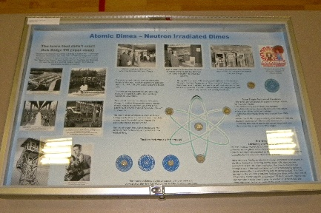
Class 1 — United States and Canadian Coins
1st Place — Anthony Kalt – Neutron Irradiated Dimes. [Exh-2016-5]
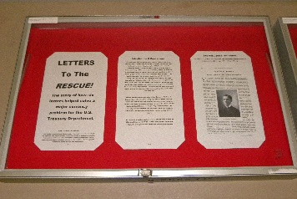 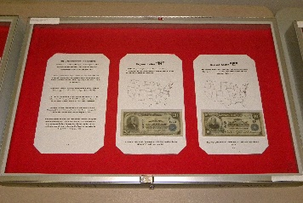 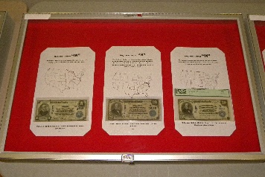 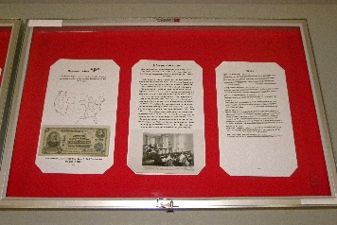
Class 2 — United States and Canadian Paper Money
1st Place & Byron F. Johnson Memorial (Best of Show) Award — Thomas Tullis
– Letters to the Rescue! [Exh-2016-3]
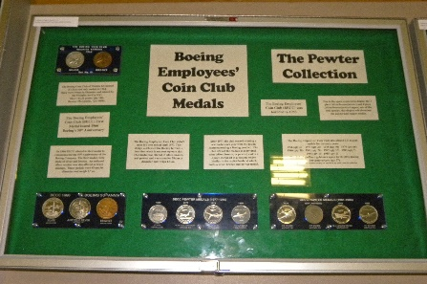 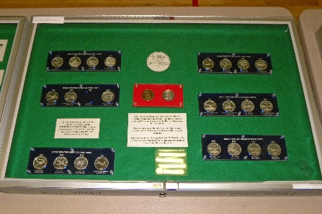 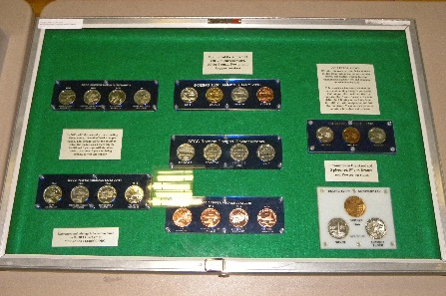
Class 3 — Tokens, Medals, and Decorations
1st Place & C.E. “Hepp” Heppner (Best Token & Medal) Award — Anthony Kalt
– Boeing Employees' Coin Club Medals: The Pewter Collection. [Exh-2016-4]
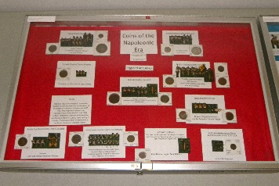 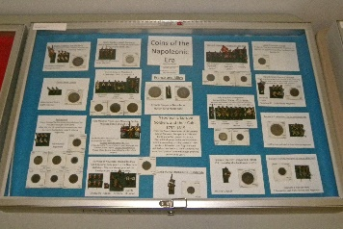 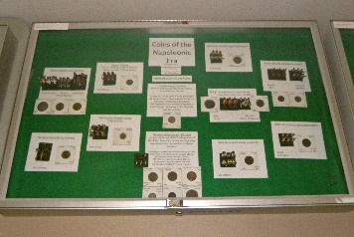 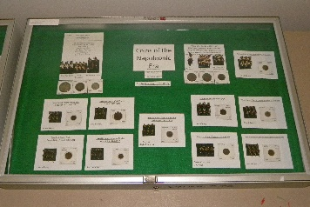
Class 4 — World Coins and Paper Money
1st Place — George Fellows – Coins of the Napoleonic Era. [Exh-2016-2]
Judges: Danny Bisgaard, Ken Hill, James Reinders, Tom Sheehan.
Chief Judge: Eric Holcomb. Exhibit Chairman: Dan Vornbrock.

2016 Convention Exhibit Report
See above for the results of this year’s competitive displays. There were six exhibits in 19 cases. Thanks to all the exhibitors! There were two non-competitive displays: a five-case display of PNNA convention memorabilia maintained by Del Cushing, and a two-case display of Medallic Art Company (MACO) medals.
Congratulations to all the winners. They will receive award plaques for their entries. Thank you to the judges listed, to Eric Holcomb for serving as Chief Judge, and to Dan Vornbrock for serving as Exhibit Chairman again this year. Their work was very much appreciated.

Exhibits at the 2017 PNNA Convention
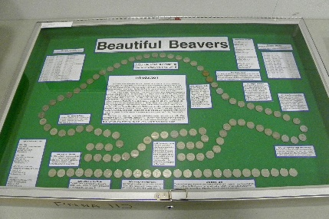
Class 1 — United States and Canadian Coins
1st Place & Best YN Exhibit — Benjamin M. – Beautiful Beavers. [Exh-2017-1]
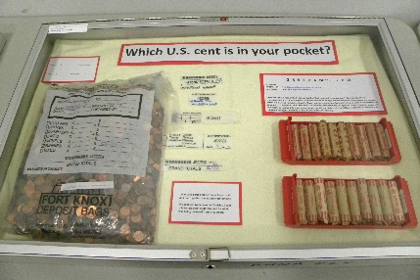 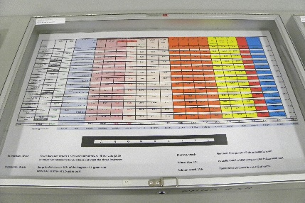 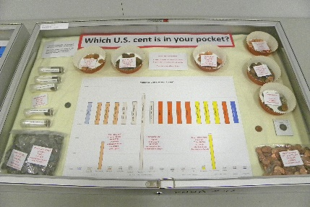
2nd Place & People’s Choice Award — Scott McClaine – Which U.S. cent is in your pocket? [Exh-2017-2]
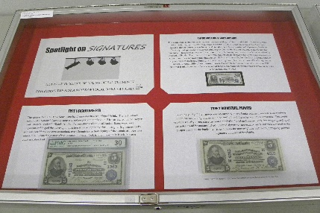 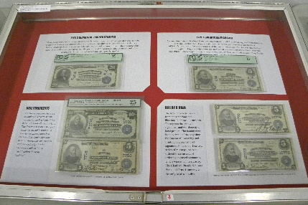 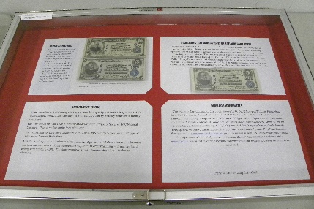
Class 2 — United States and Canadian Paper Money
1st Place & Byron F. Johnson Memorial (Best of Show) Award — Thomas Tullis
– Spotlight on Signatures: A Display of Series of 1902 National Currency /
Regarding the Signatures of Local Bank Officials. [Exh-2017-3]
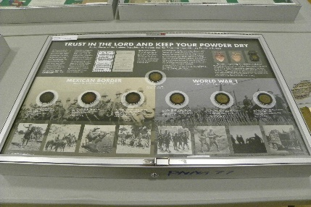
Class 3 — Tokens, Medals, and Decorations
1st Place (and 2nd Best of Show) & C.E. “Hepp” Heppner (Best Token & Medal) Award —
Tom Sparks – Trust in the Lord and Keep Your Powder Dry. [Exh-2017-5]
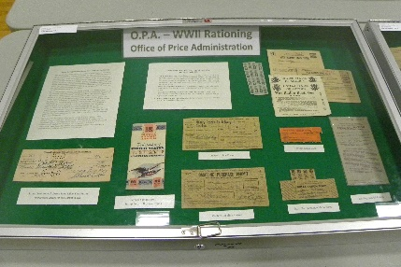 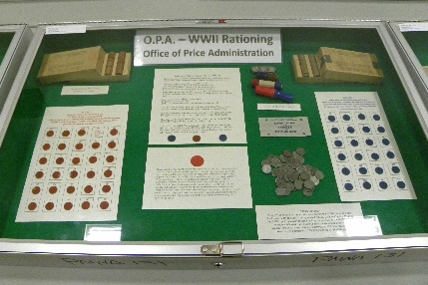 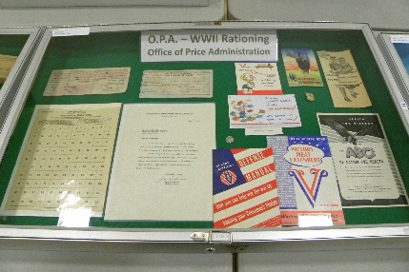
2nd Place (and 3rd Best of Show) — Anthony Kalt – O.P.A. - WWII Rationing. [Exh-2017-6]
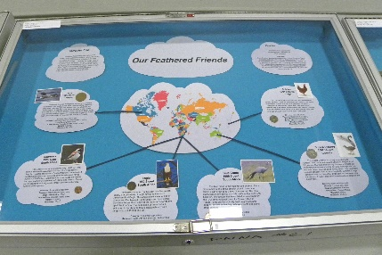 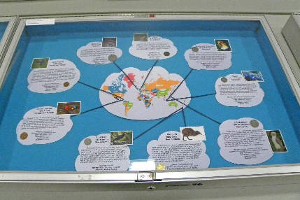
Class 4 — World Coins and Paper Money
1st Place — Alexander M. – Our Feathered Friends. [Exh-2017-7]
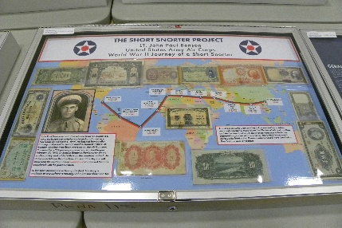 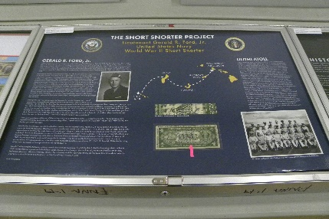 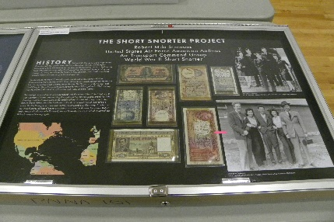
Class 5 — General or Specialized
1st Place — Tom Sparks – The Short Snorter Project: Lt. John Paul Benson / United States Army Air Corps /
World War II Journey of a Short Snorter (also Gerald Ford and Frank Sinatra signed snorters). [Exh-2017-8]
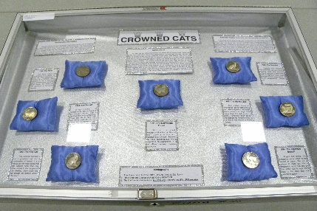
2nd Place — Truus Lagerman – Crowned Cats. [Exh-2017-9]
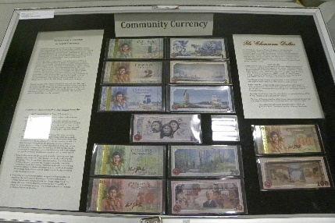 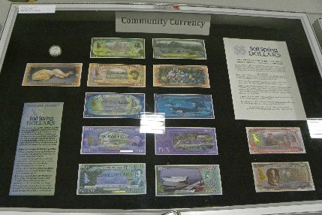 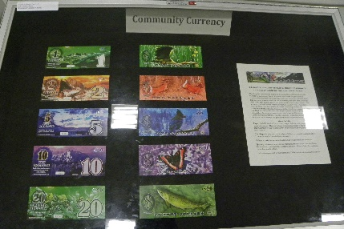
Class 6 — Pacific Northwest Numismatic Material
1st Place — Anthony Kalt – Community Currency. [Exh-2017-4]
Judges: Danny Bisgaard, James Reinders, Tom Sheehan.
Chief Judge: Eric Holcomb. Exhibit Chairman: Dan Vornbrock.

2017 Convention Exhibit Report
See above for the results of this year’s competitive displays. There were nine competitive exhibits in 20 cases, and at least one exhibit in all six classes! Thanks to all the exhibitors! In addition, there was a three-case non-competitive display of the PNNA travelling exhibit of U.S. type coins.
Congratulations to all the winners. They will receive award plaques for their entries. Thank you to the judges listed, to Eric Holcomb for serving as Chief Judge, and to Dan Vornbrock for serving as Exhibit Chairman again this year. Their work was very much appreciated.

Exhibits at the 2018 PNNA Convention
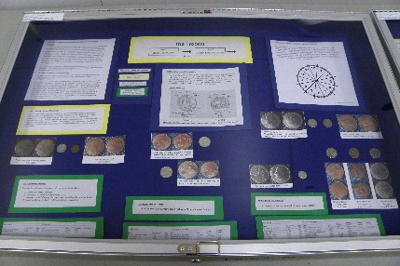 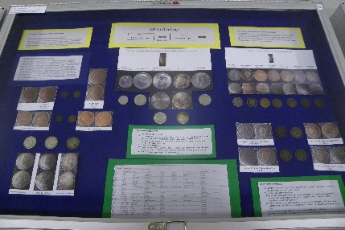 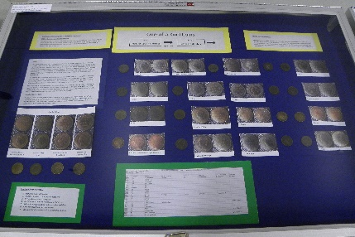
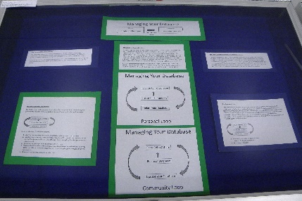 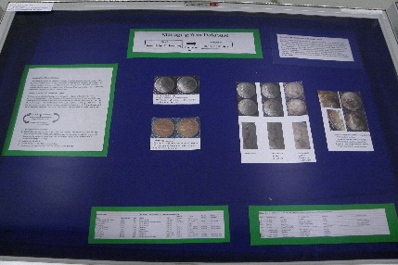 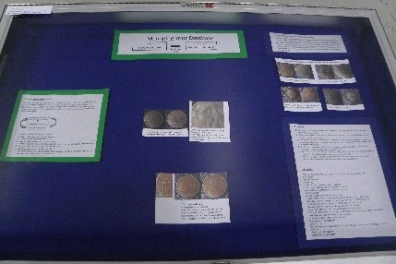
Class 1 — United States and Canadian Coins
1st Place — George Woods – The Process of Becoming a Collector of
One-of-a-Kind Coins supported by using a database. [Exh-2018-1]
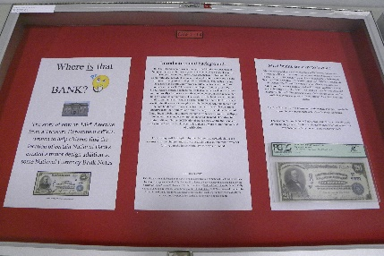 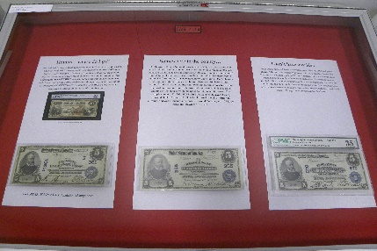
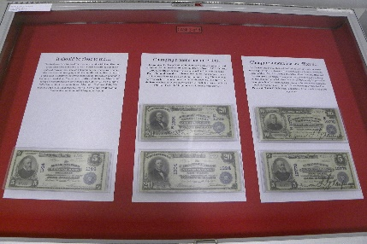 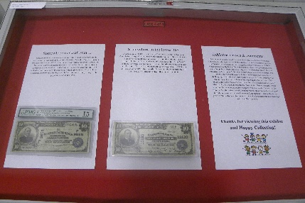
Class 2 — United States and Canadian Paper Money
1st Place & Byron F. Johnson Memorial (Best of Show) Award — Thomas Tullis –
Where is That Bank? [Exh-2018-2]
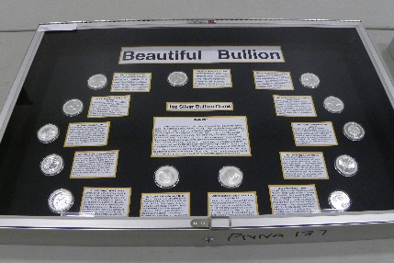
Class 4 — World Coins and Paper Money
1st Place (3rd Best of Show) — Benjamin M. – Beautiful Bullion. [Exh-2018-3]
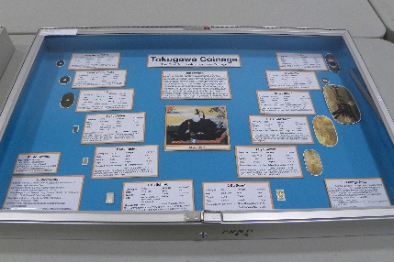
Class 5 — General or Specialized
1st Place (2nd Best of Show) & Best YN Exhibit — Alexander M. – Tokugawa Coinage:
The First Successful Japanese Coinage. [Exh-2018-4]
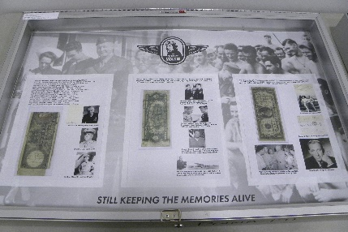 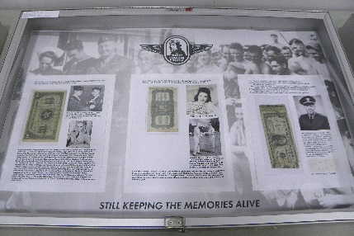 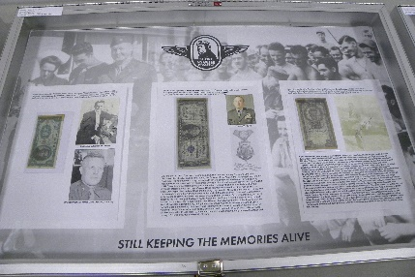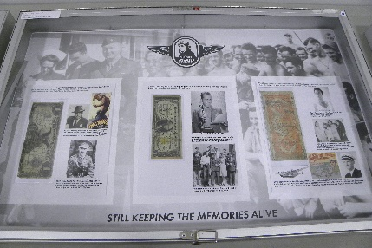 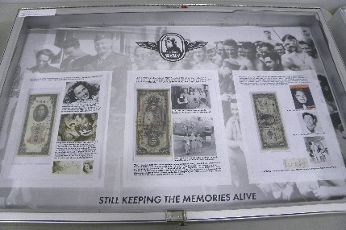 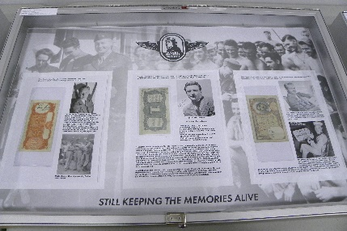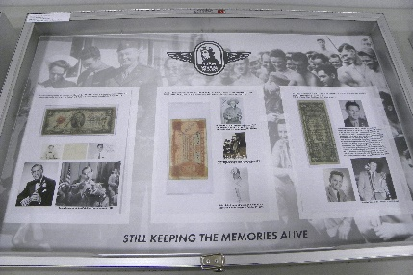
2nd Place & People’s Choice Award — Tom Sparks – The Short Snorter Project:
Generals, Admirals, Sailors & Entertainers. [Exh-2018-5]
Judges: Danny Bisgaard, James Reinders, Tom Sheehan.
Chief Judge: Eric Holcomb. Exhibit Chairman: Dan Vornbrock.

2018 Convention Exhibit Report
See above for the results of this year’s competitive displays. There were five competitive exhibits in 19 cases, plus 10 additional non-competitive cases. Thanks to all the exhibitors!
Congratulations to all the winners. They will receive award plaques for their entries. Thank you to the judges listed, to Eric Holcomb for serving as Chief Judge, and to Dan Vornbrock for serving as Exhibit Chairman again this year. Their work was very much appreciated.

Exhibits at the 2019 PNNA Convention
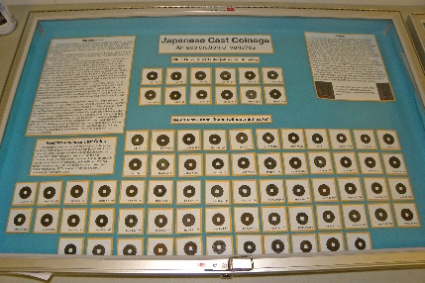 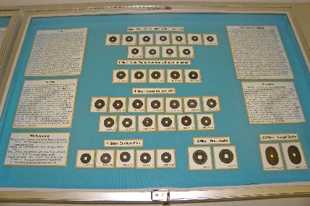 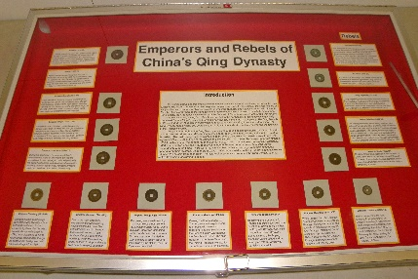
Class 1 — Coins
1st Place & Best YN Exhibit — Alexander M. – Japanese Cast Coinage: An exploration of varieties. [Exh-2019-1]
2nd Place — Benjamin M. – Explorers and Rebels of China's Qing Dynasty. [Exh-2019-2]
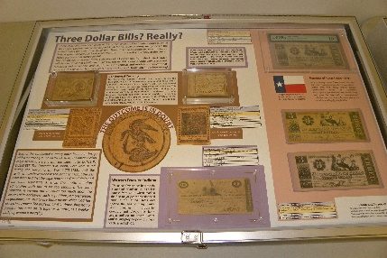 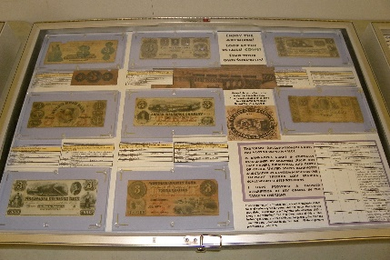
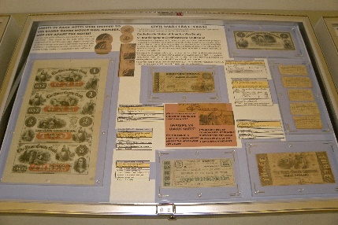 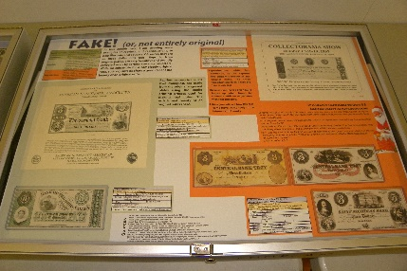
Class 2 — Paper Money
1st Place (3rd Best of Show) — James Reinders – Three Dollar Bills! Really? [Exh-2019-3]
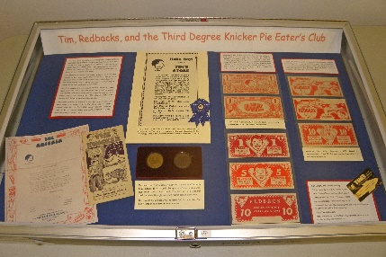
Class 3 — Tokens, Medals, and Exonumia
1st Place & C.E. “Hepp” Heppner (Best Token & Medal) Award — Gawain O'Connor –
Tim, Redbacks, and the Third Degree Knicker Pie Eater's Club. [Exh-2019-4]
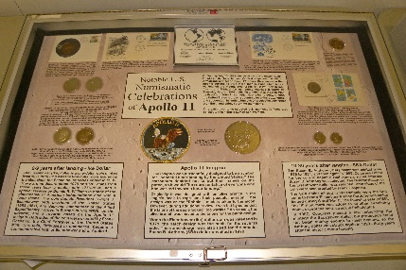 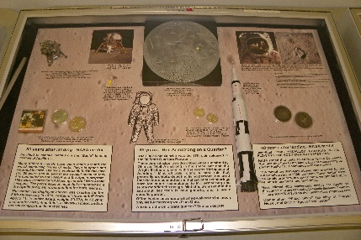 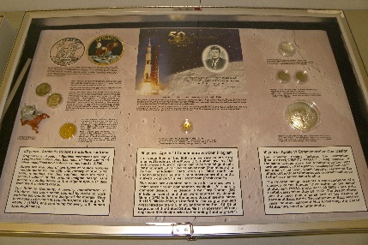
Class 4 — Common Element
1st Place & Byron F. Johnson Memorial (Best of Show) Award — James Reinders –
Notable U.S. Numismatic Celebrations of Apollo 11. [Exh-2019-5]
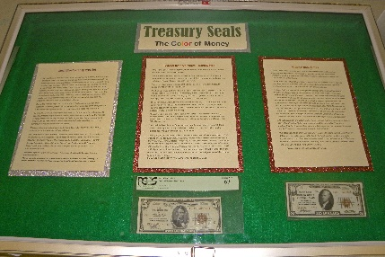 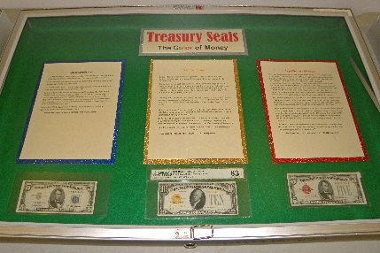 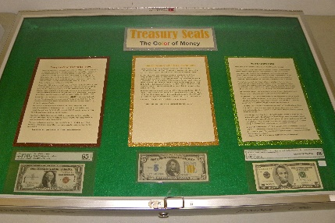
Class 5 — Topical
1st Place (2nd Best of Show) — Tony Kalt – Treasury Seals: The Color of Money. [Exh-2019-7]
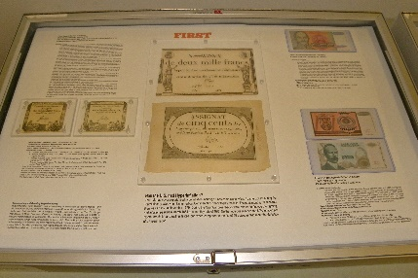 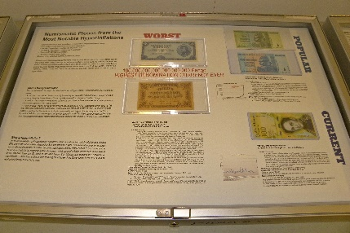 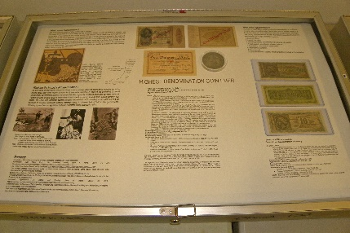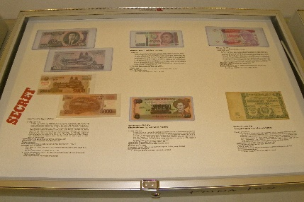 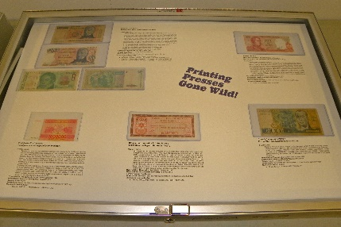
2nd Place & Del Cushing Memorial (People’s Choice) Award — James Reinders –
Numismatic Pieces from the Most Notable Hyperinflations. [Exh-2019-6]
Judges: Danny Bisgaard, Greg Smith, Tom Sheehan.
Chief Judge: Eric Holcomb. Exhibit Chairman: Tom Tullis.

2019 Convention Exhibit Report
See above for the results of this year’s competitive displays. There were seven competitive exhibits in 19 cases. Thanks to all the exhibitors!
Congratulations to all the winners. They will receive awards for their entries. Thank you to the judges listed, to Eric Holcomb for serving as Chief Judge, and to Tom Tullis for serving as Exhibit Chairman. Their work was very much appreciated.

