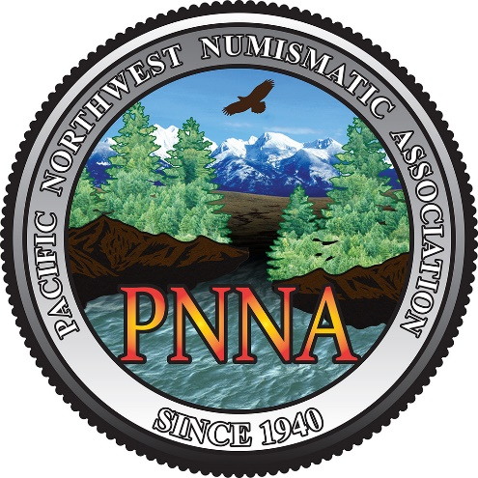
Understanding Exonumia:
A Workshop

with Independent Researchers, Collectors, and ANA Members, Kevin Akin, Margie Akin and James Bard

When: Saturday, November 2, 2019 | 9:00 am – Noon
Where: WILLAMETTE COIN CLUB/PNNA 15TH ANNUAL FALL CONVENTION (November 1-3, 2019) at the DoubleTree Lloyd Center Hotel, 1000 NE Multnomah Street, Portland, OR 97323.

Workshop Admission Cost: $20.00 for PNNA members, $30.00 for non-members, $10.00 for Young Numismatists (YN).
From beginners to experts, this workshop will increase your knowledge of all aspects of exonumia. Helpful handouts including bibliography of published and web-available resources to help identify, date, and attribute exonumia; a guide to finding and market-savvy purchasing; and instructions on how to research the origins and functions of your tokens. This workshop will be hands-on. Though it is impossible to bring examples of each-and-every kind of token, medal, ticket, store-card and the like, the presenters will bring (and give away examples) an interesting array of exonumia types, both common and rare. No prior knowledge of exonumia collecting is required. Bring an open mind and be ready to branch out into this interesting and rewarding subfield of numismatics.
Workshop Application
Name(s): (also age if YN)___________________________________________________________________________________________
Address: _____________________________________________________________________________________________________________
Email: ________________________________________________________________________________________________________________
Phone Number: _____________________________________________________________________________________________________
Amount Enclosed: __________________________________________________________________________________________________
Make check payable to Pacific Northwest Numismatic Association and mail to Scott Loos, PNNA Treasurer, PO Box 2210, North Bend, WA 98045. Phone 425-831-8789, scottloos@msn.com or use PayPal. Log onto PayPal and send your payment to sales@pnna.org

Hotel information. DoubleTree Lloyd Center Hotel, 1000 NE Multnomah Street, Portland, OR 97232. In-house reservations – call the hotel directly at 503-281-6111 and ask for Request Group: PNNA. Or call central reservations at 1-800-996-0510.

Exonumia are numismatic items (tokens, medals, or scrip) other than coins and paper money. It includes "Good For" tokens, badges, counterstamped coins, elongated coins, encased coins, souvenir medallions, tags, wooden nickels and similar items. It is related to numismatics (concerned with coins which have been legal tender), and many coin collectors are also exonumists (and don’t know it ).

