### Compilation of articles about ancient coins by Joseph Kleinman Pacific Ancient Numismatists (PAN)

This introductory article, and the 16 subsequent articles in the compilation, were first published in *The Nor’wester* from 2000 to 2005 as noted.

The text in this compilation is the same as in the original articles, except for minor edits for clarity.

### Ancient Numismatics *by Joseph Kleinman*

*This article was first published in The Nor’wester, 4th Quarter 2000.*

Consider to possibility that you and I are Romans. Consider the possibility that what they were, we are. This is how I begin a program on The Third Century and the Fall of Rome, just one of the many programs presented at our PAN Meetings. We are the Pacific Ancient Numismatists, a club dedicated to the advancement of Ancient Numismatics in the Pacific Northwest.

Did you ever stop to consider that you and I are the inheritors of the great civilizations developed by Greece and Rome? These English words that you are reading are 2/3 Latin written with the Latin Alphabet. Our Democratic form of government was developed in Ancient Athens and our Republican Constitution in Ancient Rome. The Atomic Theory was first proposed in Greece as well as the Germ Theory of Disease. Time does not allow me to discuss all the many benefits that the ancients have passed down to us.

Now consider that very few us own a genuine piece of art created by our ancient benefactors. This is a situation that never has to exist. Ancient coins can tell us so much about our common past and the people who lived it. Anybody of moderate means can own an ancient coin or several of them. Any number of different themes can be used to build an impressive collection.

Our club is a resource for collectors who want to learn and grow in this wonderful hobby. We welcome and encourage beginners to fully participate in our activities. We have as members experienced collectors as well as respected professionals who are more than willing to guide and assist you.

### The Emperor Galerius by Joseph Kleinman

*This article was first published in The Nor’wester, 1st Quarter 2001.*

In my last submission I gave an overview of Ancient Numismatics. Now I will discuss an individual who changed the course of history but is seldom recognized as doing such. Consider the Emperor Galerius. As a junior emperor or Caesar under Diocletian he was responsible for initiating the last great persecution of the Christians. It is generally believed that Constantine was the first emperor to grant religious toleration to the Christians but that is not the case, it was in fact Galerius. The text of the edict he issued just a few weeks before he died in AD. 311 reads as follows.

“Amongst our other measures for the advantage of the Empire, we have hitherto endeavored to bring all things into conformity with the ancient laws and public order of the Romans. We have been especially anxious that even the Christians, who have abandoned the religion of their ancestors, should return to reason. For they have fallen, we know not how, into such perversity and folly that, instead of adhering to those ancient institutions which possibly their own forefathers established, they have arbitrarily made laws of their own and collected together various peoples from various quarters. After the publication, on our part, of an order commanding the Christians to return to the observance of the ancient customs, many of them, it is true, submitted in view of the danger, while many others suffered death. Nevertheless, since many of them have continued to persist in their opinions and we see that in the present situation they neither duly adore and venerate the gods nor yet worship the god of the Christians, we, with our wonted clemency, have judged it wise to extend a pardon even to these men and permit them once more to become Christians and reestablish their places of meeting; in such manner, however, that they shall in no way offend against good order. We propose to notify the magistrates in another mandate regarding the course that they should pursue. Wherefore it should be the duty of the Christians, in view of our clemency, to pray to their god for our welfare, for that of the Empire, and for their own, so that the Empire may remain intact in all its parts, and that they themselves may live safely in their habitations.”

So here we have an emperor who reversed a bad decision and changed history of civilization for the better. The coinage of Galerius is readily available and very affordable.

These are pendants made with Folli of Galerius:

[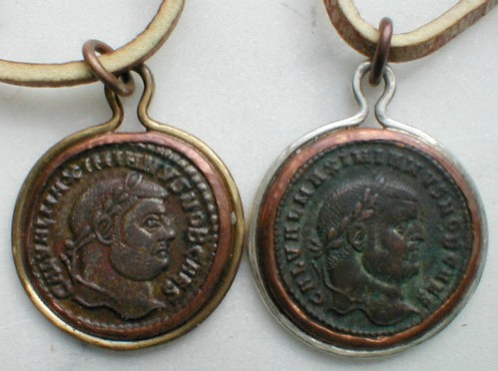](images/galerius_50.jpg)

### Ptolemy King of Egypt *by Joseph Kleinman*

*This article was first published in The Nor’wester, 2nd Quarter 2001.*

As numismatists, the related subject that can never be avoided is that of history. Like it or not history is interconnected with the study of currency and medals. This is especially true of ancient numismatics. Some of us got into the hobby because of our love of history coupled with a desire to own objects from those distant times. Many of us decided to collect ancient coins because of their tremendous eye appeal and then went on to study the historical events associated with our treasures.

As we look at the head of King Ptolemy I of Egypt let us consider the man and his accomplishments. Ptolemy was a boyhood friend of Alexander the Great and became one of his most trusted generals. He distinguished himself in Alexander's conquest of the Persian Empire and later became Satrap of Egypt in 323 BC. In 305 he took the title of King and later associated his son with him in his reign. The kingdom he established was stable and prosperous.

To King Ptolemy goes the credit for establishing and beginning the construction of the Great Library at Alexandria which was completed by his son Ptolemy II. This was no ordinary library as we moderns understand the meaning of the word. Although it may have contained as many as half a million volumes, it was also a museum and zoo as well as what we today would call a research laboratory. Some of the greatest minds of the ancient world worked there. People such as Euclid, Heron and Claudius Ptolemy the geographer and astronomer as well as Archimedes. And what of the work being done? All manner of science and mathematics, machines using gear trains were built, steam engines and jet engines were experimented with. Work in biology and medicine was advanced. Additionally, ancient texts were faithfully copied and translated. Most importantly, and what affects us to this day, Jewish scribes were employed in translating the Hebrew scriptures into the Greek language. Had that not been done, the missionary journeys of Saint Paul could not have taken place.

So here we have the beginning of many stories going in many different directions all starting with a small object that any of us can own.

This coin is a silver tetradrachm of Ptolemy I issued by his son:

[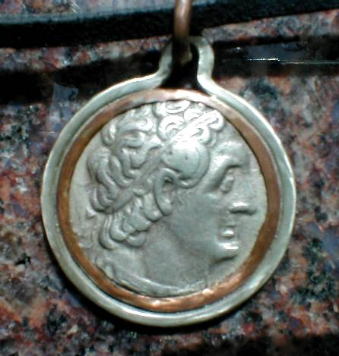](images/ptolemy_50.jpg)

**Marcus Aurelius *by Joseph Kleinman***

*This article was first published in The Nor’wester, 3rd Quarter 2001.*

With the success of the motion picture *Gladiator*, it might be interesting to take a closer look at the Emperor Marcus Aurelius. It was at the end of this emperor’s reign in the year A.D. 180 that the story begins as a war with German barbarians is ending. This is not mentioned in the movie, but it was the intention of Marcus to annex Germany into the empire as was done with Gaul and Britain in earlier centuries. Had that happened, the history of the world might have been changed for the better. In any case, Commoodus, the emperor’s son, abandoned the project in favor of less worthy pursuits.

Now let us look at Aurelius the man by considering his thoughts and intentions as expressed by him in his own words. Marcus Aurelius kept a journal which was never intended for public consumption. He called it “To Myself,” today we call it “Meditations.” It was published by his family after his death. This writer keeps a copy on his nightstand and never tires of reading it for the wisdom it contains.

Book III Entry IV

“Waste not the remainder of your life in thoughts about others, except when you are concerned with some unselfish purpose. For you are losing an opportunity to do something else, when you have such thoughts as: What is such a person doing, and why, and what is he saying, and what is he thinking, and what is he contriving? And whatever else of the kind makes us forget our own ruling principle. We ought to check in the course of our thoughts everything that is without a purpose and useless, but most of all meddling and maliciousness. A man should train himself to think only of those things about which if you were suddenly asked, what have you now in your thoughts? With perfect openness you might immediately answer, this or that: so that from your words it should be plain that everything in you is sincere and kindly, and befitting a social animal, and one that cares not for thoughts of pleasure or sensual enjoyments or any rivalry or envy or suspicion, or anything else which you would blush if you were to say it was in your mind. For such a man, who delays not to enter among the best, is like a priest and minister of the gods and uses the divinity which is within him, which keeps him uncontaminated by pleasure, unharmed by pain, untouched by insult, feeling no wrong, a fighter in the noblest fight, one who cannot be overpowered by passion, steeped in justice, accepting with all his soul everything that happens and is assigned to him as his portion.”

“Not often, nor without some great necessity and for the general interest, does he conjecture what another says, or does, or thinks. For it is only what belongs to himself that he is concerned about; he thinks constantly of what is assigned to him out of the sum total of things, and makes his own acts fair, and is persuaded that his own lot is good. For the lot assigned to each man moves along with him and carries him along with it. He remembers also that every rational being is his kinsman, and that to care for all men is natural to man; and that a man should not care for the opinion of everybody but of those only who live according to nature.”

“As for those who live not so, he bears always in mind what kind of men they are both at home and abroad, both by night and by day, and what they are, and with what companions they live their evil life. Accordingly, he values not at all the praise which comes from such men, since they are not satisfied even with themselves.”

Marcus Aurelius was the last of the so called “Good Emperors.” After his death, the empire began its decline into despotism and eventual collapse. Marcus Aurelius as emperor on a bronze sestertius:

[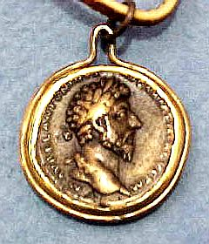](images/aurelius.jpg)

### Myths & Legends by Joseph Kleinman

*This article was first published in The Nor’wester, 4th Quarter 2001.*

The ancients used myths and legends to illustrate truths and principals just as we do today. Many of them have come down to us and are useful in the teaching of valuable lessons to children. One remembers such stories as The Tortoise and the Hare, The Ant and the Grasshopper, The Fox and the Stork – all to teach as well as to entertain. A number of these stories deal with people who may have lived. My favorite myth is the story of King Midas who acquired “The Golden Touch.” It teaches that having wealth alone leaves us empty and unfulfilled.

Let us look at some myths and see what principal they attempt to teach. Consider the story of Pegasus. The hero Perseus is given the task of slaying The Medusa, a snake haired monster whose ability to turn men to stone if looked upon protects her from attack. Enter Athena, the goddess of war and wisdom who advises Perseus to polish the boss of his shield so that by looking into it he can see Medusa and cut off her head as she sleeps. From the blood of Medusa springs Pegasus, the winged horse who flies to the acropolis of Corinth.

Another story is that of Persephone, the maiden kidnapped by Hades who must spend half the year in the underworld but comes to the surface in the spring so that the crops may begin to grow.

Likewise, there is the story of Dionysus, the god associated with the annual grape and grain harvest. Persephone and Dionysus in ancient times had mysteries, what today we would call passion plays celebrated in their honor.

But all these myths had one common theme running through them. One principal that was so profound and important that the lesson had to remembered through these timeless stories. The theme is that of death, burial and resurrection — the core belief of the faith that still prevails in the western world.

[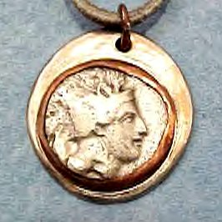](images/athena.jpg)[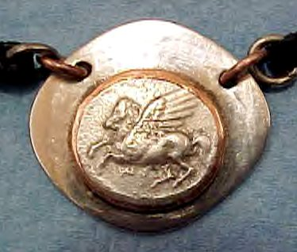](images/pegasus.jpg)  
Left – Athena on a Silver Double Drachma from Lucania, a region in the south of Italy   
colonized by Greeks. It dates from the 4th century BC.  
Right – Pegasus on a Silver Stater of Corinth.

### A Talking Coin *by Joseph Kleinman*

*This article was first published in The Nor’wester, 1st Quarter 2002.*

Many of us involved in ancient numismatics wonder what it would be like if our coins could talk, to speak to us of their travels and experiences. No doubt they did much the same things that our modern currency does. Pay for food, lodging, clothing and perhaps transportation. For sure they were brought into pagan temples and paid for sacrifices to various gods and goddesses. Let us now examine a coin of an individual whose life still has an impact on us to this very day.

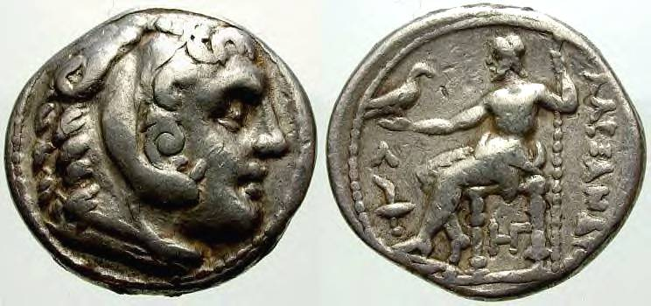

The coin is a Silver Tetradrachm of no less a personage then Alexander the Great. On the obverse of the coin is the head of Alexander posing as the demigod Herakles or Hercules as the Romans would have called him. Why Hercules? Alexander considered himself to be a god, Herakles was the last son of Zeus king of the gods thus the connection. How do we know that the head is that of Alexander? Hercules was often depicted as a mature man having a beard, here we see a beardless youth. Additionally, the depiction closely resembles sculpted busts of Alexander as well as other coin types that make no pretension as to who the subject is.

The reverse of the coin is of equal interest. We see the god Zeus seated on his throne holding an Eagle, his companion bird. This reverse type may very well be a representation of one of the “Seven Wonders of the World,” only one of two shown on ancient coins. The master sculptor Phidias created a statue of Zeus in Ivory and Gold which was known throughout the ancient world. This statue was set up at Olympus although it may have been moved to Athens. Behind Zeus is the inscription “Alexander.”

To the ancients, no more had to be said.

### Politics and Religion (The Biblical Tribute Penny) *by Joseph Kleinman*

*This article was first published in The Nor’wester, 2nd Quarter 2002.*

Most of us are cautioned to avoid the topics of politics and religion when in polite society. However, there is a popular field in ancient numismatics devoted to these normally sensitive subjects, namely, what are referred to as Biblical Coins.

Just what are Biblical Coins? Well they could be coins that are mentioned in the Bible or they could be coins associated with events or places mentioned in the Bible. For example, a collection can be built with coins from each city associated with the missionary journeys of Saint Paul as mentioned in the Book of Acts. The events in that book take place in the reign of Nero, A.D. 54 – 68. Another example of a Bible based collection might be the coins from each of the “Seven Cities of Asia” as mentioned in the Book of Revelation. The Book of Revelation was penned in the time of the Emperor Domition, A.D. 81 – 96. These are just two of several themes that may be covered by what has become known Biblical Coins.

But for the serious collector of Biblical Coins there is one “must have” item that although common enough can nevertheless be quite costly. I am referring to what today we call the "Tribute Penny." The Tribute Penny is a Roman Imperial Silver Denarius from the reign of Emperor Tiberius, A.D. 14 – 37. It is called a Penny because when the King James Version of the Bible was compiled in 1611, a Penny was a small English Silver coin. It is this coin that will be the topic of this article.

[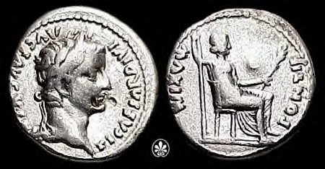](images/tiberius_3.jpg)  
*Photo © Classical Numismatic Group, Inc.* [*www.cngcoins.com*](http://www.cngcoins.com)*. Used by permission.*

The Tribute Penny is the focal point in the story of a confrontation between Jesus Christ and his enemies who are seeking to prevent his message from reaching the general population. Before we continue it will be useful if we put the confrontation into a historical perspective – In the eighth century B.C. the Assyrian Empire destroyed the Kingdom of Israel. In the sixth century the Kingdom of Judea was destroyed by the Babylonians. Next the Persians ruled the area to be followed by the Greeks and finally the country fell under Roman occupation but with a puppet king. At the time Jesus was preaching, the people of Israel had been under foreign domination for over seven hundred years.

Jesus was a Jewish Rabbi traveling through the countryside with his students (Disciples) and proclaiming the advent of a new kind of society (“Kingdom of God”), one in which the old forms of oppression will be eliminated. It is apparent from his treatment of the women at the well and of his healing the servant of a Roman Centurion that this new society would not be exclusively Judean. Today we might call this a universal worldview. In any case, we can see how such a message would be a threat to those who might have an interest in maintaining the status quo.

The Trap. At a public meeting, the enemies of Jesus ask him if it is lawful to pay taxes to the Romans. If he answers no he brands himself as a revolutionary and enemy of the reigning king and of the Romans. If he answers yes, he cuts himself off from his own people and his message (Gospel) becomes meaningless. What to do? Enter the coin.

Jesus discovers the trap and calls his enemies hypocrites and then says to them, “show me the money of the tribute” and they produce the coin. About one day’s wage for a laborer at that time. Now Jesus asks, “whose image and whose inscription are on the tribute money” and they answer Caesar’s. Jesus then says, “therefore render unto Caesar the things that are Caesar’s and unto God the things that are God’s.” This answer defeats his enemies. Why?

What Jesus did was to open a new area of inquiry. We must now ask the question what belongs to Caesar and what belongs to God? To the people of that time and that land the prevailing opinion would be that nothing belongs to Caesar and everything belongs to God. “The earth is the Lord’s and the fullness thereof and all that dwell therein” (24th Psalm). So, we can see why it is at this point that the enemies of Jesus begin to plot his death. The Romans did put Jesus to death with the method reserved for those who would make rebellion.

I doubt that anybody at that time would even imagine that the religion founded on the teachings (at least in part) of that Rabbi would become the official religion of the empire that killed him.

### The Republic of Rome *by Joseph Kleinman*

*This article was first published in The Nor’wester, 3rd Quarter 2002.*

At the time that Rome was established as a city, Greeks were colonizing the Italian peninsula, Phoenicia was establishing colonies on the North African coast and the Assyrian Empire was poised to attack the Kingdom of Israel.

Rome’s founding according to legend occurred in the year 753 BC. The Roman Republic was established in 509 BC, when the last of the Etruscan kings was overthrown and an assemblage of elders (a Senate) was created to govern the community. This republic lasted until 27 BC at which time Octavian was granted the title Augustus and so began The Empire.

The coinage of the Roman Republic underwent several reforms during its long history. Covering the history of those reforms would be far too lengthily an opus to put into a newsletter such as this one. However, there are some features of the later coinage that the collector of classical coins can appreciate. As discussed in an earlier article, ancient coins are one of the few ways in which a person of modest means can secure a genuine ancient art object.

Among the most desirable pieces of numismatic art are the Silver coins of Greece. Especially popular are the coins of the Colony of Syracuse as well as the cities of Corinth and Athens. Building a collection of quality Greek Silver can be quite costly. A single coin of a common issue can easily cost several hundred dollars and the prices can run into the thousands.

The coinage of the Roman Republic on the other hand, offers the collector of quality ancient art the opportunity to assemble a gallery of coins which mirror the Classical Greek style. It should also be mentioned that many of the coin die engravers were themselves Greek. The investment associated with building a quality cabinet of Roman Republican Denarii is miniscule when compared to the cost of Greek Silver. Many pieces in Very Fine+ condition can be purchased for between fifty to one hundred dollars.

An example of such a piece is the one illustrated below. This is indeed a mystery coin. Here we have a Republican Denarius issued by the Moneyer L. Julius Bursio. This piece struck in 85 BC. shows the god Apollo who was the god of prophecy, music, medicine, the sun god and the protector of flocks. However, on this coin he also wears the wings of Mercury and has the trident of Neptune behind his head in the field. No satisfactory explanation has been given for this type of syncretism this early in the history of Rome.

[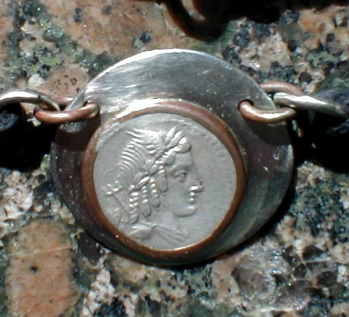](images/Apollo_c.jpg)

**Liberty *by Joseph Kleinman***

*This article was first published in The Nor’wester, 4th Quarter 2002.*

As I write this submission to our newsletter on this 11th day of September 2002, I cannot help but think about the events of last year and what it may mean for us today. However, before I continue, I should like to request that nobody reading this believe a word I say. I make that request because most of what I say will be my opinion and mine alone.

What happened last year was an attack upon our Western Civilization. On that day, the target for that multiple attack was our financial markets as well as our military establishment and the offices of our representative government. More specifically, it was an attack upon our liberty.

I submit that our prosperity and our freedoms stem from our Greek and Roman heritage and their profound understanding and love of liberty. So much so that wars were often fought to protect it or to secure it.

The coin illustrated is a Roman Republican coin celebrating the conclusion of a war, which they lost. We call that war The Social War. It is a strange name for a war I think you will agree. The Italian States under Roman Rule fought it for political equality. The Roman Tribune Livius Drusus took up the cause of those states but his murder in 91 BC put an end to their hopes and the war began.

[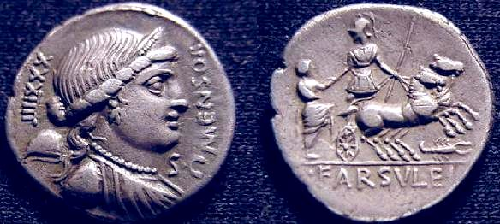](images/mensor.jpg)

The Italians organized themselves into a confederacy called Italia and raised a huge army which inflicted a number of defeats upon The Roman forces. Eventually, the Romans relented and passed the Lex Julia in 90 BC. The provisions of this law granted Roman Citizenship to any free Italian who applied. The coin was struck in 75 BC by the Moneyer, Farsuleius Mensor as a special issue by the consent of the Senate as the SC on the obverse indicates. On the obverse is the female bust of Liberty with a Liberty Cap behind. The reverse shows a Roman Soldier assisting an Italian wearing a Toga into his chariot. The results of that war and the law it established created the possibility for a stronger and greater Rome. That Rome which would become the blueprint for our own American Nation whose coinage proclaims Liberty.

### Lesser Deity *by Joseph Kleinman*

*This article was first published in The Nor’wester, 1st Quarter 2003.*

Most of us are familiar with the gods and goddesses of the ancient Greeks and Romans.

We have Zeus (Jupiter to the Romans), Apollo, Venus and so on. However, there were other deities that were also part of the ancient pantheon of gods. The Romans were especially adept at maintaining a variety of these lesser deities, which today we call personifications. A personification is simply a quality, condition or state of being that is presented as a human being. For example, in New Your Harbor there is a monument that we call the Statue of Liberty. In the last article I showed an example of that personification on a Silver Denarius. Another example of a personification would be the statue of Justice that often appears on or near a courthouse. The ancients had an abundance of these personifications, which they venerated along with their usual Olympian deities.

On ancient coins personifications were used in order to associate an attribute or condition with the person or authority issuing the coin. This was extremely prevalent during the Imperial Period but began much earlier in Republican times. Back then there were neither newspapers nor any other means of mass communication. The only medium available to the government was the ability to issue coins. Some of the personifications were male and some female. For example, we have Abundance, Clemency, Concord, Fortune, Joy and Hope shown as female. For the male we have Spirit, Honor, Virtue, Good Outcome and so on. So, an emperor wishing to take credit for a victory achieved on the battlefield might place an inscription on the reverse of a coin reading VICTORIAAVG, the victory of the emperor.

Personifications and the study of them can secure for us a deeper understanding of those distant times and make an excellent basis for an ancient coin collection.

The coin illustrated with this opus is a Roman Republican Silver Denarius of the moneyer M. Herennius. This was an issue struck between 108-107 BC. The obverse shows the personification PIETAS (piety). Piety had a different meaning to the Romans then it does for us. To us it might mean a deeply religious man or woman but to the Romans it meant loyalty, faithfulness to one’s family or to the state. The reverse of the coin shows one of the Catanaean Brothers running right and bearing his father on his shoulders. This was to rescue his family from an eruption of Mount Etna. However, there is a far more profound meaning to the reverse because it recalls the foundation story of the Roman People, when Aneas rescues his father from the burning City of Troy.

[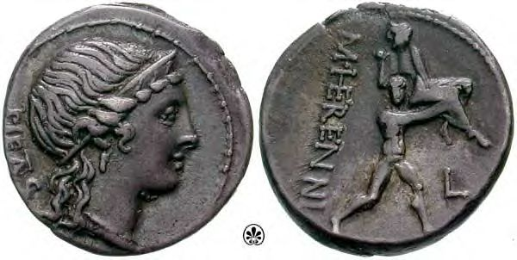](images/herennia1a.jpg)  
*Photo © Classical Numismatic Group, Inc.* [*www.cngcoins.com*](http://www.cngcoins.com)*. Used by permission.*

### Hadrian by Joseph Kleinman

*This article was first published in The Nor’wester, 2nd Quarter 2003.*

When we consider the careers of the Roman Emperors, most of us might conger up in our imagination images of people who we would rather not associate with. Emperors such as Caligula, Nero and Commodus to name just a few. However, there were quite a few good emperors, gifted men such as Vespasian, Titus and Nerva and his successor Trajan. It was Trajan who brought the empire to its greatest size in terms of territory or lands conquered.

Hadrian, the subject of this article, was in my opinion the greatest of all emperors. Why you might ask would I subscribe to that opinion. Because it was Hadrian who transformed the empire from a society of rank and privilege as far as the provinces were concerned into a commonwealth of equal districts. Upon becoming emperor because of Trajan’s death in AD 117, he began a program of reforms which touch our lives even to this day. He was the first emperor to codify Roman law and eliminated some of the abuses of the slave system. For example, a slave owner could no longer sell a slave to a gladiatorial school. However, some of his reforms were not popular with the Senate as they felt that their privileges were undermined. It is important to remember that Hadrian like his uncle Trajan before him was a Spaniard. This would explain his more favorable treatment toward his non-Italian subjects.

Hadrian considered himself another Augustus in that he created a new world order. He was a tireless worker on behalf of the welfare of the empire and made two separate tours of the provinces to see that his reforms were carried out. One of those reforms was in the realm of military policy. For centuries Rome had been an aggressive conquering state. It was Hadrian who made the decision to consolidate rather than to expand the frontiers of empire. When I visited England several years ago, I had the privilege of walking on part of the wall he ordered built across that island. This new policy led to an era of peace and prosperity the world had never known.

Hadrian was a man of many talents, Statesman, Philosopher, Architect, Soldier and even Poet. Had I been in Rome on the occasion of one of his returns to that city, I would have greeted him together with the rest of the populace in the salute, hale Caesar, hale Hadrian.

The coin available for viewing (previously on another web site) is a Silver Denarius showing the bust of the emperor and the personification Fortuna on the reverse holding a rudder and cornucopia. This to celebrate the fortunate return of the emperor to Rome. The coinage of Hadrian is quite reasonable in cost and makes an excellent theme for a collection.

{Image no longer available, however you can search for similar coins.}

### The Nero you do not know *by Joseph Kleinman*

*This article was first published in The Nor’wester, 4th Quarter 2003.*

Many of us consider the Emperor Nero to be one of the most evil men ever to march across the stage of world history. Right up there with Hitler, Stalin and our present-day adversaries in the war on terror. But if we take an objective view and look at the facts, we conclude that history does not support all the bad press that is heaped upon the head of Nero.

Before going into some specifics associated with the career of Nero, let us begin with his background and early education. Nero was a Roman Patrician and as such received a liberal education. He was schooled in philosophy and law and studied the classics in both Latin and Greek. He was an accomplished athlete, artist and actor. In fact, it was his artistic activities that caused the nobility of Roman society to ridicule him.

Suetonius, in his Lives of the Twelve Caesars, reports that he had a deep booming voice that would have required good training and much practice. He came to the throne in AD 54 at the age of 16. Early in his reign he improved the economy, reduced taxes and was generally kind and generous. The young emperor was even interested in the artistic merit associated with the coinage issued by his mints and did much to improve its style.

The two most dastardly and cowardly acts attributed to Nero was his starting the Great Fire of Rome in AD 64 and then blaming the Christians for the blaze in order to shift suspicion away from himself. Let us examine those charges. In the first place, Nero was not anywhere near the city when the fire broke out, but at his villa 35 miles away. When he received the news, he rushed back to the city and made every effort to have the fire extinguished. Then he organized aid for the victims after the blaze was put out. At that time there were few Christians in Rome and the ones that were there were considered Jewish. Nero at the time was married to Poppaea, a woman who was well disposed to the Jews so any policy established against the Christians would have been opposed by Poppaea whom Nero loved. Additionally, there is no mention of a Christian persecution in the writings of Josephus, a Jewish Historian and a contemporary of Nero. Most importantly, there is no mention of a Christian persecution in any of the New Testament writings. Perhaps the only New Testament reference to Nero may be found in The Book of Revelation written by written by the Apostle John who mentions “The Beast.” This reference may be associated with the first Jewish War against Rome which broke out in AD 66, two years before the death of Nero.

The coin illustrated is a silver Denarius showing Nero and a Jupiter reverse. The picture of a good artist gone bad.

[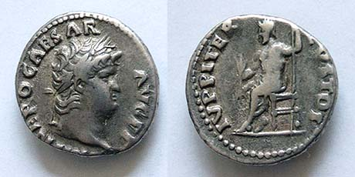](images/nero.jpg)  
*Photo credits: Perry Seigel of Herakles Numismatics and Dave Surber of* [*WildWinds*](http://www.wildwinds.com)*.*

### One of the Worst *by Joseph Kleinman*

*This article was first published in The Nor’wester, 1st Quarter 2004.*

In my last submission I shared some historical information associated with the Emperor Nero. Nero although by no means a sweetheart nevertheless had some redeeming qualities. This time I will introduce an individual who in my opinion was one of the worst emperors to ever govern the Roman Empire. He is known by the name Elagabalus. Elagabalus, however, is not his name — it is the name of the god he worshipped. The name he took after becoming emperor was Marcus Aurelius Antoninus, after one of the most pious and good emperors.

This individual was a boy of 14 when his grandmother Julia Mesea, related to the Emperor Septimius Severus, initiated a coup against the then Emperor Macrinus. These events accord in AD 218. Once becoming emperor, he and his family journeyed to Rome arriving in July of 219. Once there he began a career of vice and cruelty which deeply offended the more conservative Romans. Among his more outrageous offences was his marriage to three different women of the patrician class one of whom was a Vestal Virgin. One of his wives was a noble women Anna Faustina who was of the house of Marcus Aurelius and was reported to be between 35 and 45 years of age. So vile and gross were his amusements that they cannot be related in a publication of this nature but can be accessed by reading the ancient historians, one of whom is Dio Cassius. The 19th century historian S.W. Stevenson called Elagabalus “the most cruel and infamous wretch that ever disgraced humanity and polluted a throne.”

Because of his well-deserved unpopularity, his grandmother persuaded him to declare his cousin Severus Alexander as Caesar. The young Alexander soon became popular with the army and Elagabalus tried on several occasions to have him assassinated. Finally, in the year 222 the Praetorian Guard placed Alexander under their protection and murdered their emperor and his mother and threw their bodies into the River Tiber to the general rejoicing of the Roman World.

The coin is a Silver Denarius showing the emperor’s bust and the naked figure of the sun god whom he worshipped. *Photo credits: Alan van Arsdale and Dave Surber of* [*WildWinds*](http://www.wildwinds.com)*.*

[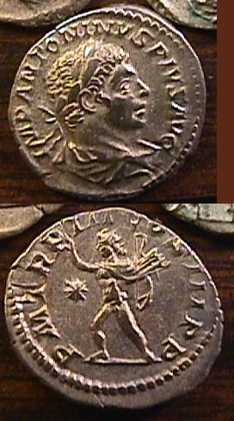](images/Elagabalus.jpeg)

### Our Persian Heritage *by Joseph Kleinman*

*This article was first published in The Nor’wester, 2nd Quarter 2004.*

In my first submission, I wrote an introduction to ancient numismatics. In it I said that our cultural and political institutions are based primarily in those developed by the ancient Greeks and Romans. That statement is essentially true. However, there is an element that is not studied very often as an academic subject and that is our religious heritage which although transmitted to us by the Romans, did not originate with them.

As the title of this submission is our Persian Heritage, it is now necessary to recount the historical events which would establish our connection to ancient Persia. In the year 586 BC the Kingdom of Judah was conquered by Babylon and its people were driven into exile. Not many years later, Babylon was in turn conquered by Cyrus the Great of Persia and the Jews began their long association with an Aryan people who like them practiced a monotheistic religion. Although some of the Jews returned to their homeland to rebuild Jerusalem (this time as a Persian outpost), many of them stayed behind and established their communities within this new empire.

The rest of the history in short order goes like this. Alexander the Great conquers Persia, Parthia replaces the Syrian Greeks in Asia, Rome conquers Syria but not Parthia and this situation does not alter until the third century. In AD 226 the Sassanian monarchy establishes the Neo-Persian Empire. The state religion of this Neo-Persian Empire is Zoroastrianism, the monotheistic religion of ancient Persia.

Zoroastrianism is a religion that still exists in Iran and parts of India. Its basic belief is centered around the notion of a struggle between the forces of good and evil. The good being the wise lord Ormuzd who is opposed by the evil spirit Ahriman. One may suppose that the Christian concept of the Devil is a variation of this evil spirit. The good and evil in the world is represented by the presence of light and darkness. Accordingly, the worship of the faithful takes place around a Fire Altar. Some of the qualities associated with the religion are that its adherents practice hospitality, philanthropy and benevolence. Zoroastrianism had a spin-off in a faith that was to have a profound influence on Western Civilization, the cult of the god Mithra. Mithra was created by Ormuzd so like Jesus did not come into being as the result of a sexual union. He was looked upon as the god of faithfulness, purity and the protector of men. The cult was brought to Rome in the first century BC and became prevalent throughout the empire but especially in the army. Recruits, after undergoing a period of trial were baptized into a brotherhood with a “Father” at its head. This cult may well have become a world religion had it allowed women to take a more active part but that is only my opinion. It was supported by the military emperors of the third century and a similar cult, that of SOL INVICTO, the unconquered sun was established as a state religion by the Emperor Aurelian (AD 270-275). At this point in our story we connect the dots and follow it to its logical conclusion when in the fourth century, following the lead of Constantine, the Roman Empire became officially Christian. So now, we have established a connection or rather a link between what was believed in ancient Persia to what has become the prevalent religious doctrines associated with the Christian faith.

The coin is a Silver Sassanian Drachma showing the Zoroastrian Fire Altar (on the reverse) with two attendants.

[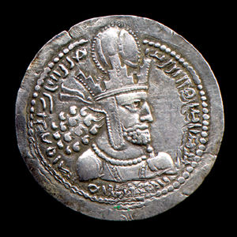](images/i_sas_shapI_23_rs_o6.jpg)[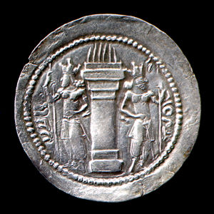](images/i_sas_shapI_23_rs_r6.jpg)  
*Images courtesy of Thomas K. Mallon-McCorgray.*

### The striking of ancient coins *by Joseph Kleinman*

*This article was first published in The Nor’wester, 1st Quarter 2005.*

Most of us who collect modern coins understand the modern minting process. Additionally, some of us may also be knowledgeable regarding the work of the coin die engraver. For instance, most of us know that modern coin blanks are punched out from sheets of metal that were produced at a mill. We also know that the dies are cut by machinery using digital technology. Things were quite different in ancient times.

In ancient times none of the techniques or technology existed that would or could be used to produce the exquisite results that they nevertheless achieved. How did they do it?

Beginning with the flan or planchet, we know that they were manufactured by a casting process. Molten metal was poured into a mold and then broken out after cooling. This process did not always produce flans of equal size and weight. That is just one of the reasons why any two ancient coins of the same issue are never exactly alike. The coin dies were cut by hand individually. A bow drill was most likely used to produce a reverse image on a bronze die that was work-hardened. Remember that the die engraver did not have the benefit of strong acids, high magnification or even an adequate source of available light. The actual process of striking the coin is illustrated on this Roman Republican Silver Denarius of the mint official T. CARISIVS, a senator responsible for the operation of the mint in 46 BC when this coin was struck. The flan was heated in an annealing oven and when the desired temperature was reached the flan was removed from the oven (with the tongs shown) and placed on the anvil holding the reverse die. The obverse die (shown above the anvil) was struck with the hammer (shown to the right of the anvil). The obverse die is in the shape of the cap warn by Vulcan, the Roman god of the forge.

The coin features the bust of Juno Moneta (from where we get the word money). The Mint of Rome was located adjacent to the temple of Juno Moneta on the Arx summit of the Capitoline Hill.

[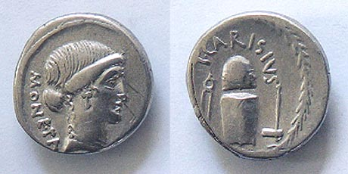](images/carisia1.jpg)  
*Photo credits: Perry Seigel of Herakles Numismatics and Dave Surber of* [*WildWinds*](http://www.wildwinds.com)*.*

### Constantine, called The Great *by Joseph Kleinman*

*This article was first published in The Nor’wester, 2nd Quarter 2005.*

Throughout history there have been men (and women too) who have shaped our world and then are seldom even thought of as great historical figures. Such a man is Constantine. How many of us even know when he governed the vast Roman Empire and shaped the very foundations of our civilization? To write a chronicle of his reign in a journal such as this would be impossible. Only commentary is possible. I chose to write about this man at this time because I wanted a figure from the classical world whose coinage anybody of modest means could collect. Additionally, I needed a person who profoundly changed the direction of history, a person whose policies touch our very lives even today. Constantine easily qualifies on every point.

This then is my commentary. Civilization can be likened to a stool having three legs (this according to Gibbon) The Family, The State and The Altar. In our modern western nations, they tend to be somewhat distinct. Not so in the ancient world. In ancient times each state had an official religion. In some nations, Egypt for example, the king was also a living god. In the Roman Empire, some of the worst emperors demanded divine honors from their subjects and many of the good ones were deified after their deaths.

Constantine changed that. Constantine favored the Christians because of his victory over Maxentius at the Milvian Bridge just outside of Rome in AD 312. He is considered to be the first Christian emperor but wasn’t baptized until just before his death in the year AD 337. However, he took a keen interest in church affairs and was instrumental in directing the future course of church history and that of Europe and the world.

In AD 324 Constantine defeated the rival emperor in the east (who was later killed) and became ruler of a united empire. In AD 325 he called a general council of the church in order to settle the Arian Controversy. The church had been split over the doctrine of the Trinity or Catholic view as opposed to the opinion of the Arians who held that the Son was not co-equal and co-eternal with the Father. This controversy involved the very nature of the godhead. Out of this council (which Constantine presided over) came the Nicaean Creed which is recited in most of our churches today.

In AD 326 Constantine experienced his darkest ordeal. His eldest son Crispus was implicated in a plot against Constantine by his stepmother the Empress Fausta. Thereupon, Constantine ordered the execution of Crispus. When in due course the plot was proven to be fabricated by Fausta, Constantine ordered her to be executed by having her scalded to death by steam. Later, Constantine had a golden statue of Crispus erected to the memory of the son that he wrongly condemned. A medallion (illustrated) was also issued in honor of the unfortunate Caesar.

The reforms of Constantine were not all beneficial in my opinion. His new economic policies included the debasement of the coinage. His social and religious reforms led to a new despotism based on the Persian model and as defender of the “True Faith” he became more powerful than any of his predecessors ever were. He can be credited (at least in part) with the establishment of feudalism in Europe. His division of the empire among his three surviving sons further weakened the imperial system, especially in the West. However, on balance, given the circumstances that existed at that time, I would have to say that Constantine changed the world for the better. One would have to wonder who at that time could have done a better job.

The Decline and Fall of The Roman Empire by Edward Gibbon gives an excellent overview of the reign of Constantine. Also covered in The Decline and Fall is an account of the rise of Christianity within The Roman Empire. Most of the coins of Constantine and his family can be secured inexpensively.

[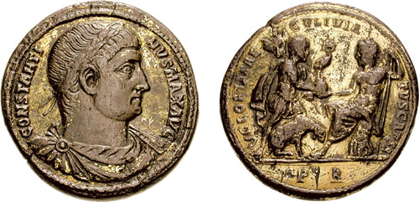](images/Rome_RIC_vII_279.jpg)  
Medallion issued in memory of Crispus, son of Constantine. (See text for description.)

*Image courtesy of Classical Numismatic Group, Inc.  
Serving the world in Ancient, Medieval & British Numismatics   
since 1975. Website* [*http://www.cngcoins.com/*](http://www.cngcoins.com/)*.*

### Back from the Brink – Aurelian *by Joseph Kleinman*

*This article was first published in The Nor’wester, 3rd Quarter 2005.*

Most of us who have a knowledge of ancient history hold to the concept of divisions. That is to say that we believe that historical events fall within definite epochs. For example, when considering the history of the Roman Empire we tend to believe that the Western Empire fell in the fifth century followed by the “Dark Ages” and that the Eastern Empire continued on until the mid-fifteenth century when it was conquered by The Turks.

I hold to a different concept.

Most historians would agree that the Western Empire did not fall in the same sense that the Soviet Union did but that it was broken up after a long period of corruption and decay. That the fall was not an event taking place at a point in time, but a breakup as the result of a process. The breakup that we shall look at in this opus did not occur in the fifth century but in the third.

The mid third century was a time of deep crisis for the Roman Empire. The emperors were concerned mainly with maintaining the loyalty of the armies whom they had to placate with ever larger donatives which put a tremendous burden on the already overtaxed citizens. At the same time, the frontiers were constantly being threatened by barbarian tribes who were steadily gaining strength as the empire became ever weaker. On or around AD 260 the empire faced a double threat. While the armies were contending with the German tribes on the Rhine / Danube frontier, the Persians attacked. This was during the joint reign of Valerian and his son Gallienus. Both emperors took the field and led their armies against Rome’s enemies. It was Valerian that went east to meet the Persians. After some initial success, the army of Valerian was trapped, and the emperor captured alive and later killed. This event sent shockwaves throughout the entire Roman world. Very soon after that, provinces began to break away in order to form separate states that might better provide for their own defense. Spain was lost, Britain and Gaul were lost and, in the East, Egypt and Syria were controlled by Queen Zenobia of Palmyra who intended to carve out an empire of her own. Without the resources of the lost provinces and with a greatly reduced territory from which to recruit troops for the legions, the empire was doomed.

Although Gallienus was successful in repelling further barbarian invasions into Roman territory, try as he might, he could not recover the lost provinces. In AD 268 he was assassinated by a group of officers one of whom was the future emperor, Aurelian. In AD 270 Aurelian became emperor and began the campaigns that would restore the Roman world to a condition resembling its former greatness. One after another the barbarian tribes were routed, the usurpers that had broken away surrendered and their provinces brought back under the rule of Rome. The short-lived Empire of Palmyra was defeated, and Queen Zenobia was brought back as a captive to Rome where wearing golden chains she rode in the Triumph accorded to Aurelian by the Roman Senate.

In domestic affairs, Aurelian reformed the coinage and established a new state religion that was monotheistic in character. The cult of the unconquered son.

As is so true of the events of the third century, the story ends in tragedy and death. It was the intention of Aurelian to wage war against Persia in order to re-establish the province of Mesopotamia. Had he been successful, think of how that would have changed history. Unfortunately, he too was the victim of a plot hatched by his own secretary who had angered him. He forged a list of officers who were to be purged by the emperor and in their fear, struck first and killed him. When they discovered the deception, they executed the secretary and appealed to the Senate to appoint a new emperor. Thus, ended the career of one of the most competent rulers of a troubled age.

[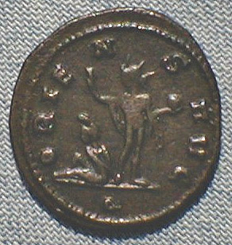](images/Aurelian_r.jpg)[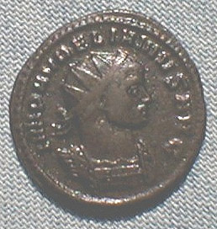](images/Aurelian_o.jpg)The coin is a double Denarius or Antoninianus as they are called. The reverse shows the figure of the SOL INVICTVS (the unconquered son) standing over a Persian captive.