PNNA Touched by National Tragedy
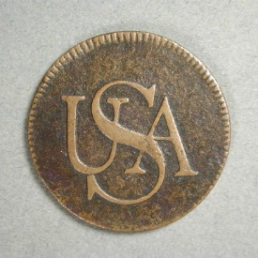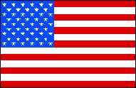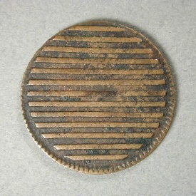
United We Stand, then as now.
Photos: “Bar Copper” imported from England by New York merchant in 1785.
See our Photo Gallery of U.S. Colonials for other examples of coins and tokens from early America.

9/11 Tenth Anniversary - September 11, 2011.
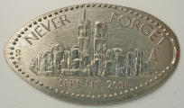
The PNNA joined many other organizations nationwide in expressing our horror and grief over the tragic events of September 11, 2001, while at the same time taking comfort in the remarkable response of the American people that we witnessed. There was one reported case where a relative of a PNNA member lost a friend or neighbor in the World Trade Center attack. We continue to share these feelings and to “never forget.”
- Willamette Coin Club Contributes to Relief Efforts -
See the 1st Quarter 2002 edition of The Nor'wester.
- See stories about ancient coins, including "Liberty," by Joseph Kleinman.

Numismatic Remembrance of National Tragedies
Medallic art and numismatic items have often reflected human triumphs and tragedies throughout most of recorded history, and no doubt will continue to do so. Many numismatic items of remembrance and/or items with a patriotic theme related to the September 11, 2001 events were issued. We hope that numismatic items such as these will suitably honor the dead and the resilient spirit of the living, while raising funds for worthy causes.
Here are some examples of how numismatic items have served as a remembrance of past national tragedies.
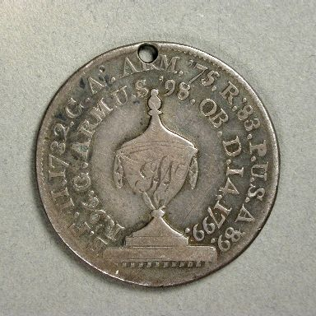
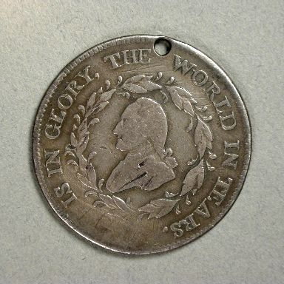
George Washington funeral — The "Father of Our Country" died on December 14, 1799, at the age of 67. Washington's stature at the time was such that his death had a profound effect on the young nation. The silver funeral medal shown here depicts Washington on the obverse and a funeral urn inscribed “GW” on the reverse. Part of the legend on the obverse reads “HE IS IN GLORY, THE WORLD IN TEARS.” Also see the George Washington papers website at the University of Virginia, https://washingtonpapers.org/.
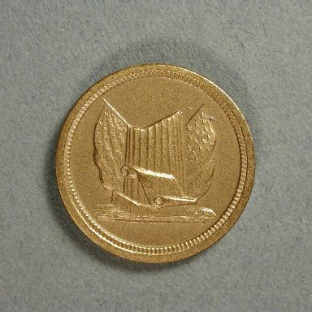
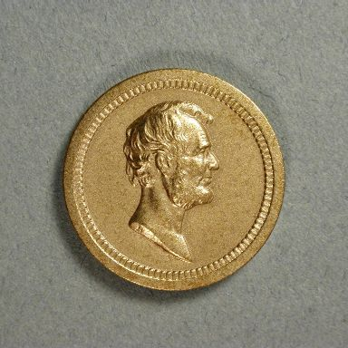
Civil War / Abraham Lincoln — The Civil War was the most destructive war in America’s history (killing about 500,000 Americans including Confederate forces). Abraham Lincoln, the president who led the Union through this difficult period, was himself assassinated on April 15, 1865 at the age of 56. Many numismatic items, including the well-known Civil War tokens, are associated with this war. This is a recent reproduction of a medal honoring Lincoln.

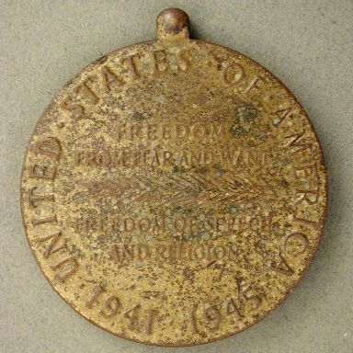
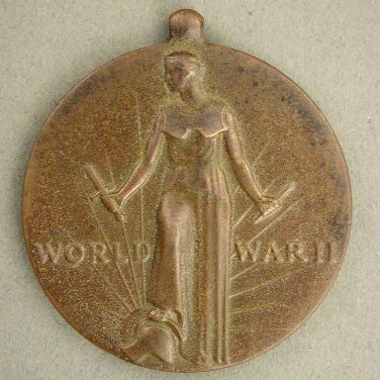
World War II — The Second World War was the most destructive and deadliest war in the history of the world, although it did not kill as many Americans (about 400,000) as the Civil War. World War II had an enormous influence on numismatics, and readers who are interested in this subject are referred to the book World War II Remembered - history in your hands - a numismatic study by C. Frederick Schwan and Joseph E. Boling. The medal shown here is a World War II victory medal.

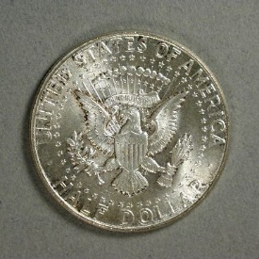
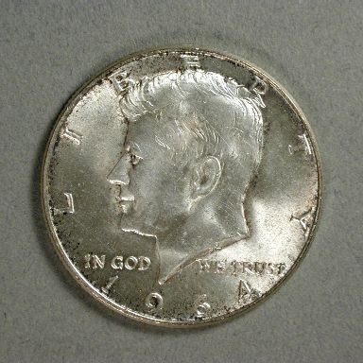
Kennedy assassination — The violent death of John F. Kennedy on November 22, 1963, at the young age of 46, is an event that is still etched in the memory of many Americans. Congress responded almost immediately by authorizing a new half dollar coin bearing Kennedy’s portrait to replace the Franklin half dollar. The Kennedy half, first issued in 1964, depicts the presidential seal on the reverse.

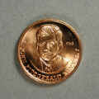
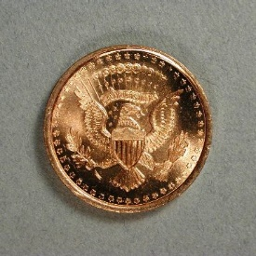
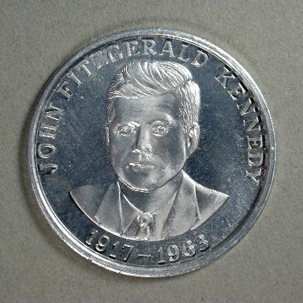
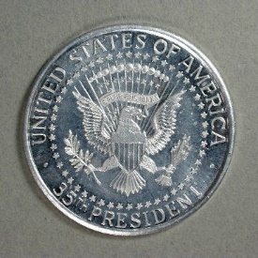
On these two privately issued Kennedy commemorative medals, the eagle's head faces to the eagle's left, a sign of war or distress.

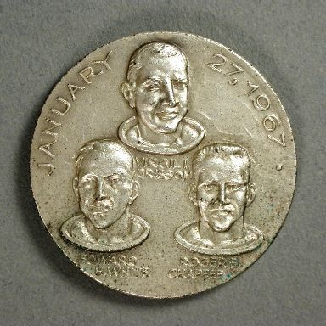
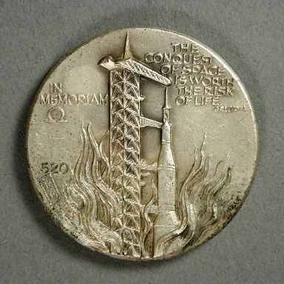
Apollo 1 fire — In the process of reaching Kennedy’s goal of landing a man on the moon and returning him safely to the Earth before the end of the 1960’s, astronauts Virgil Grissom, Edward White and Roger Chaffee were killed in a fire during a launch pad exercise on January 27, 1967. The silver medal shown here was issued in remembrance of this event. Kennedy’s goal was reached with Apollo 11 on July 20, 1969.

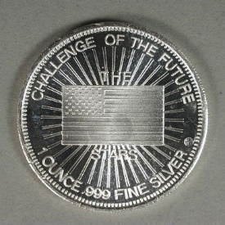
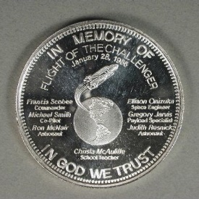
Challenger disaster — January 28, 1986, when seven astronauts were killed in the explosion of the space shuttle Challenger shortly after launch, now stands as one of the two saddest days for America’s space program. Compounding the tragedy was the realization that it could easily have been prevented. The silver round shown here was issued in memory of the flight and calls out the stars as the “challenge of the future.”
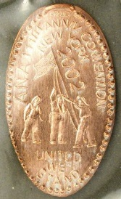
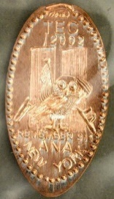
September 11, 2001 — The elongated cents pictured here were issued by The Elongated Collectors (TEC) for the ANA anniversary convention in New York City, July 31-August 4, 2002. The owl is the symbol of TEC. The first design depicts the former World Trade Center twin towers while honoring NYC police and firefighters. The second design depicts the flag-raising at the WTC site after the attack.

Columbia disaster (February 1, 2003) — See the next page.

Numismatic Tributes to Columbia
Although not of the same magnitude as September 11, 2001, the loss of the Columbia and crew on February 1, 2003, was a tragedy that affected many of us deeply. As has been true throughout much of human history, medallic art reflects great triumphs and tragedies and helps current and future generations remember the bravery and dedication of those individuals involved.
This page displays several commemorative medals issued to commemorate the great successes of the space shuttle Columbia from its historic first flight (April 12-14, 1981) up through its 20th anniversary and completion of renovation in 2001.
These are all separate, individual medals or coins, except for the first two images, which are the obverse and reverse of the same medal made by the famous Franklin Mint.
