Introduction to 1959 Oregon Centennial Tokens

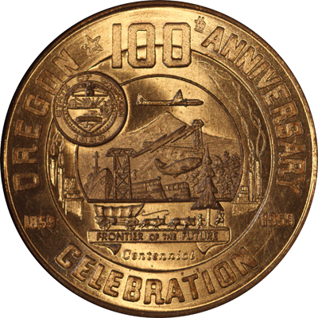
In 1845, Asa Lovejoy and Francis Pettygrove flipped an 1835 large cent to determine the name of a new settlement. Pettygrove won best two out of three and so the developing community was named Portland after his hometown in Maine. Fourteen years later, Portland was growing fast, and on Valentines Day of 1859 Oregon became the 33rd state admitted to the union, with Portland being its major port. Portland grew to be the largest city in the state because it was a hub for transportation and because of its industrial prowess. Today, it is still the largest city in the state but it is now famous for being a leading “green city” with its massive public parks, sustainable buildings, city-wide composting program, and extensive mass transit system, distancing itself far from its past which was tied directly to the forestry industry that built up the state. While Oregon as a whole developed largely because of logging, Portland was always an industrial leader, and it was a model city as the rest of the state diversified. In 1959, Oregon celebrated the centennial of its statehood with a large budget granted by the state government; the central element was the Oregon Centennial Exposition, held at the Portland Expo center.
Official Centennial Emblem as depicted on the tokens.
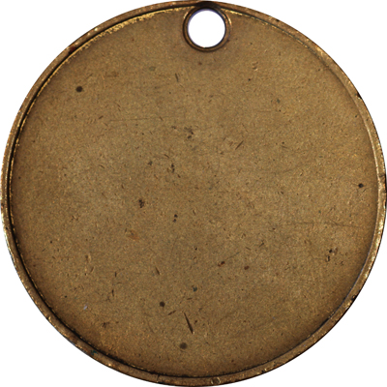
The Oregon Centennial Emblem was commissioned by the state and was used to on exhibition materials and souvenirs. The emblem depicted a harbor with various technologies: a pane, smokestacks, and ships, but it also has a covered wagon, remembering the past. Underneath it read “Frontier of the Future,” an appropriate slogan for a western state that was fast in development. One of the many things that the emblem was used on was a series of tokens and medals produced not by the state, but by the Northwest Specialty Sales Co., which in turn successfully marketed them to 38 localities that purchased the pieces. Many localities sold them as a fundraiser to finance their local centennial celebrations. Each locality had the option of using the standard obverse and a customizable standard reverse that said, “Good for 50¢ in trade” and a slogan of their choice.
Uniface tokens were made as sample pieces to market to the localities. Most are found with original holes.
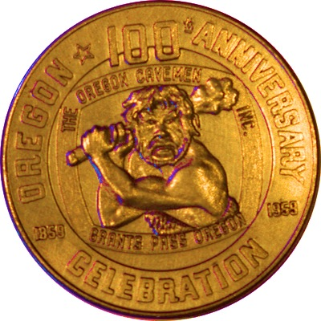
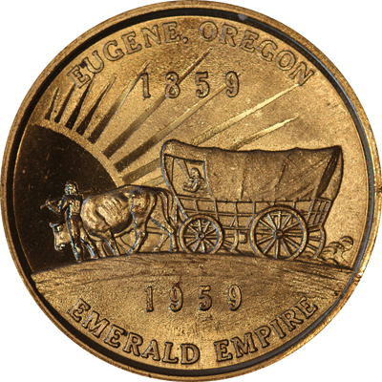
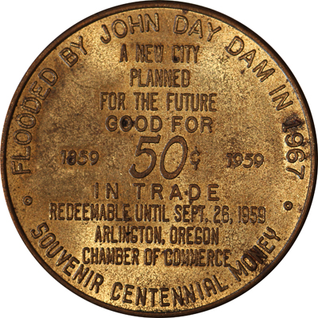
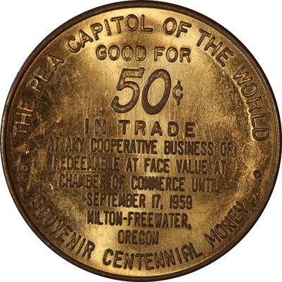
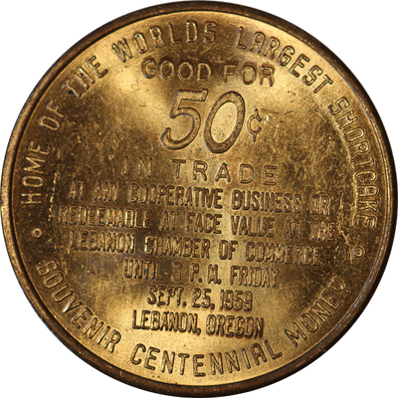
The locations were each able to represent their region with the short slogan, and each gave visitors to their celebrations mementos of the area. Lebanon proudly declared themselves “home of the worlds largest strawberry shortcake,” and Milton-Freewater was “The Pea Capitol of the World.” Arlington oddly wrote “Flooded by the John Day Dam in 1967,” predicting the destruction of their city by the dam that had been under construction for a year. The construction of the dam was delayed, and the town was flooded in 1968. Grants Pass was the only location to be creative with its customization of the obverse, replacing the scene of the emblem with a caveman.
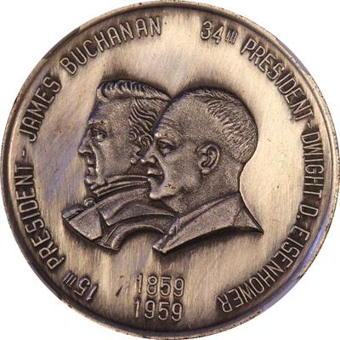
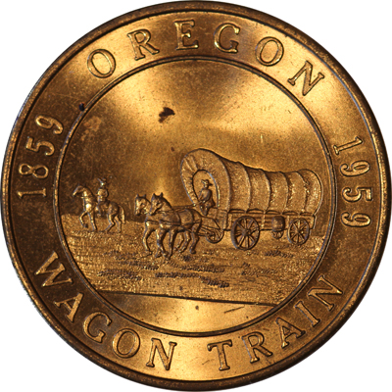
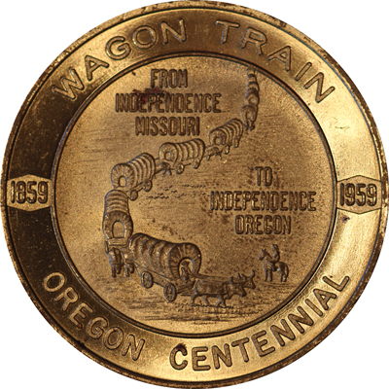
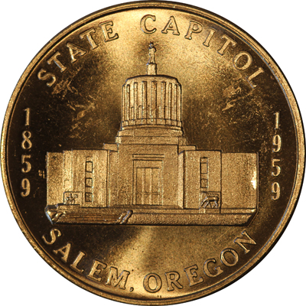
Four locations produced medals now recognized as so-called dollars: Eugene, Salem, Independence, and Roseburg. Eugene used the Oregon Trail commemorative reverse design. Salem depicted the state capitol building. Independence depicted a wagon train, “From Independence Missouri to Independence Oregon.” Roseburg’s medal is dubbed the “Wagon Train Dollar” because of its classic image of a covered wagon. A fifth so-called dollar, without a location mentioned, also depicts the Oregon centennial emblem on the obverse, with Buchanan and Eisenhower’s portraits on the reverse, commemorating the president in office when Oregon achieved statehood, and the president during the centennial.

I have been collecting Oregon Centennial material for about three years, and I now have a complete set of issuing locations. Most of the tokens can be picked up quite cheep at coin shops or local shows, and they’re great pieces because of the interesting stories behind them. There are some tokens with contemporary after-market plating that can still be found as well, although they are scarcer and a little harder to find, and there are also die varieties that add interest to the difficulty of attaining a truly complete collection. While most of the tokens will run no more than $10, the so-called dollars do command a premium and some of them are extremely rare. For example, only 175 Buchanan/Eisenhower pieces were struck in silver, which is the most common, and now very few are seen on the market. Many other tokens and medals, that do not depict the centennial emblem, are also part of my collection of centennial material. Included in that category are my personal favorites, the beautiful Pendleton Roundup dollars. Personally I love collecting local material because so much of the fun is in the hunt and the research, they are generally speaking rather inexpensive, and because I get to learn so many local stories and facts.

Article written by Katie Reinders for the PNNA,
December 2012

